Quelle heure est-il?
mercredi treize mai
LO. To write a sentence to tell the time – o’clock and half past the hour.
Underneath each clock, write the time in French. The first one is done for you.
Use the word bank at the bottom to help with spelling.
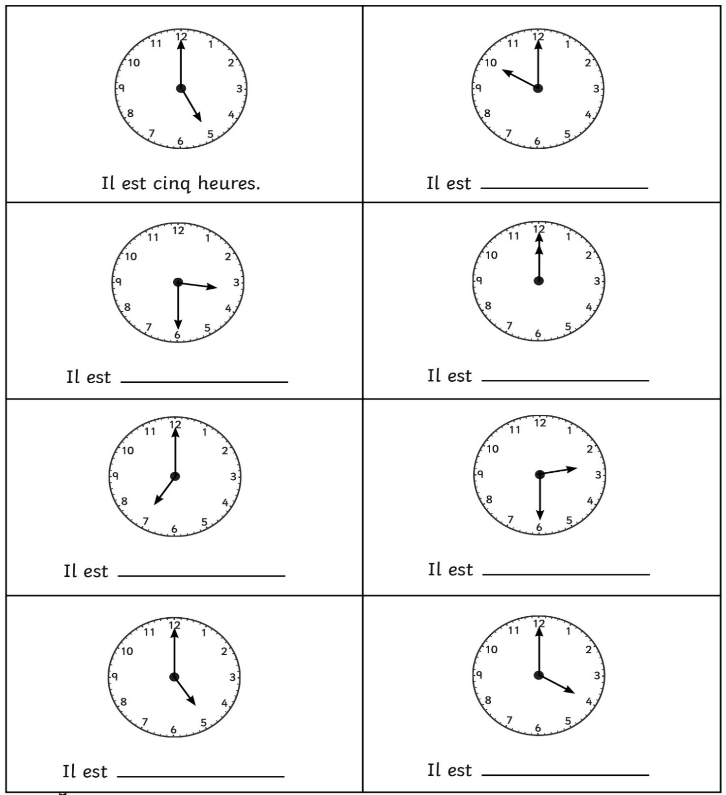

heure heures et demie
une deux trois quatre cinq six
sept huit neuf dix onze douze
Quelle heure est-il?
mercredi treize mai
LO. To write a sentence to tell the time – quarter past and quarter to.
Underneath each clock, write the time in French. The first one is done for you.
Use the word bank at the bottom to help with spelling.
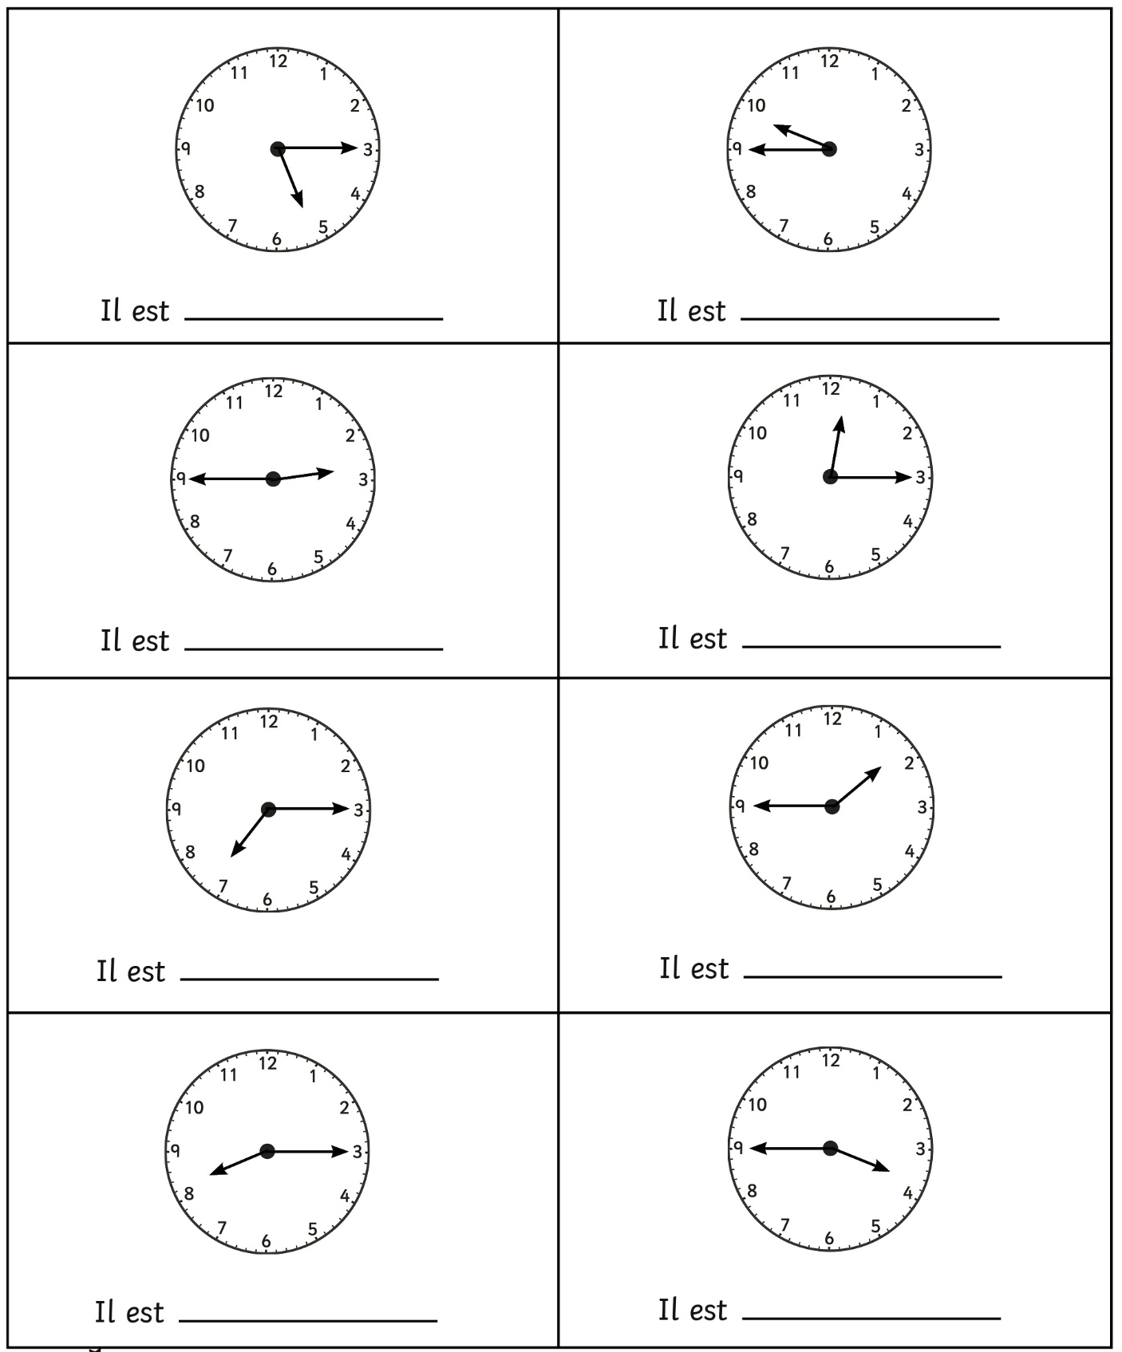
heure heures et quart moins le quart
une deux trois quatre cinq six
sept huit neuf dix onze douze

