What is your address? Prompt sheet
Use the following prompts to help you construct a simple question and answer.
As the word ‘adresse’ is masculine, it does not matter whether a male or female asks or answers the question, the pronouns are always masculine.
Ton adresse = your adress
Mon adresse = my address
The following prompt show the question and answer.
What is your address? My address is 23, Montagnes Square, Marseille.
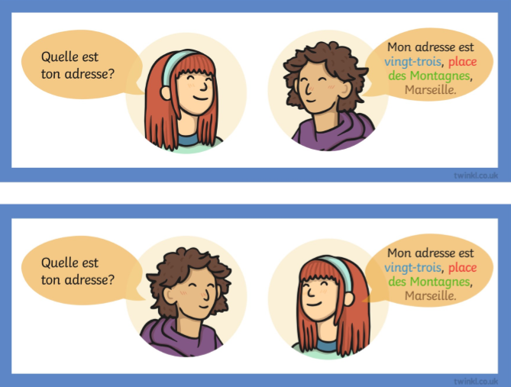
You will also need some additional words;
Boulevard = main road Rue = street
Avenue = avenue/small road Allée = driveway/track
Place = square
The other words are towns/cities in France and street/road names and remain in French.
du/de la/des = ‘of the’ in the name of the street etc.
du = masculine de la = feminine des = plural
c’est = it is

