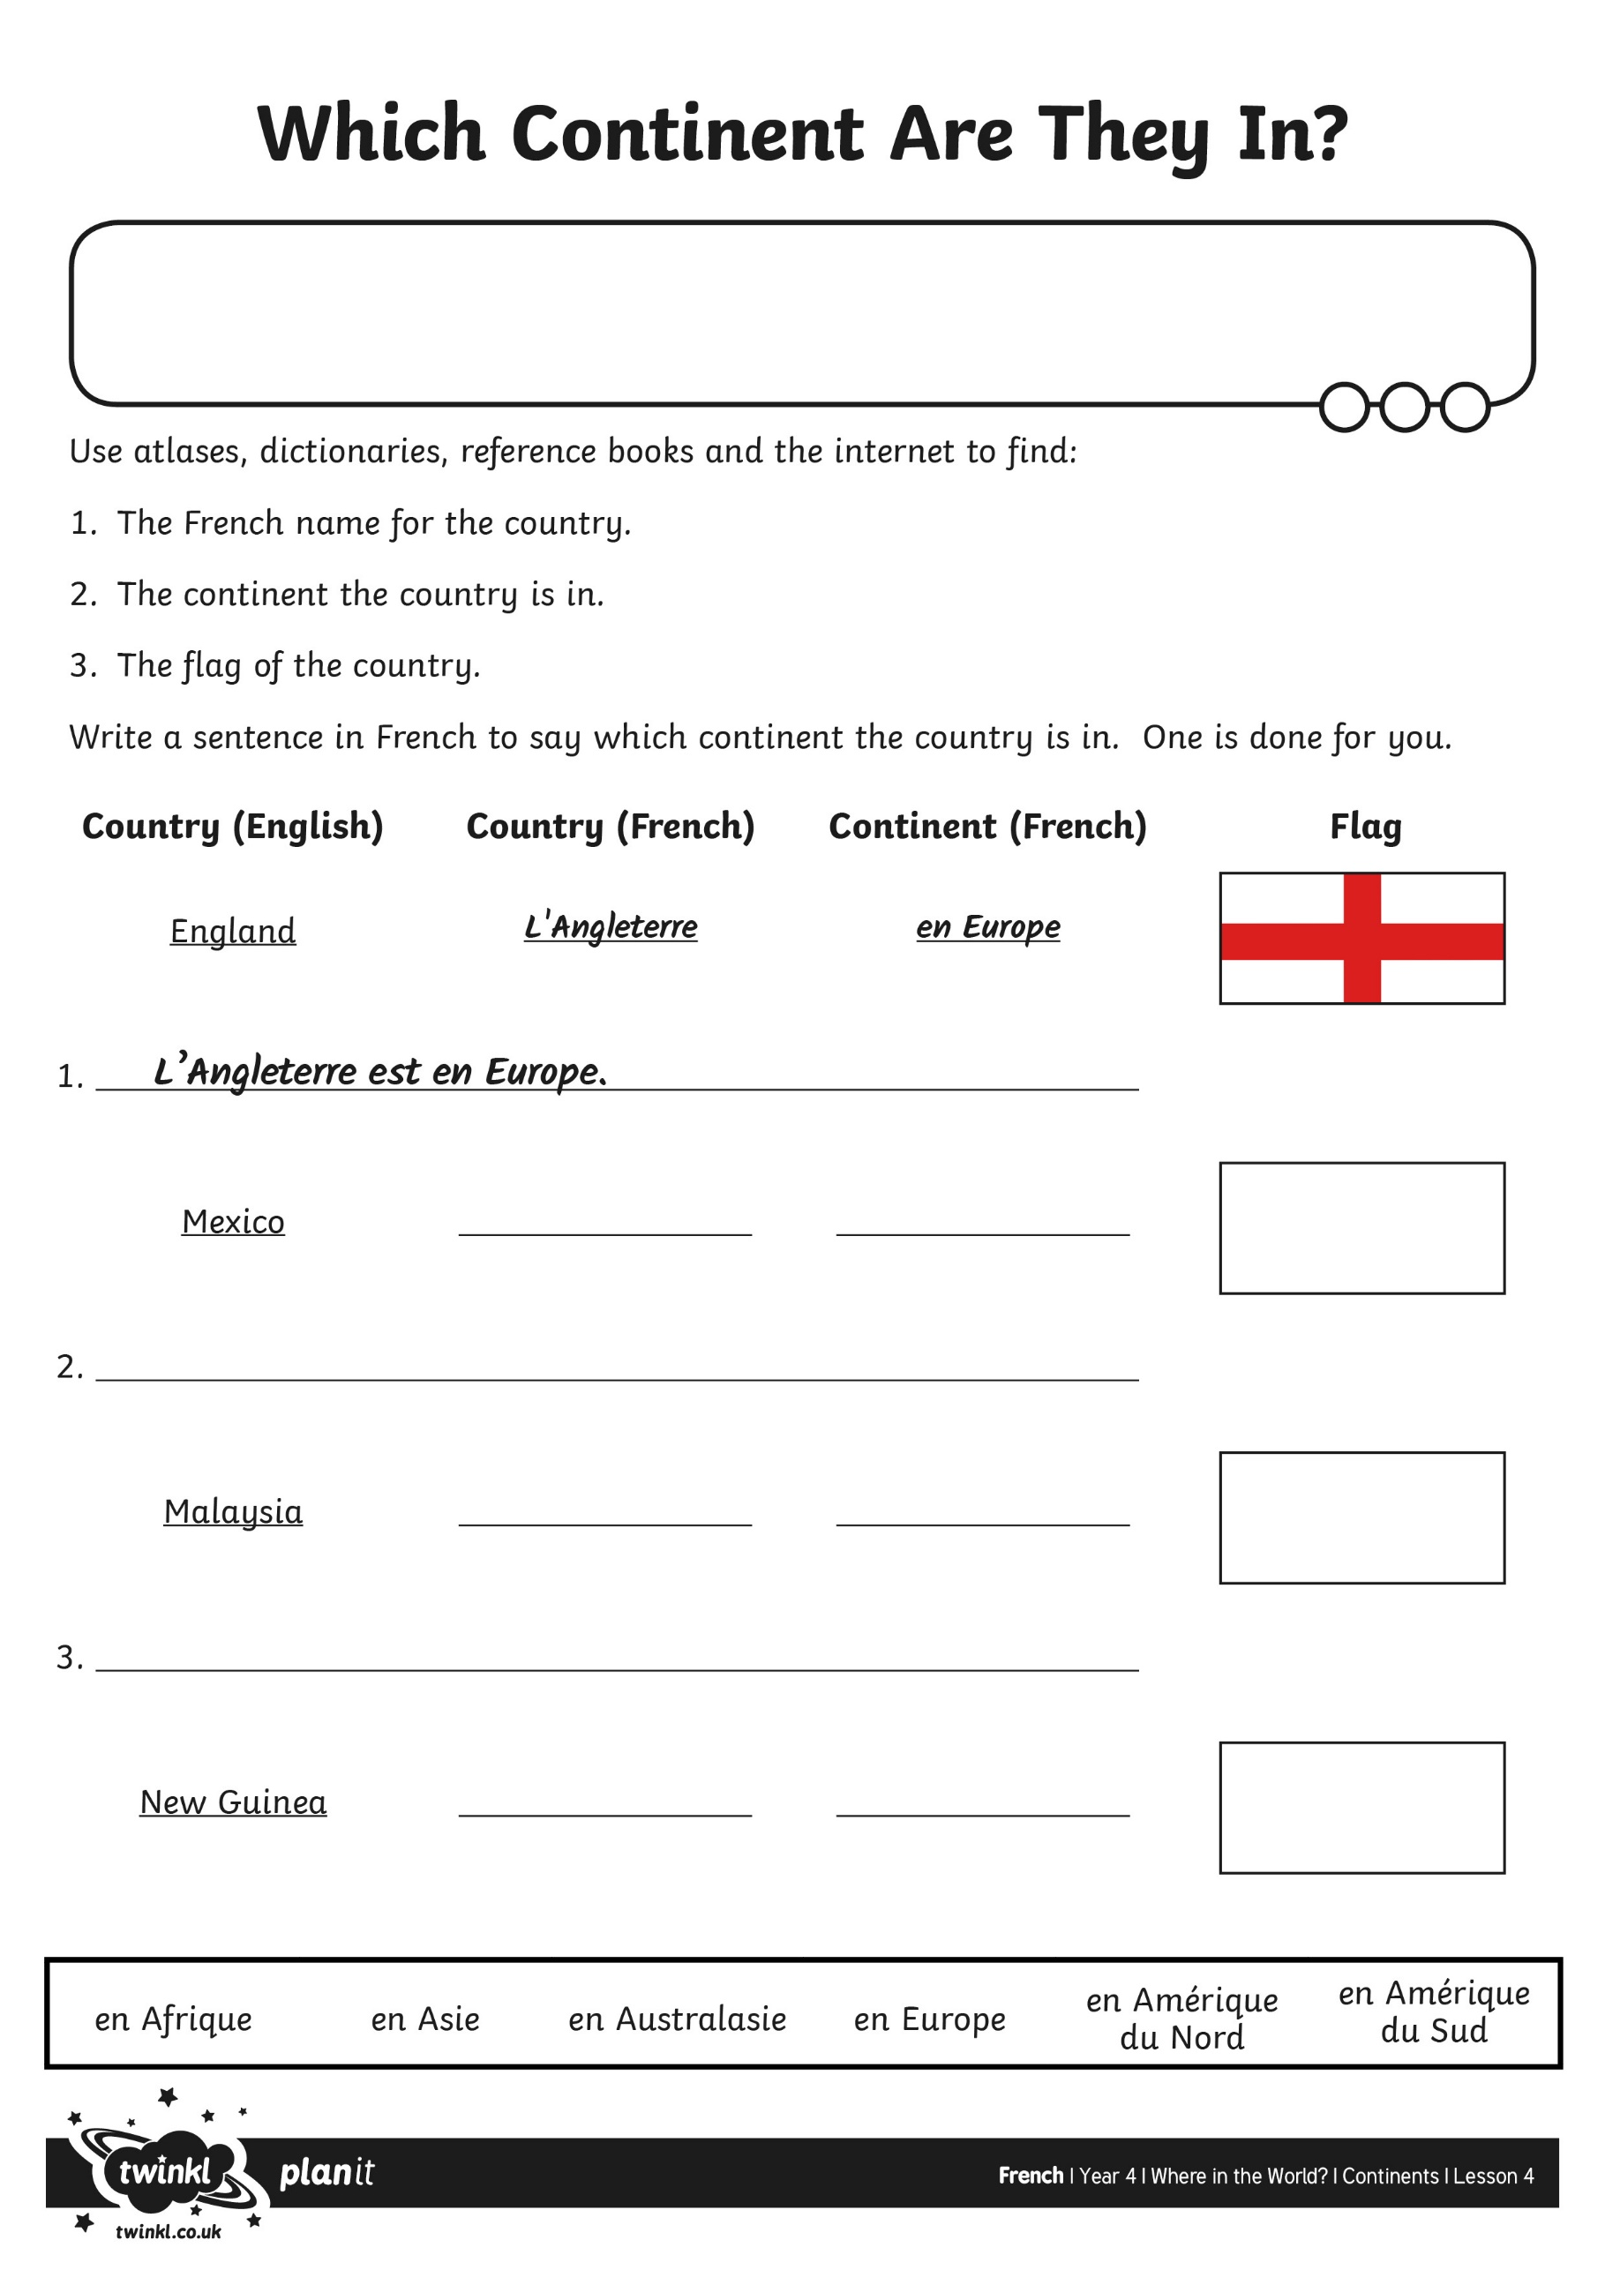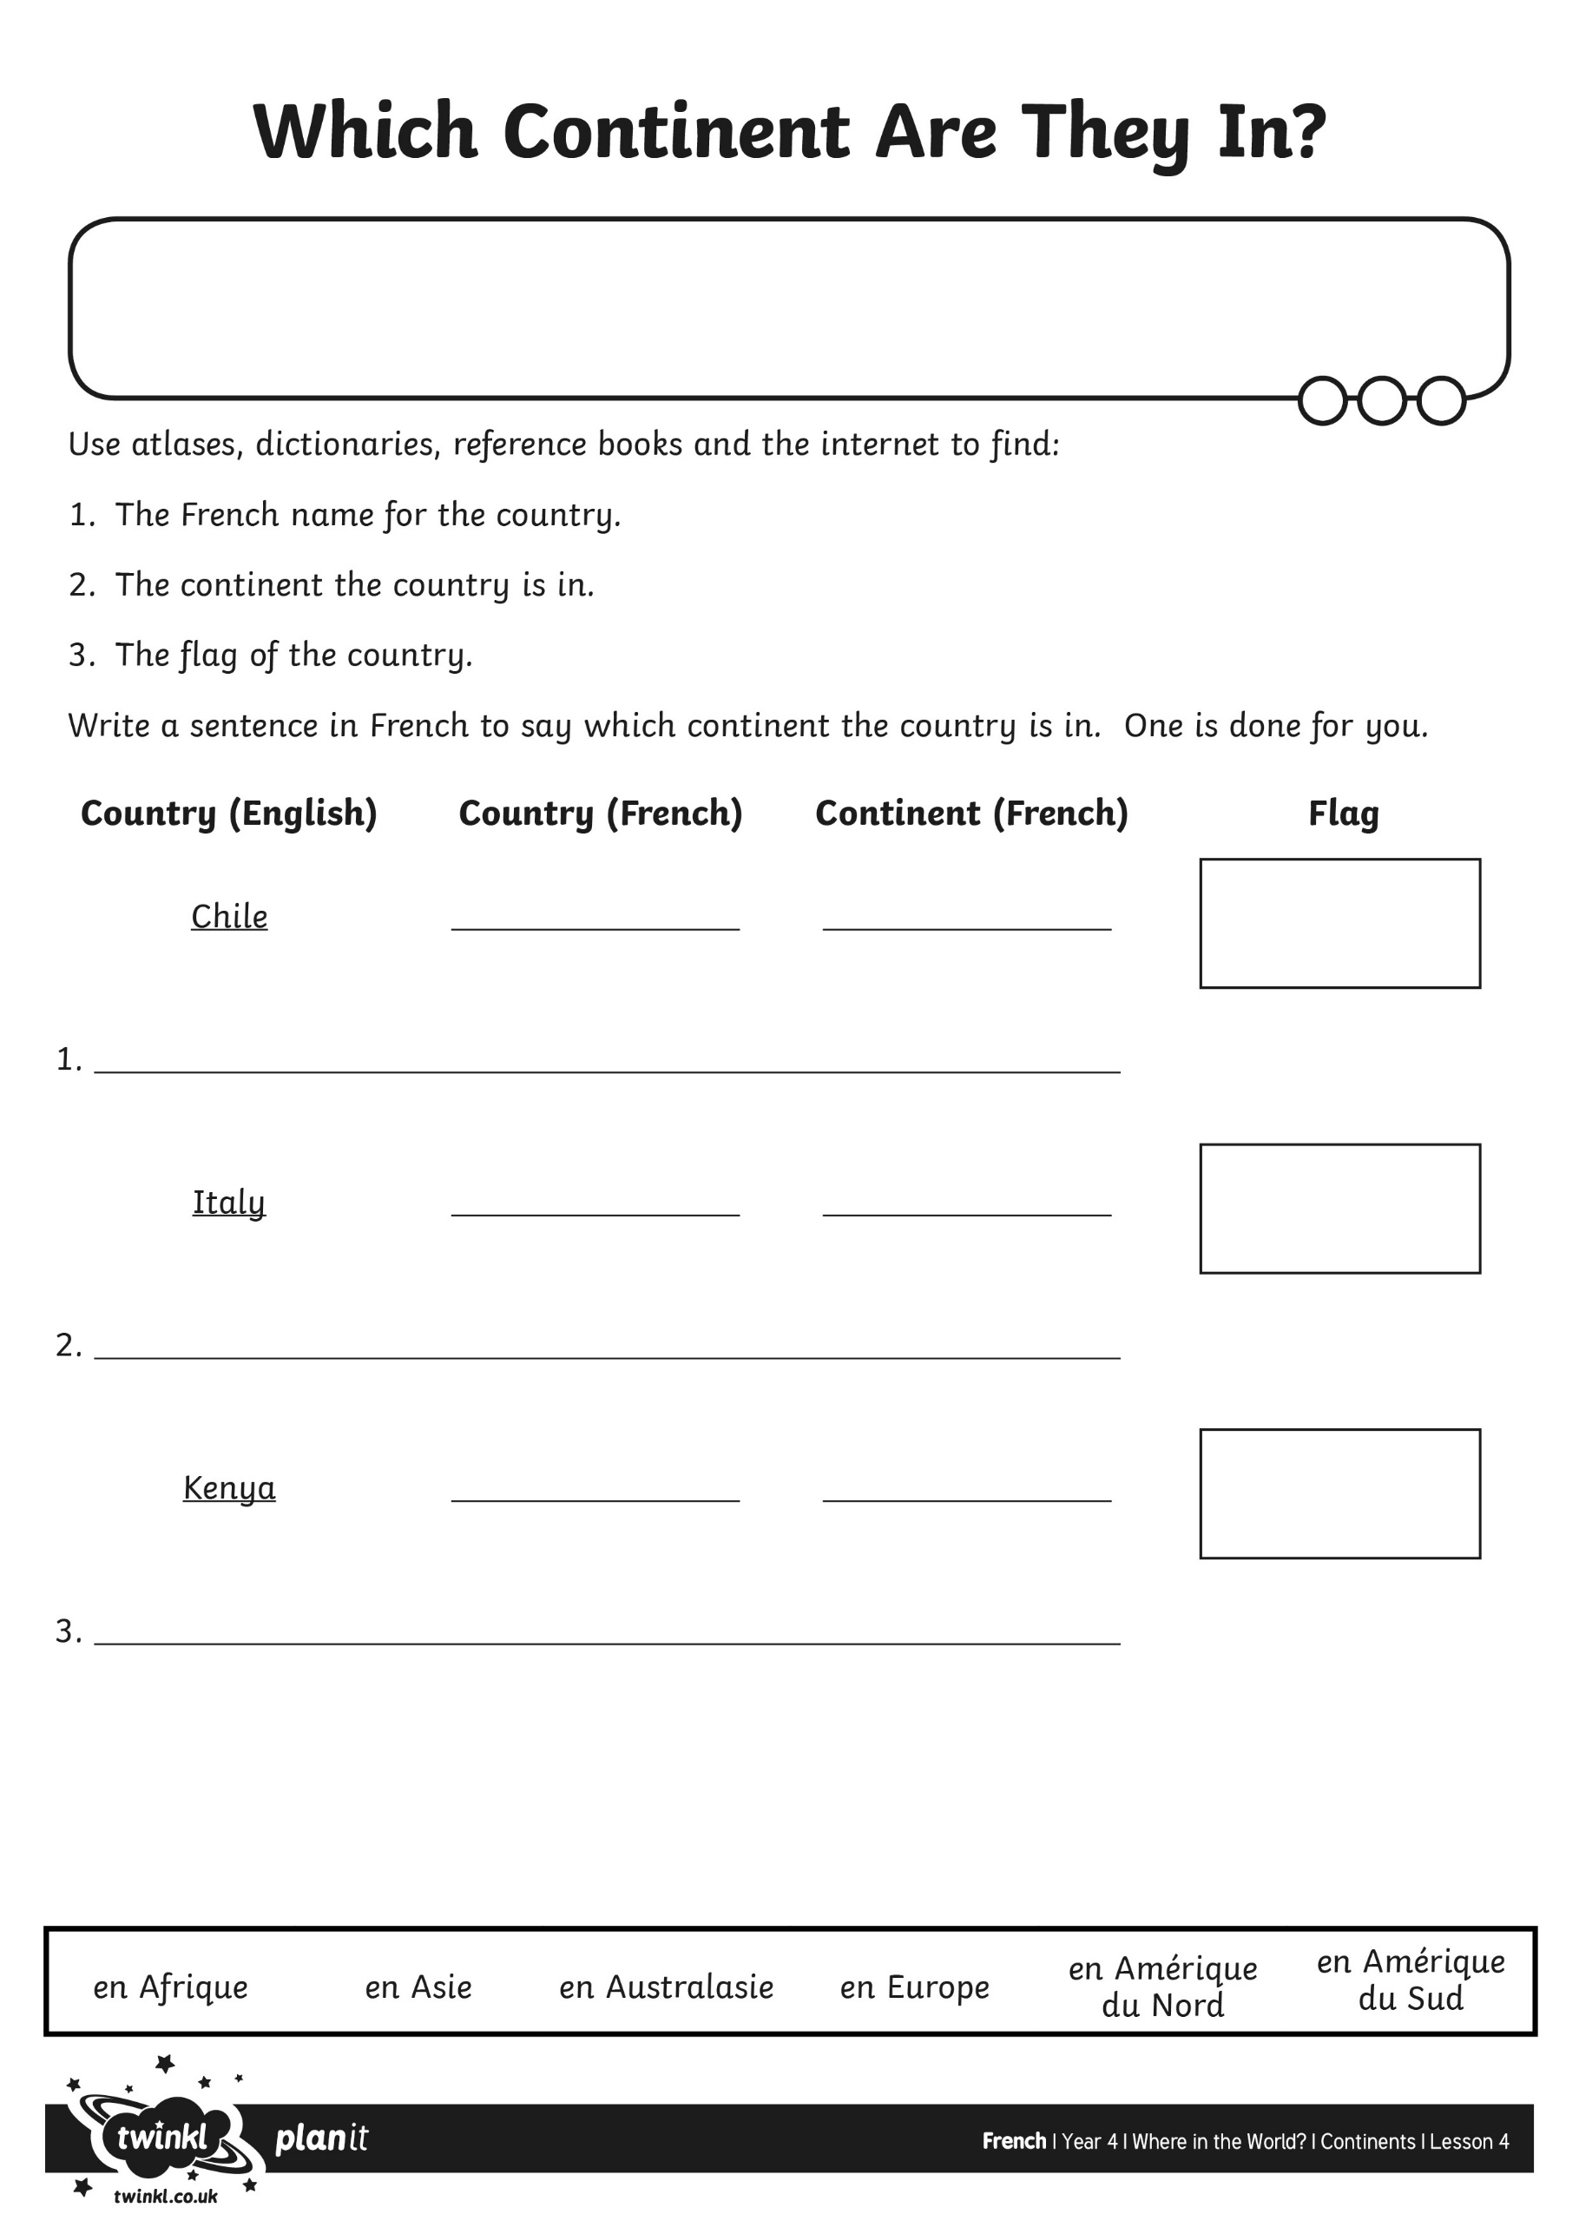
mercredi le premier juillet
LO. To can say which continent a country is from.
LO. To choose the correct preposition: ‘en’ for continents.

mercredi le premier juillet
LO. To can say which continent a country is from.
LO. To choose the correct preposition: ‘en’ for continents.

