Carl Warner - Fruit and Vegetable Sculptures Date
LO. To study & reflect upon the work of a ‘fruit and vegetable’ sculptor.
Look at the two pictures below. Warner has used his photographs of vegetables to create imaginary landscapes incorporating vegetables for a fantasy affect. Compare the two images. What do you like/dislike about the photographs? How do they make you feel? How effective do you think they are? What can you see in the picture?
What colours are used? How has he made these compositions? What material is used to create this picture?
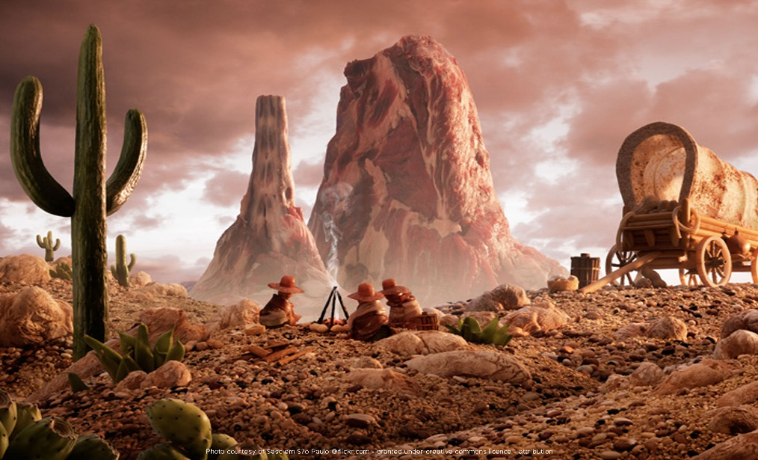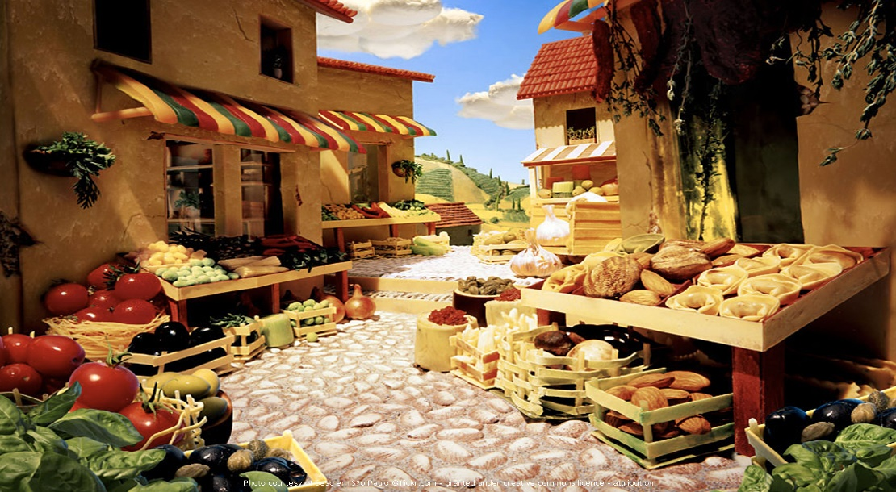
Cowboy Valley Tuscan Market
_______________________________________________________________________________________________________________________________________________________________
_______________________________________________________________________________________________________________________________________________________________
_______________________________________________________________________________________________________________________________________________________________
_______________________________________________________________________________________________________________________________________________________________
_______________________________________________________________________________________________________________________________________________________________
_______________________________________________________________________________________________________________________________________________________________
Carl Warner - Fruit and Vegetable Sculptures Date
LO. To study & reflect upon the work of a ‘fruit and vegetable’ sculptor.
Look at the two pictures below. Warner has used his photographs of vegetables to create imaginary landscapes incorporating vegetables for a fantasy affect. Compare the two images. What do you like/dislike about the photographs? How do they make you feel? How effective do you think they are? What can you see in the picture?
What colours are used? How has he made these compositions? What material is used to create this picture?
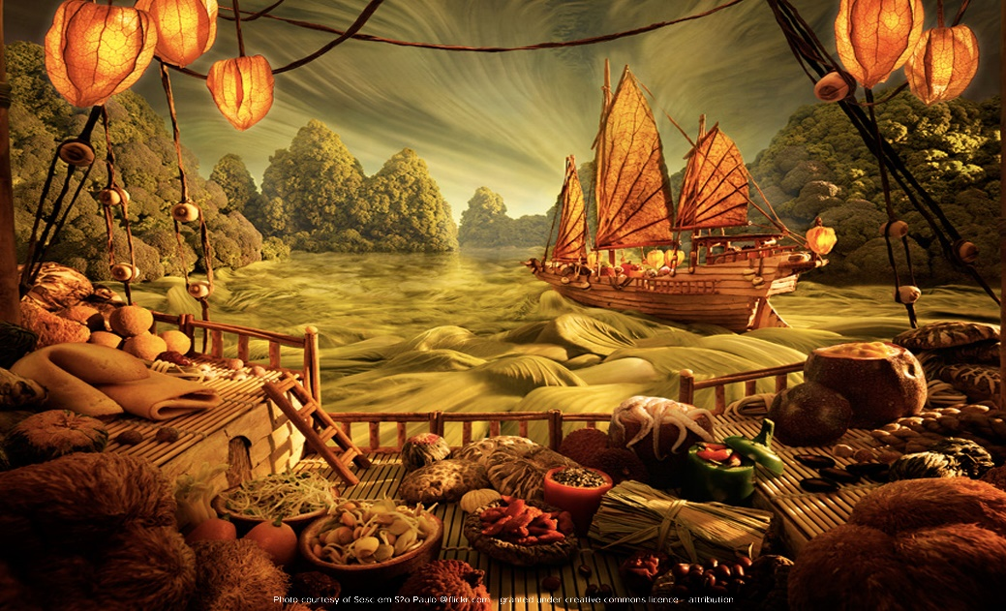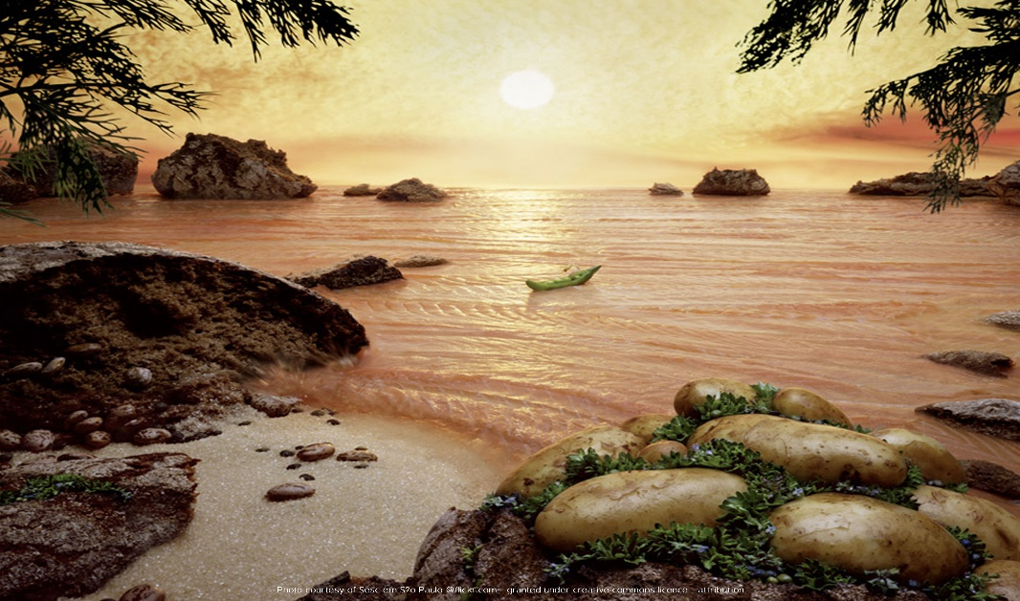
Chinese Junk Salmon Sea
_______________________________________________________________________________________________________________________________________________________________
_______________________________________________________________________________________________________________________________________________________________
_______________________________________________________________________________________________________________________________________________________________
_______________________________________________________________________________________________________________________________________________________________
_______________________________________________________________________________________________________________________________________________________________
_______________________________________________________________________________________________________________________________________________________________

