Thursday 18th June
LO: To write a time traveller’s diary on a holiday in Southport in the past.
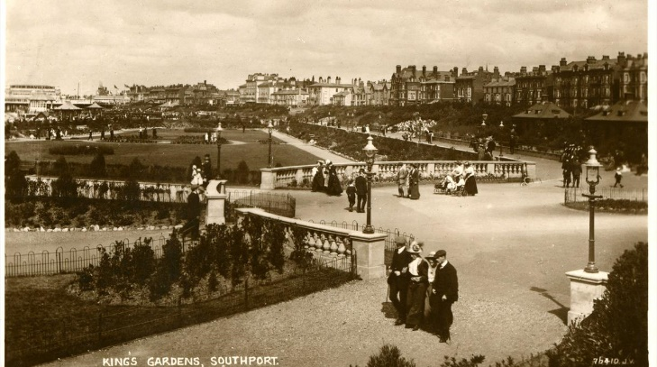
Imagine you have gone back in time to 1920 when Southport was ‘the’ place to go on holiday! What might you write in your diary?
- What did you see?
- What were people wearing?
- Where did you go?
- What attractions did you visit?
Dear Diary,
Today I travelled back in time to 1920 and spent the day in ‘Olden Days’ Southport! I had the most incredible time.

Goodbye for now Diary,

