Thursday 25th June
LO: To research key facts about Ambleside.
Ambleside is a town in Cumbria in North West England. It is a rural town. In future lessons, we are going to compare the similarities and differences between Southport as an urban town, and Ambleside as a rural town.
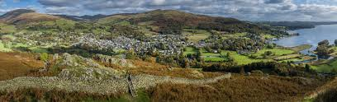
But first, you need to learn about Ambleside!
Use the internet to research what Ambleside is like. You might find:
- maps
- photos
- tourist information
- what the landscape looks like
- what the land is used for
- whether there are any rivers or lakes
- and more!
Try to record at least 5 key facts, but the more you find out the better!

