Tourism Southport V Ambleside
Thursday 2nd July
LO: to list reasons why tourists would visit Ambleside and Southport.
Explain the reasons why tourists would visit Ambleside and Southport.
Using the research you have undertaken about Southport and Ambleside as tourist attractions, you need to use your knowledge to find reasons for why tourists to visit both Southport and Ambleside.
Why is tourism important to both localities?

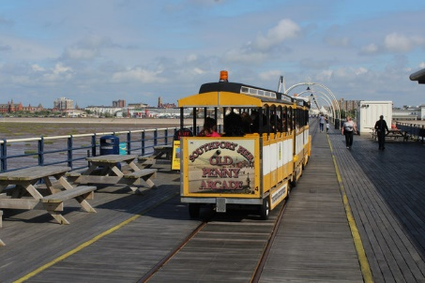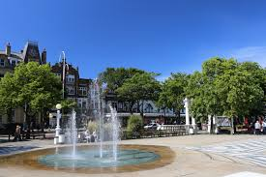

Reasons for visiting Southport… _____________________________________________________
____________________________________________________________________________
________________________________________________________________________________________________________________________________________________________
____________________________________________________________________________
____________________________________________________________________________

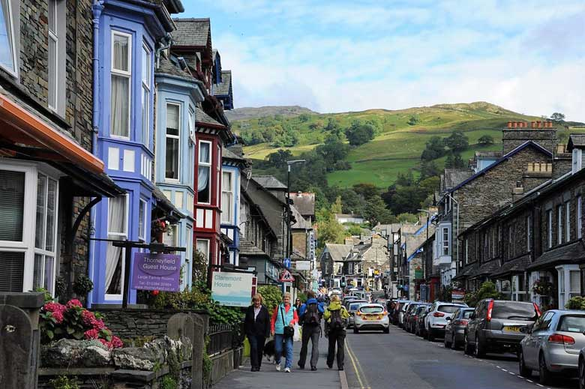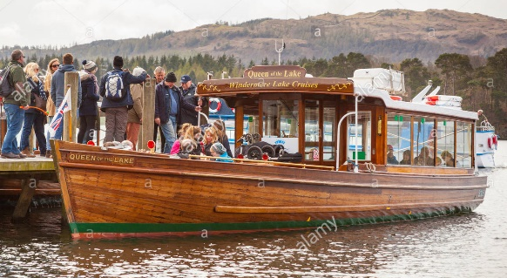

Reasons for visiting Ambleside …_____________________________________________________
____________________________________________________________________________
________________________________________________________________________________________________________________________________________________________
____________________________________________________________________________
____________________________________________________________________________

