Thursday 9th July
LO: To consider and begin to explain the physical characteristics of Southport and Ambleside.

Today we are looking specifically at the physical characteristics of an urban settlement; Southport and a rural settlement; Ambleside.
Look carefully at these photographs and think about the physical features; landscape, lakes, hills, beaches man-made or natural etc
Southport
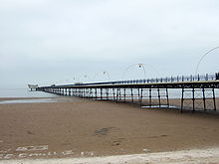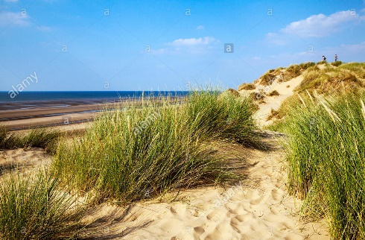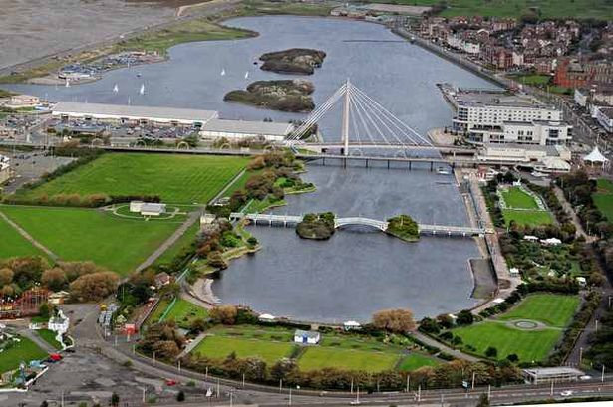

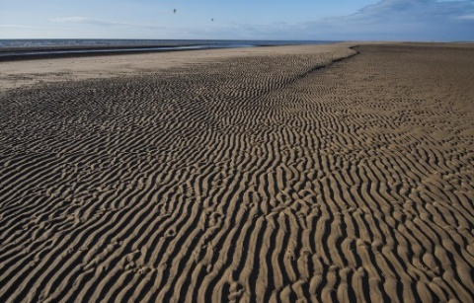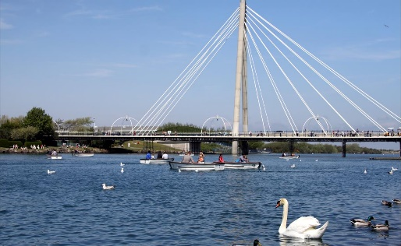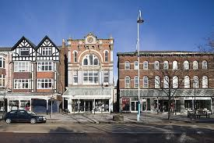
Ambleside
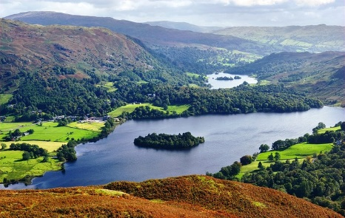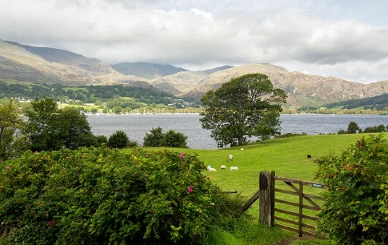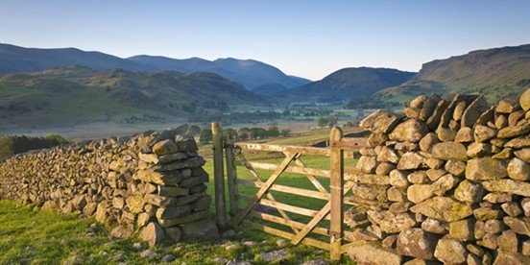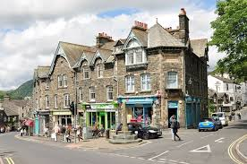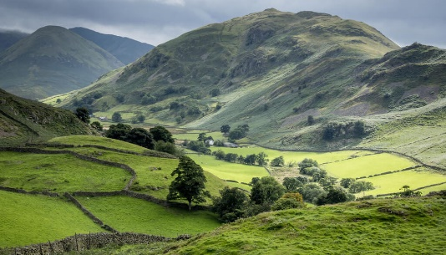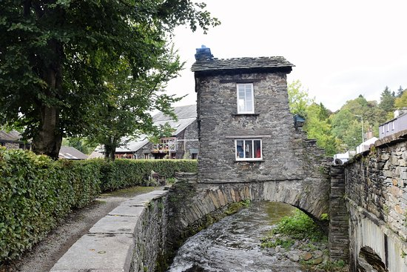
Using these images and any of your own, think about the features of the physical characteristics of each place.
Then compare and contrast each place. What is the same and what is different?
For example, Southport has a man-made lake, whereas the lakes around Ambleside are natural.

