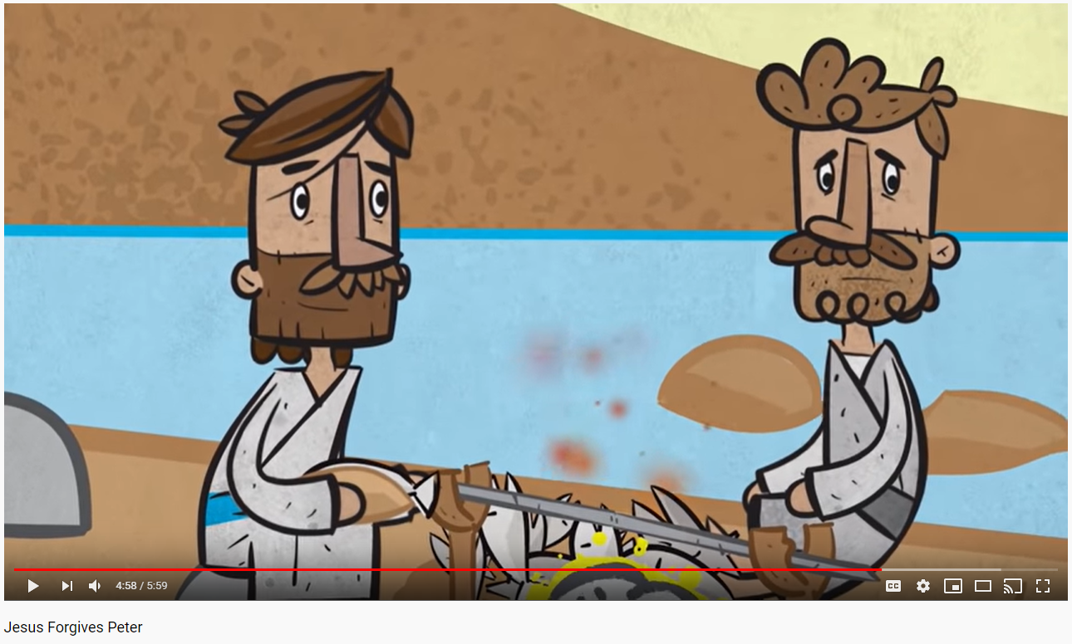
Tuesday 24th March
LO: To show how I could ask for forgiveness.
If you were Peter standing in front of Jesus after the fishing trip, how would you feel?

Have you ever hurt someone and been forgiven for something? Was it easy or hard to ask someone else for forgiveness and say sorry? Why?
When we are the ones who have been hurt, why do you think it can be hard to forgive others?
How I could show forgiveness:
Your Task
Write, type or draw what you think would be a good way to ask for forgiveness.
This could be a letter, apologising for what you did wrong with a plan of how to fix things.
It could also be a picture of what you could do to show the person you are sorry, perhaps by sharing with them, giving them a card, or inviting them to play with you.

