Monday 23rd November
LO: To describe the features of a Christingle

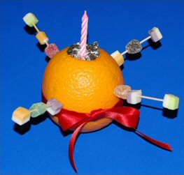

Write a sentence about the meaning of each of the key features of the Christingle.

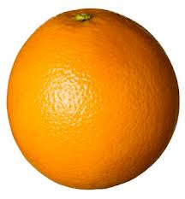
The orange reminds us of __
__________________________________________________________________________________


The ribbon reminds us of __
__________________________________________________________________________________

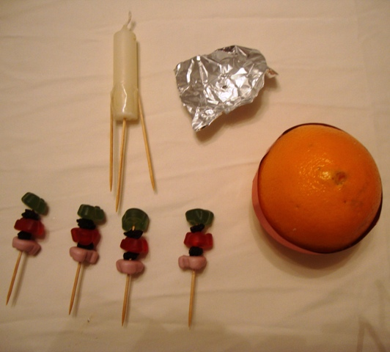

The candle reminds us of __
__________________________________________________________________________________
The sweets remind us of ___
__________________________________________________________________________________

