Tuesday 5th January
LO: To understand the meaning of authority and to discuss how we know that Jesus had power and authority.

What does the word ‘authority’ mean to you? Can you think of somebody who has authority?
____________________________________________________________________________________________________________________________________________________________________________________________________________________________

Authority is _____________________________________________________________________ _______________________________________________________________________________________________________________________________________________________________________________.
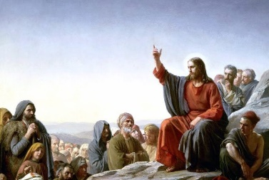

Jesus Walks on the Water (Matthew 14:22 – 25)
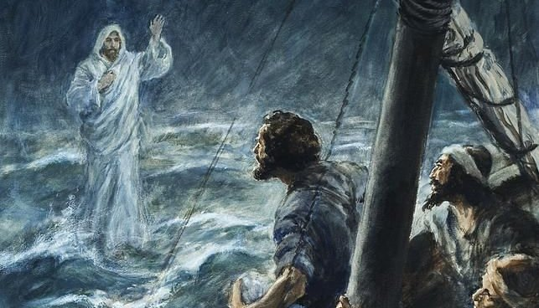
‘Shortly before dawn Jesus went out to them, walking on the lake’.
How was Jesus able to walk on water but Peter was not? How did he use his authority to command the sea? Consider why those on the boat said “Truly you are the Son of God.”
____________________________________________________________________________________________________________________________________________________________________________________________________________________________________________________________________________________________________________________________________________________________________________________________________________________________________________________ .

