Tuesday 5th January
LO: To understand the meaning of authority and to discuss how we know that Jesus had power and authority.

What does the word ‘authority’ mean to you? *A head teacher has authority in a school*
____________________________________________________________________________________________________________________________________________________________________________________________________________________________

Authority is the power or ___________________ to give orders, make ______________ and enforce obedience.
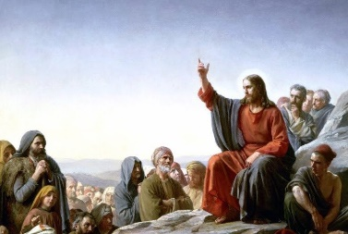

Jesus Walks on the Water (Matthew 14:22 – 25)
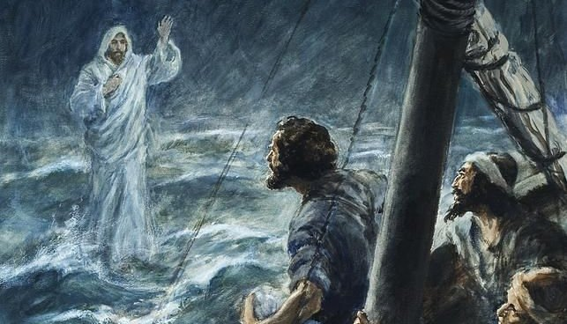
‘Shortly before dawn Jesus went out to them, walking on the lake’.
How was Jesus able to walk on water but Peter was not? How did he use his authority to command the sea?
It was only possible as Jesus the Son of God had power and authority over ___________________________________________________________ _____________________________________________________________________________________________________________________________________________________________________________ .
Key words:
Son of God, Jesus, nature, power, authority, sickness, death, control, sea.

