1Decision Help Guide (Year 4)
Log in to 1decision.co.uk.
Username: stphilipsprimary
Password: stphilipsps6ss
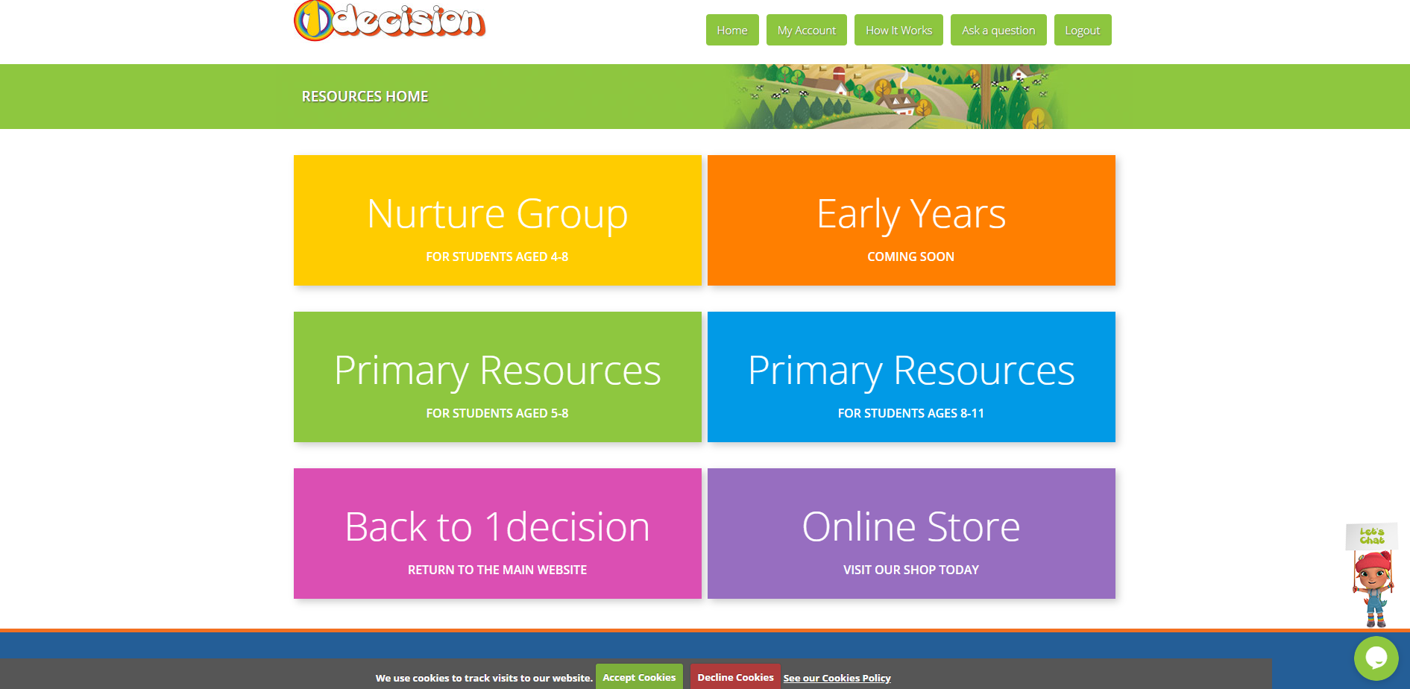

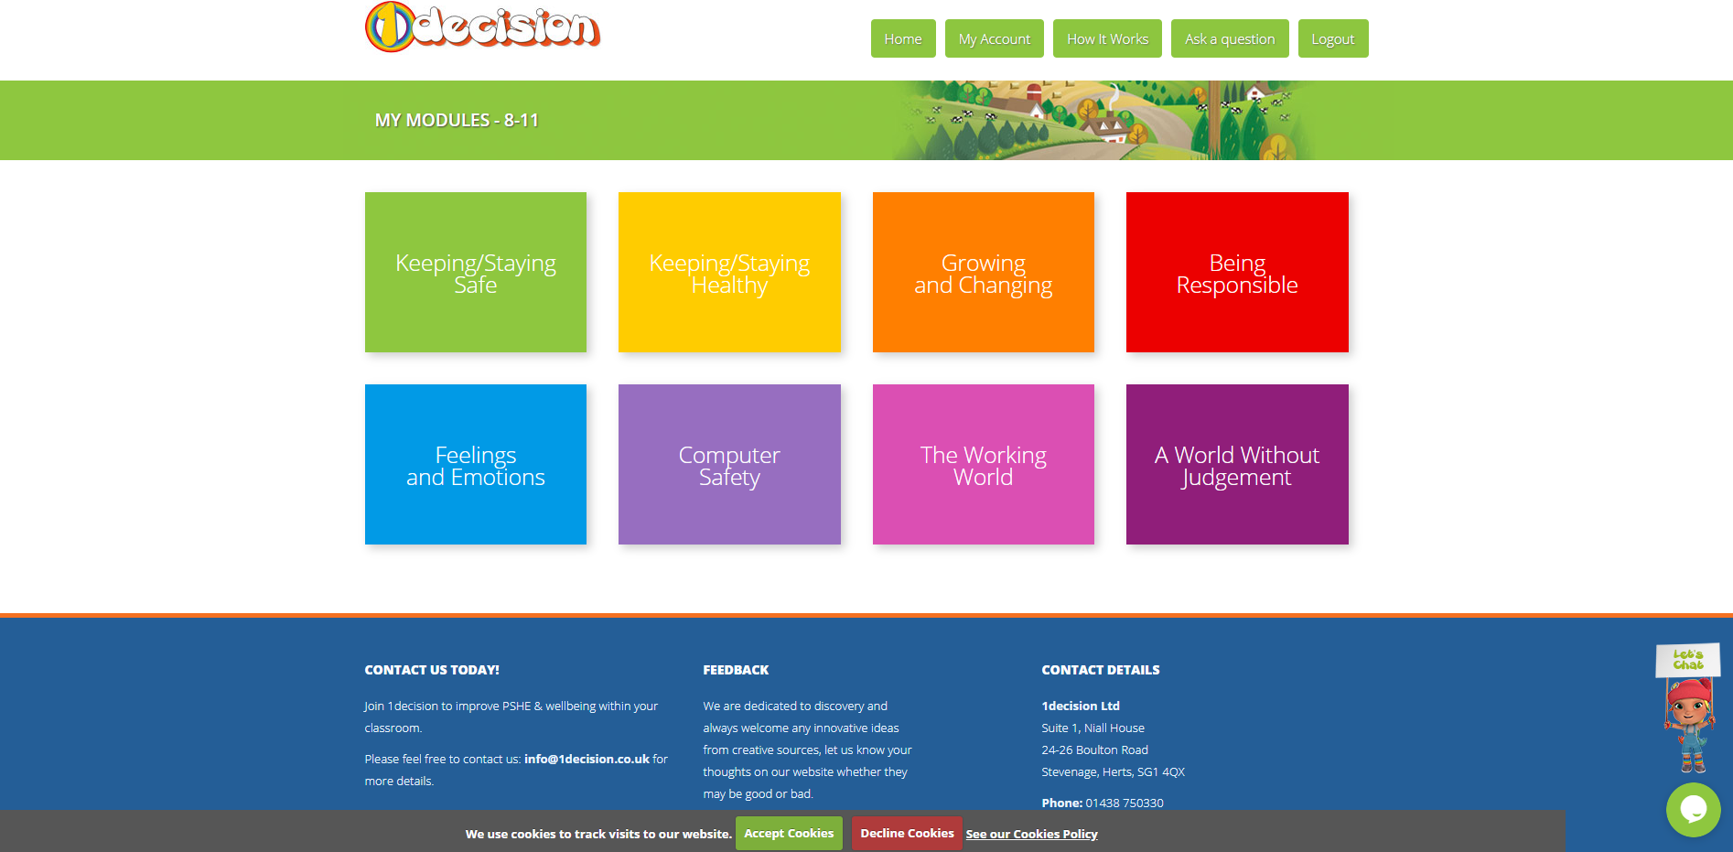

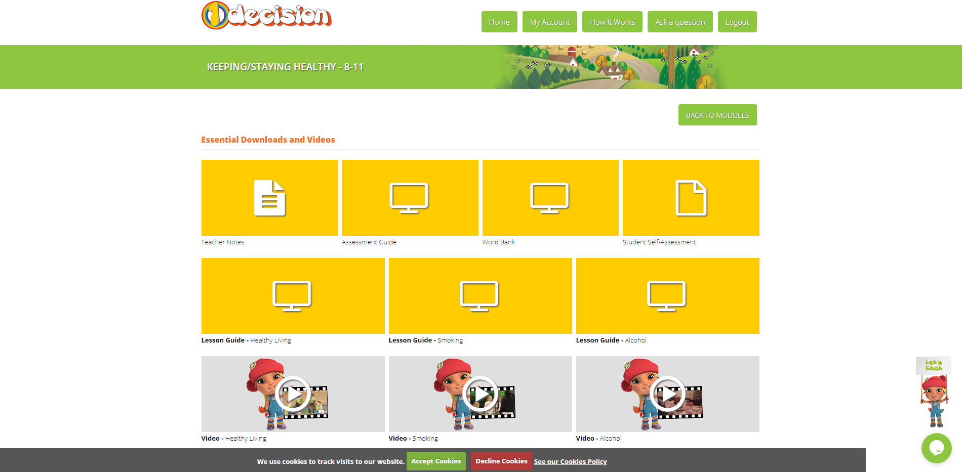

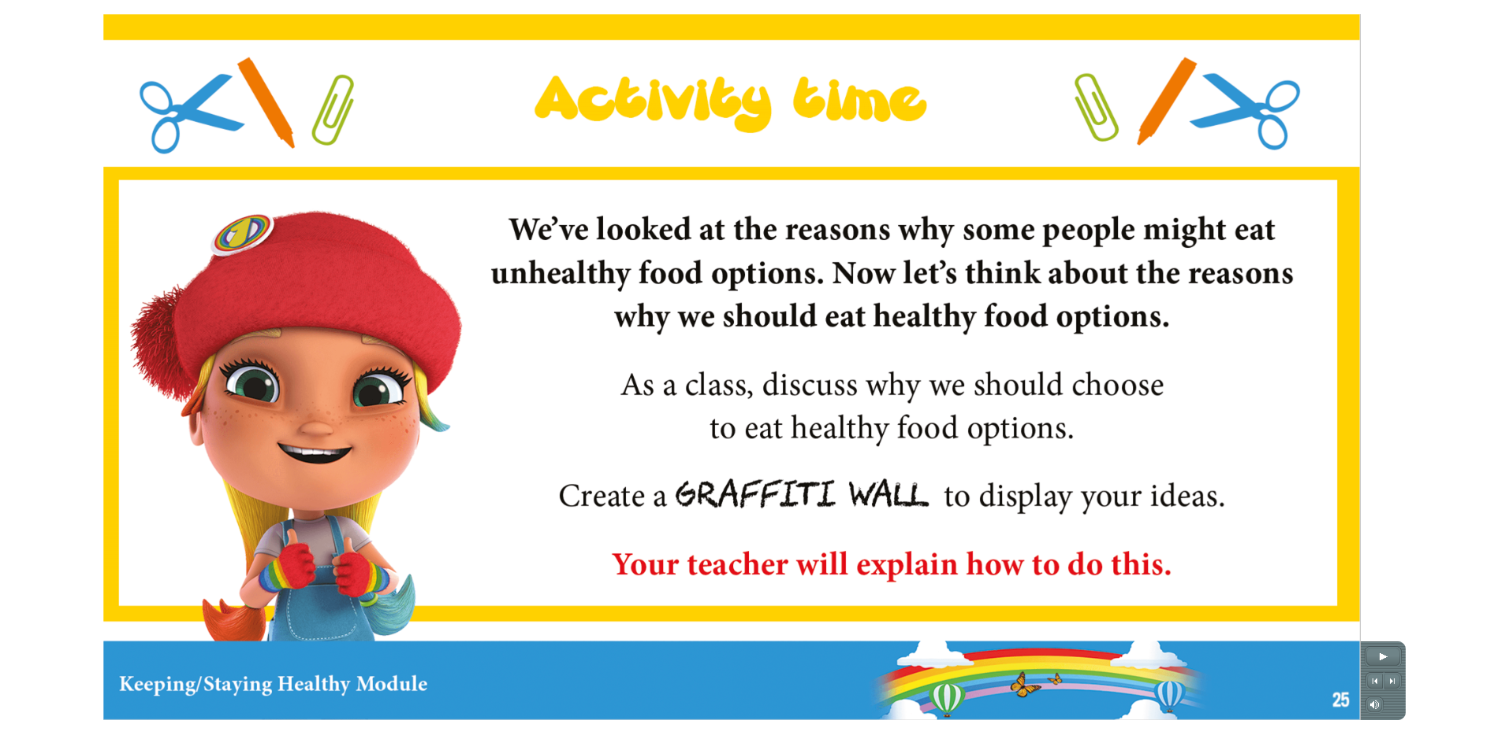
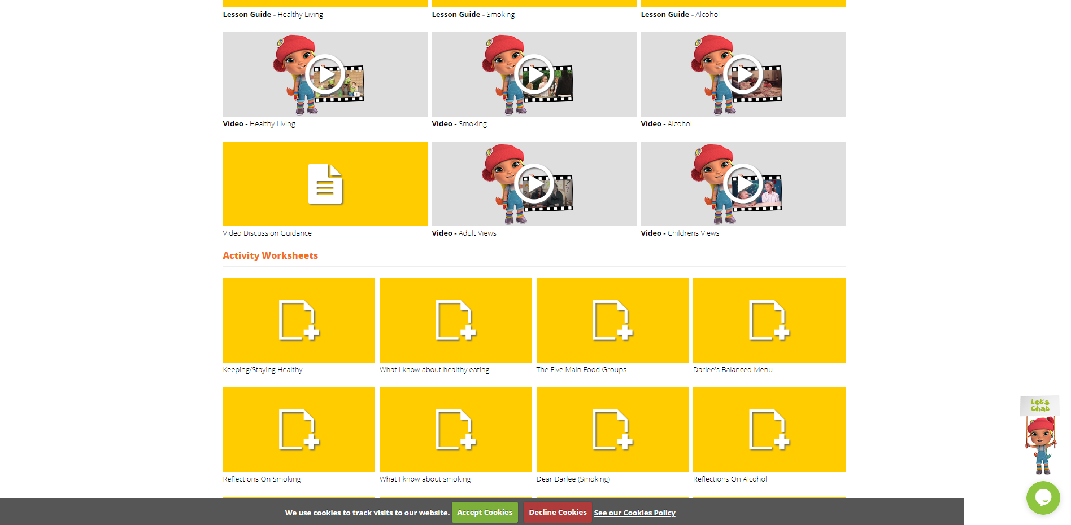
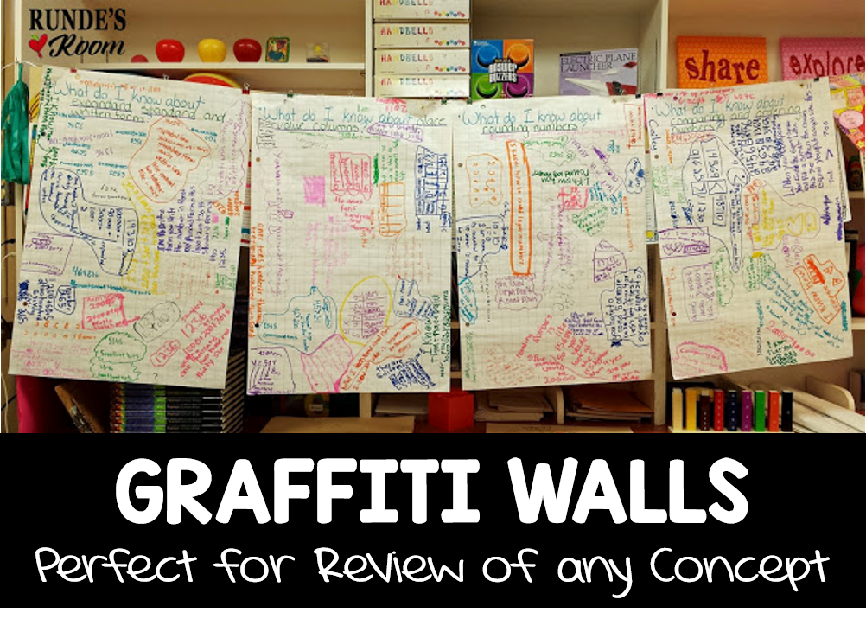
When you get to today’s activity (slide 25) the instructions are to create a graffiti wall. This just means lots of different ideas all recorded as a mismatch of information. It could be words, pictures, different colours, written, typed – it is up to you! Here are some examples:

