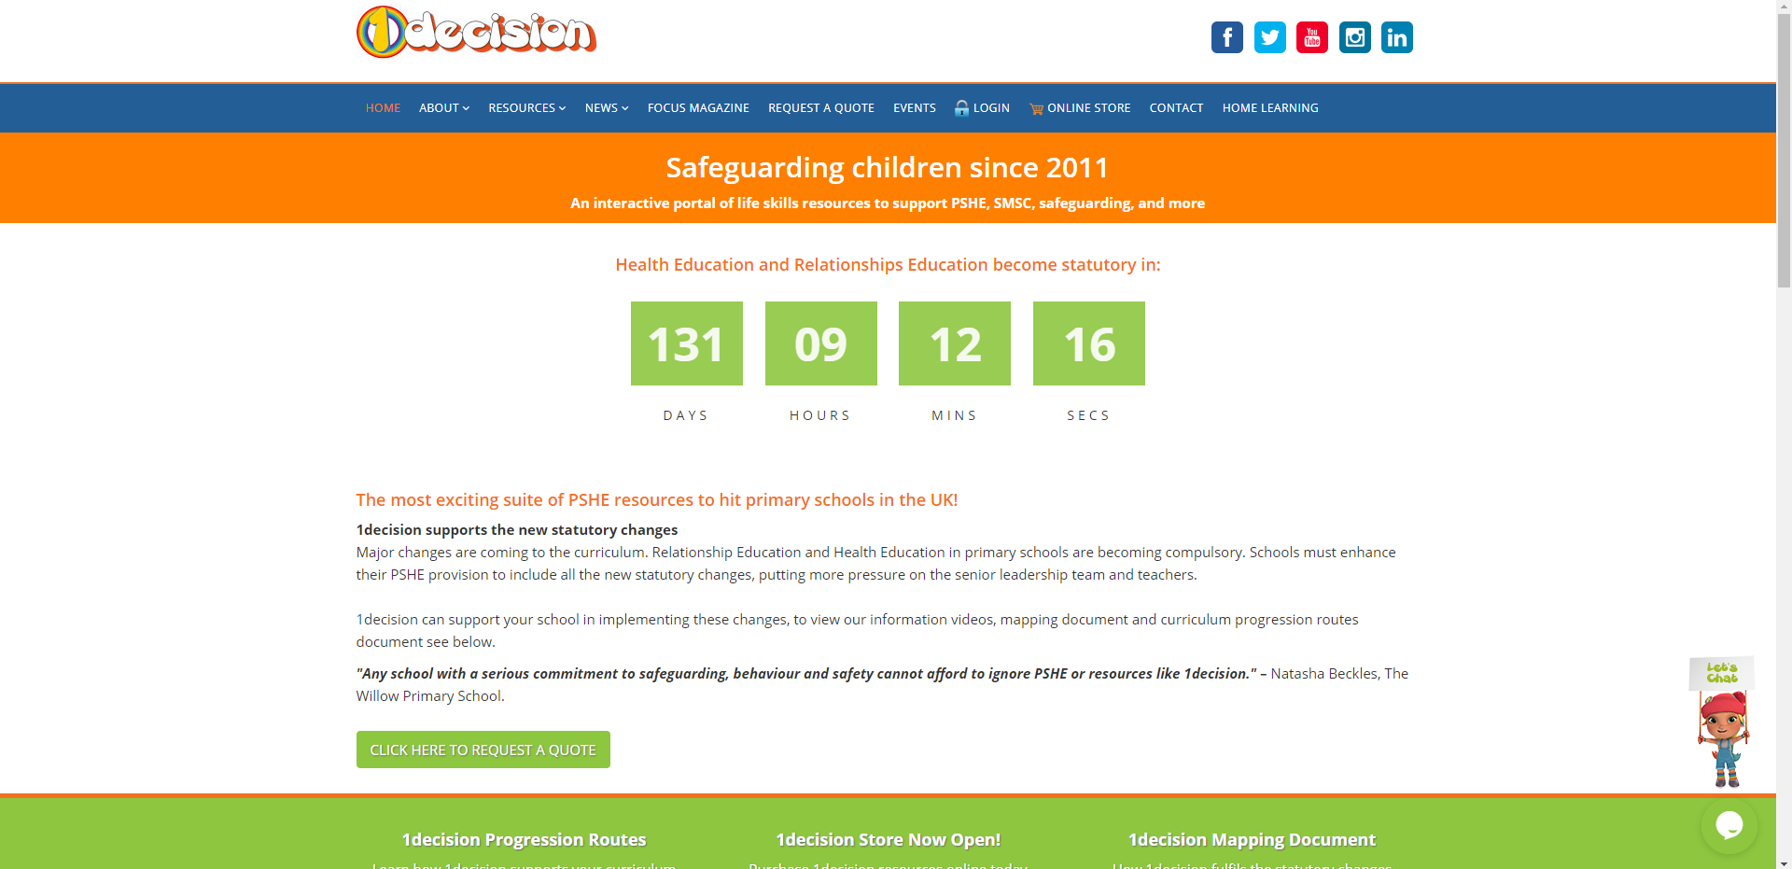
Please note: the teachers notes and video have NOT been linked on the class page, but the worksheets and other resources from the lesson have.
Username: stphilipsprimary
Password: stphilipsps6ss

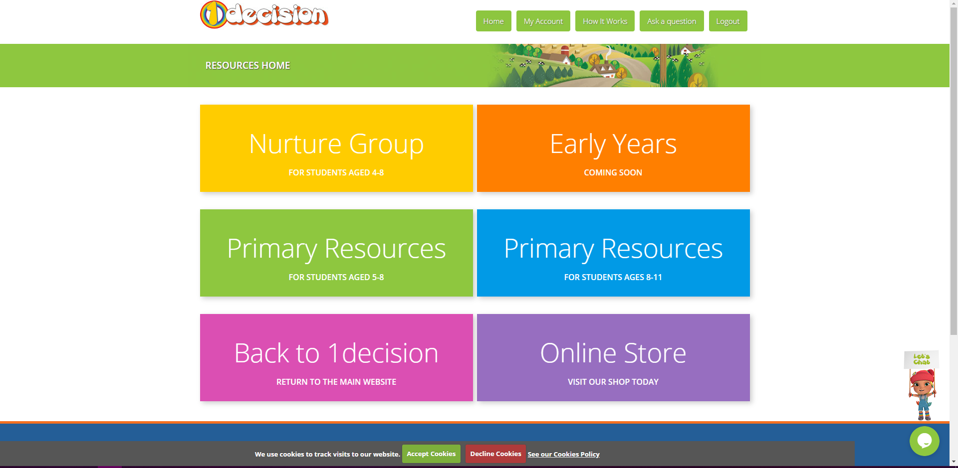

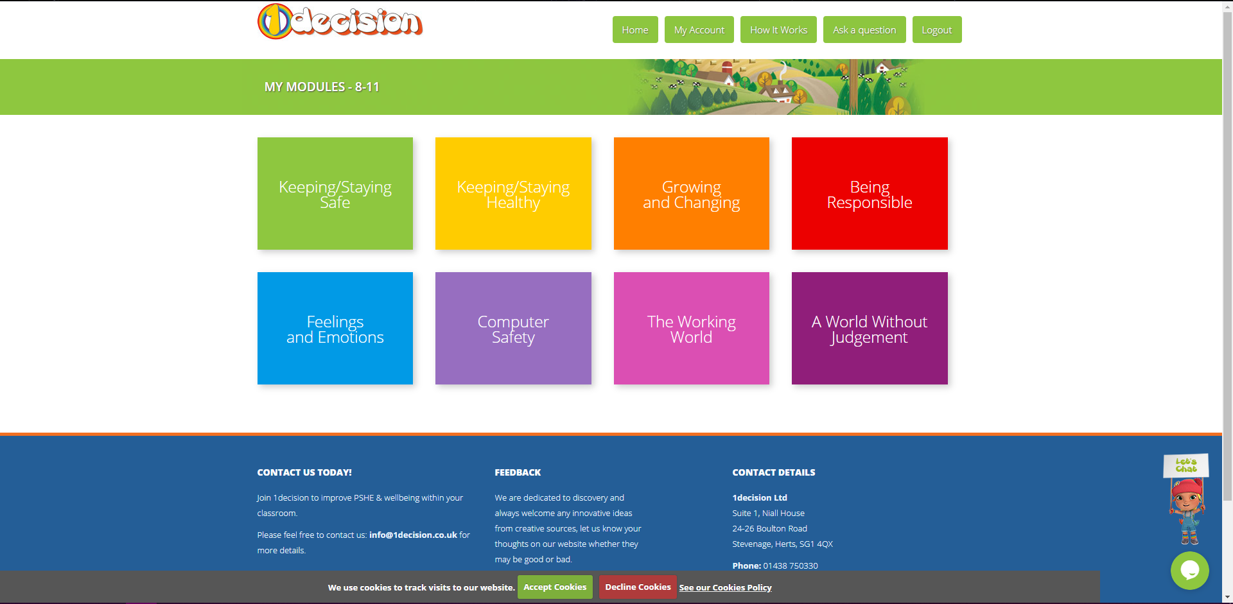


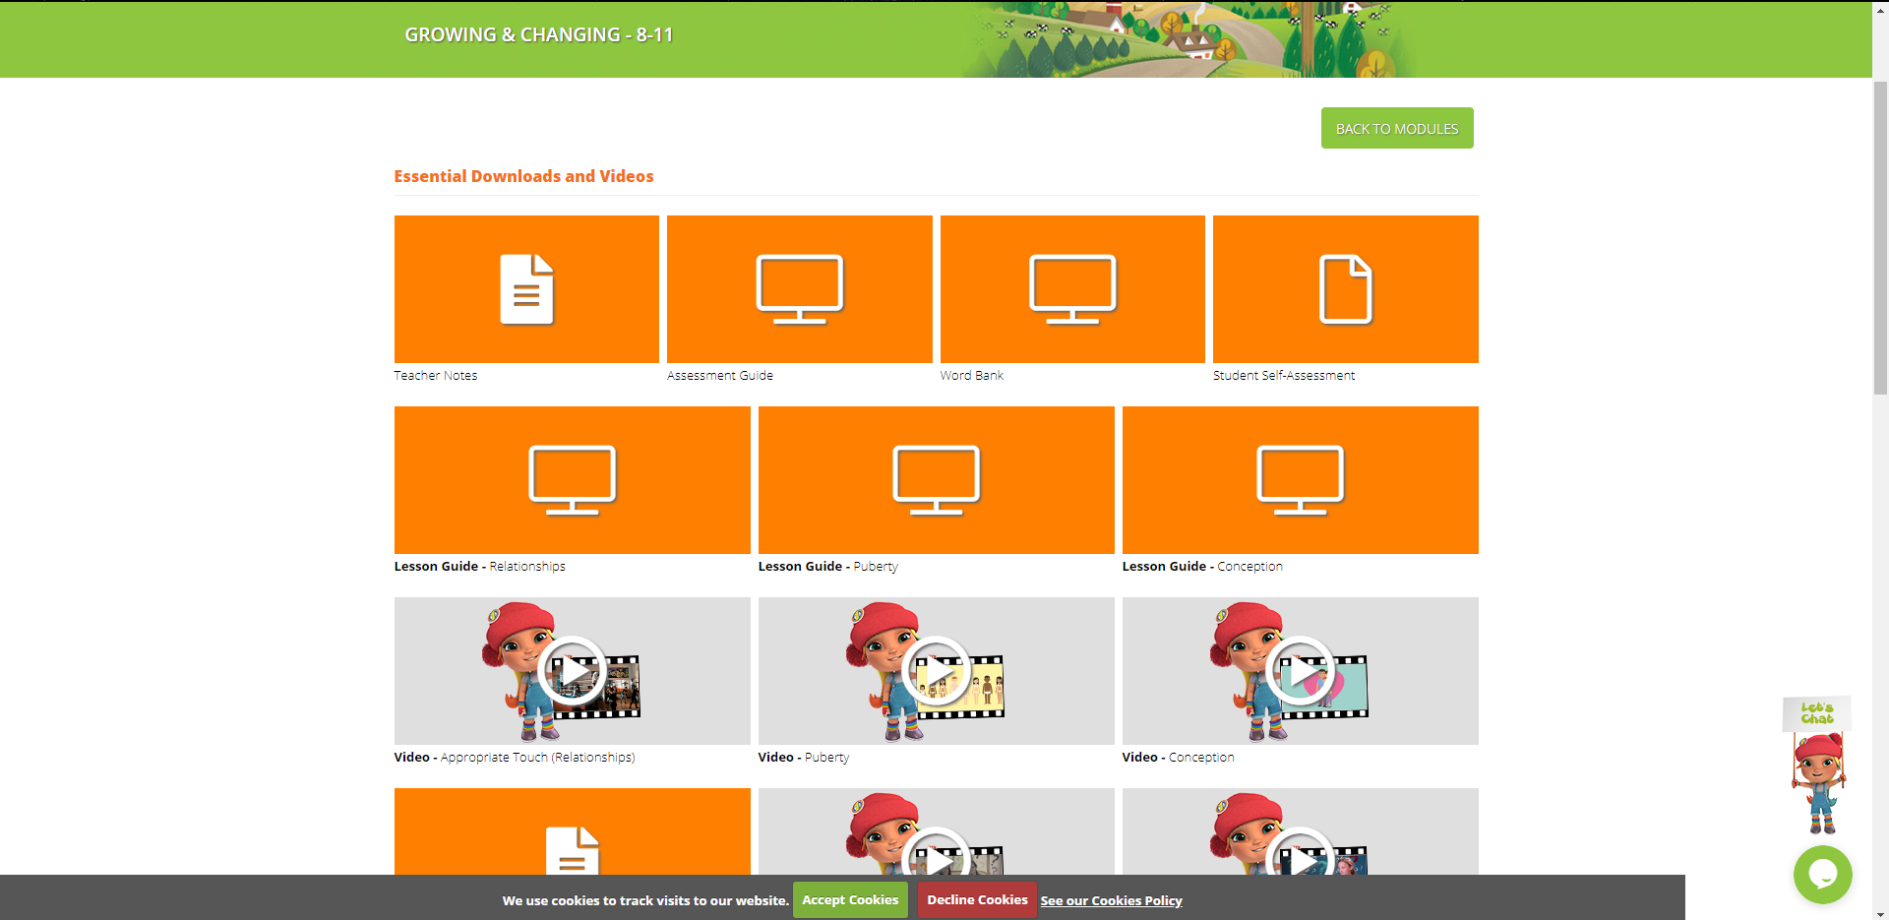

We will be going up to slide 17 today.
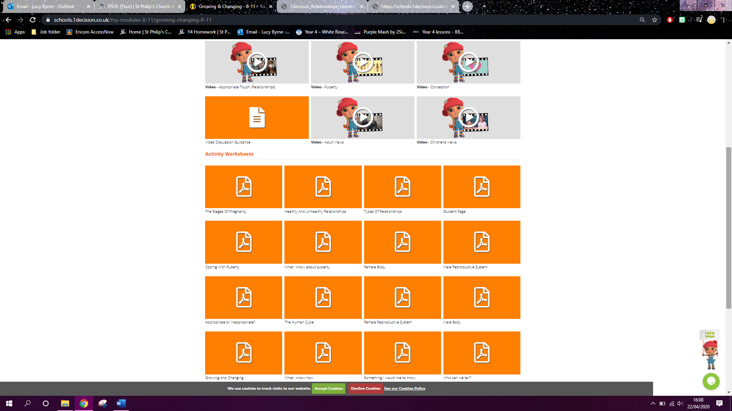
The orange file resources you need can also be found on the class site.

