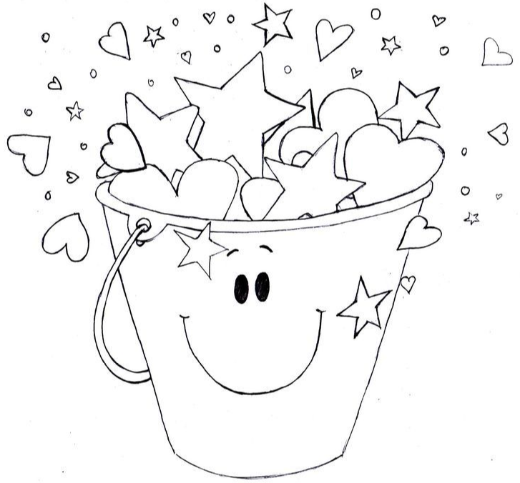
Hugs
Compliments
Smiling :D
Listening
Offering to help
Saying thank you
High five
I CAN BE A BUCKET FILLER!!

