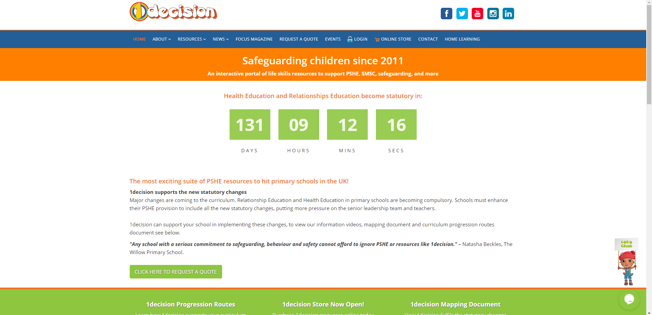
Please note: the teacher’s notes, powerpoint and video have NOT been linked on the class page, but the worksheets from the lesson have.
Username: stphilipsprimary
Password: stphilipsps6ss

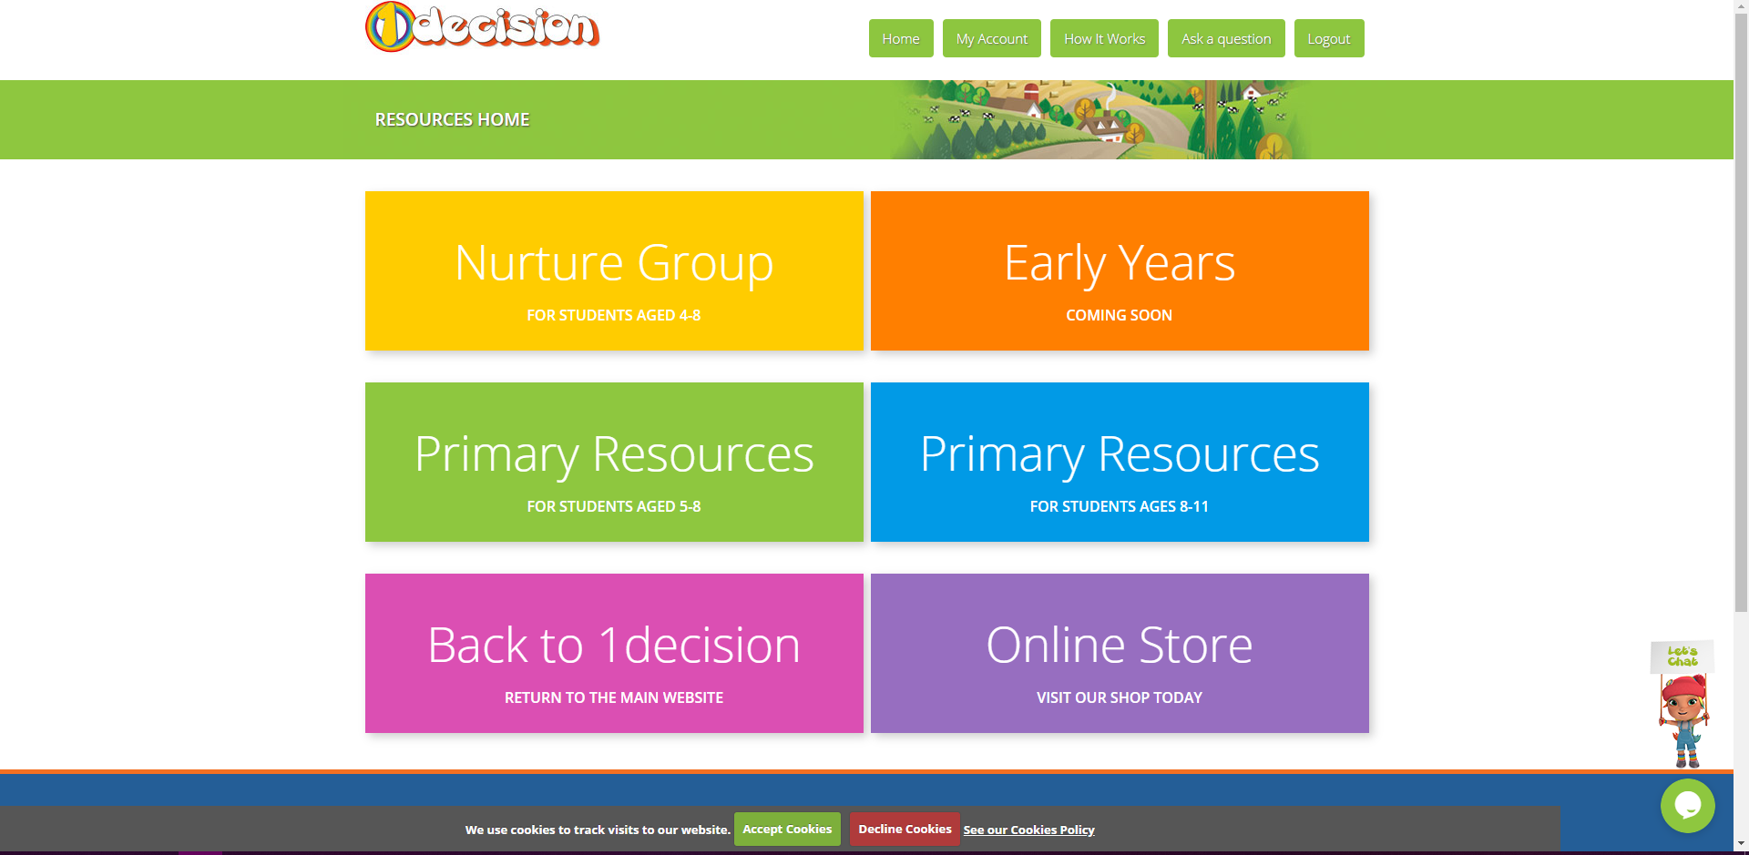


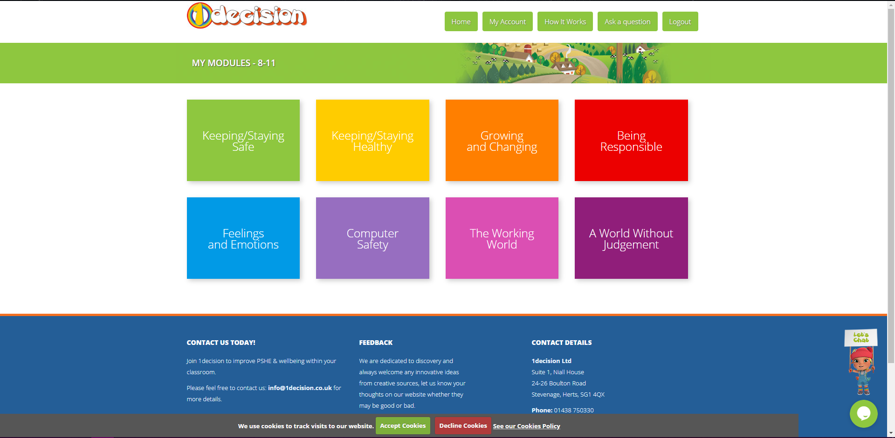
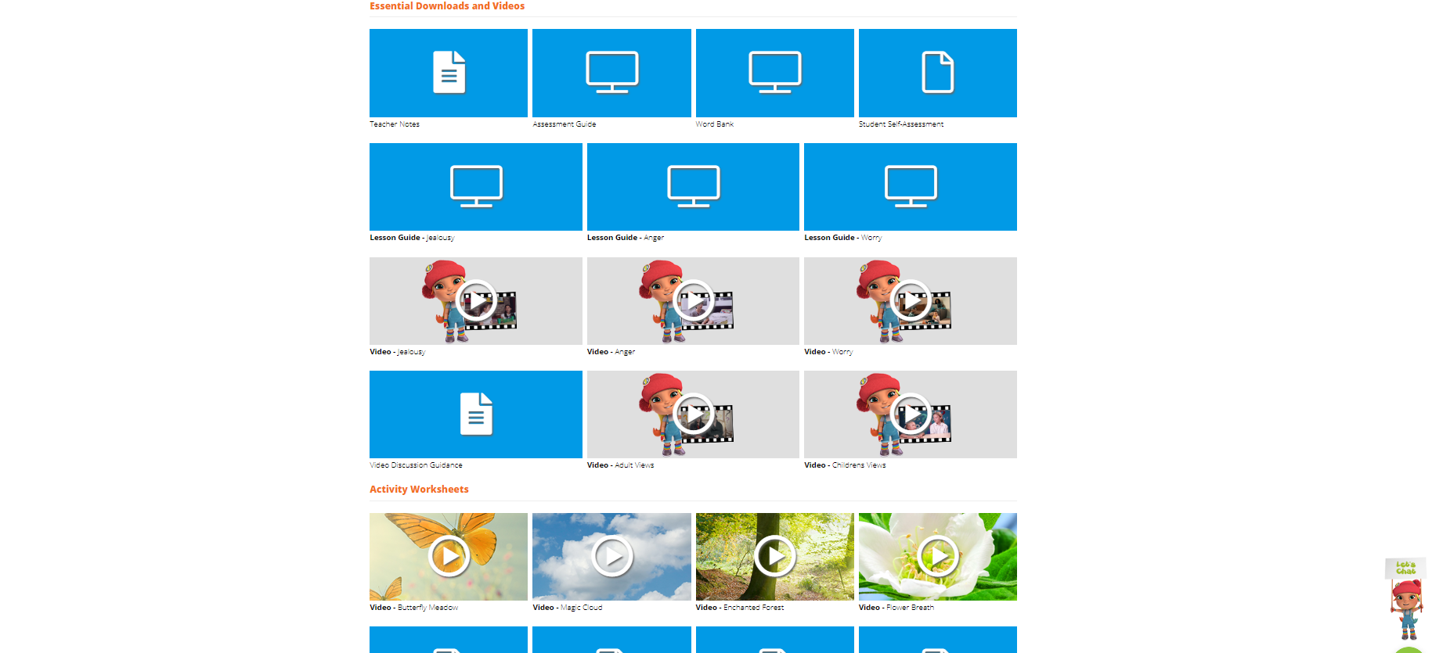

We will be going up to slide 17 today.

The teacher’s notes can be found above the lesson guide if required.

