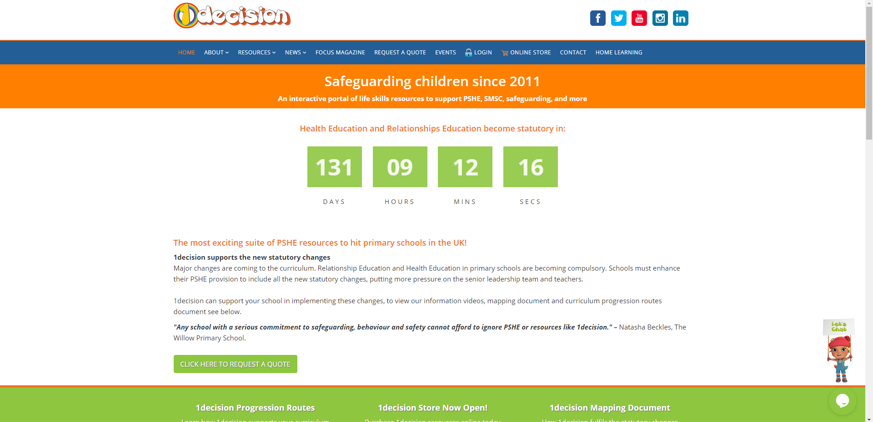
Please note: the teacher’s notes, powerpoint and video have NOT been linked on the class page, but the worksheets from the lesson have.
Username: stphilipsprimary
Password: stphilipsps6ss

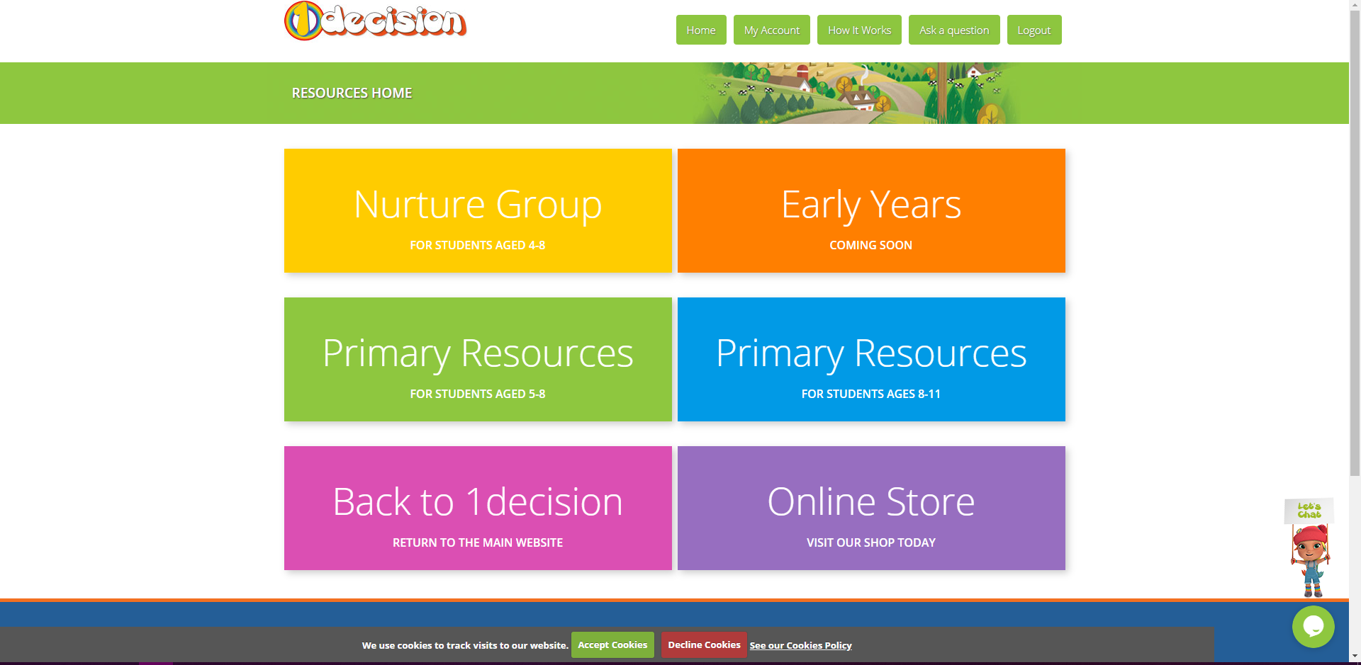


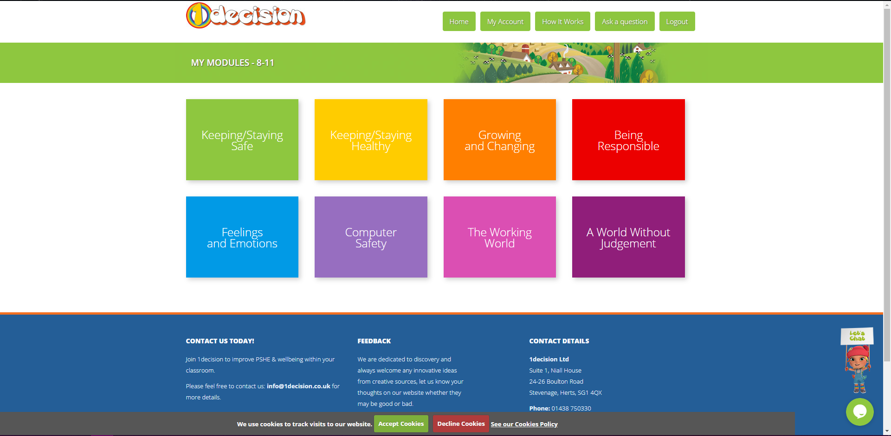
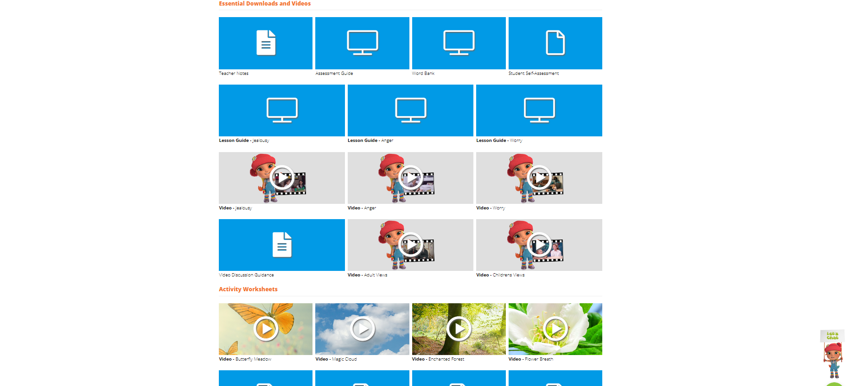

You might want to remind yourself of what we did last week.
This week we will be going from slide 17 to slide 29 today.

The teacher’s notes can be found above the lesson guide if required.

