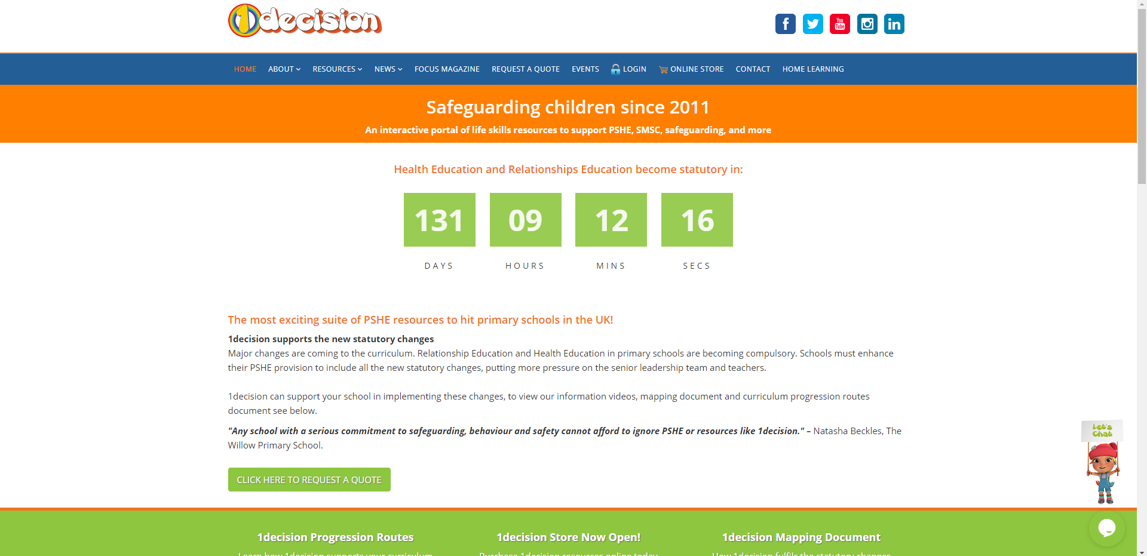
Please note: the teacher’s notes and powerpoint and videos have NOT been linked on the class page, but a suggested worksheet from the lesson has.
Username: stphilipsprimary
Password: stphilipsps6ss

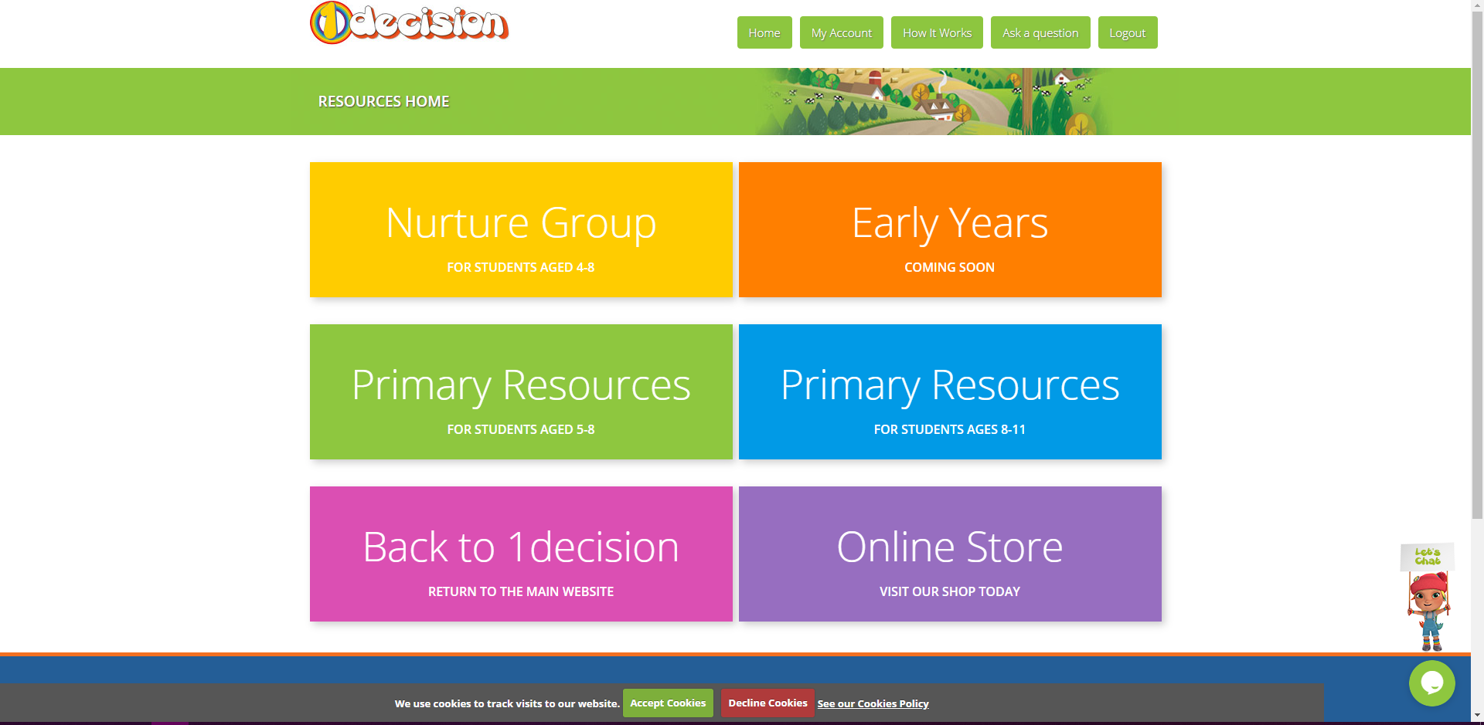


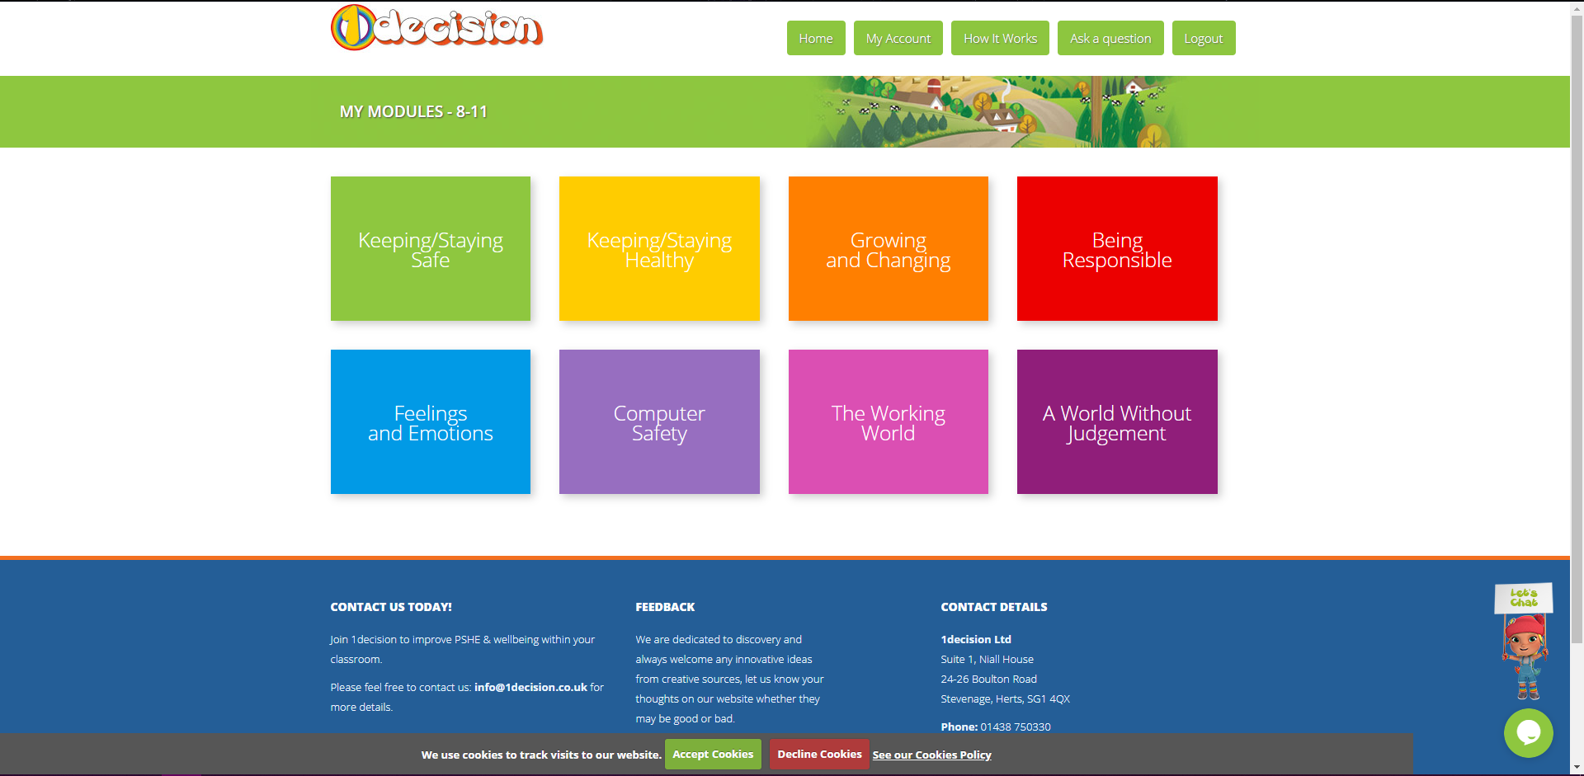
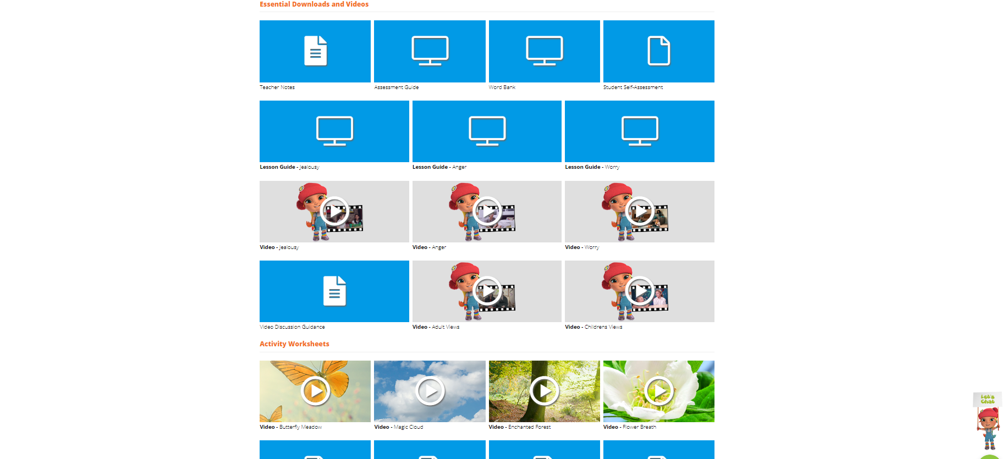

You might want to remind yourself of what we did last week.
This week we will be going from slide 30 to end today.

You may want to return to slide 28 for some ideas to complete your task!

The teacher’s notes can be found above the lesson guide if required.

