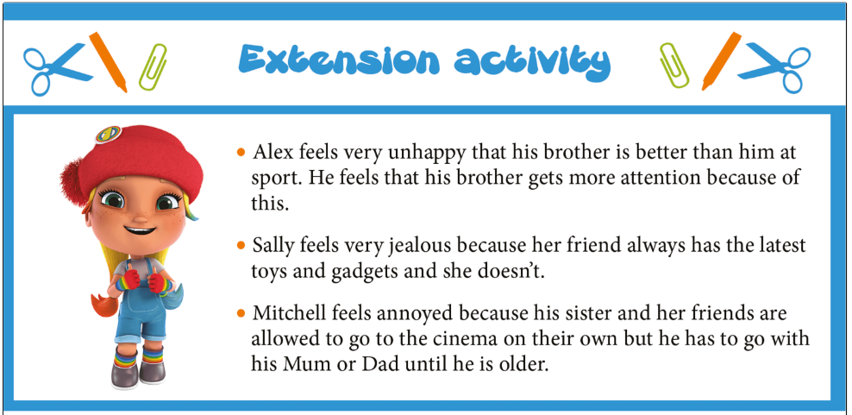
What coping strategies would you suggest to Alex, Sally and Mitchell to help them deal with their feelings? (Hint: look back at slide 28 for Darlee’s ideas!)
You can create diagrams, posters, or write letters to display your thoughts and suggestions. I have started a mind map below if you would like to use it.
.
.
.
Write down what made you feel happy today
Ways to cope if you feel jealous.

