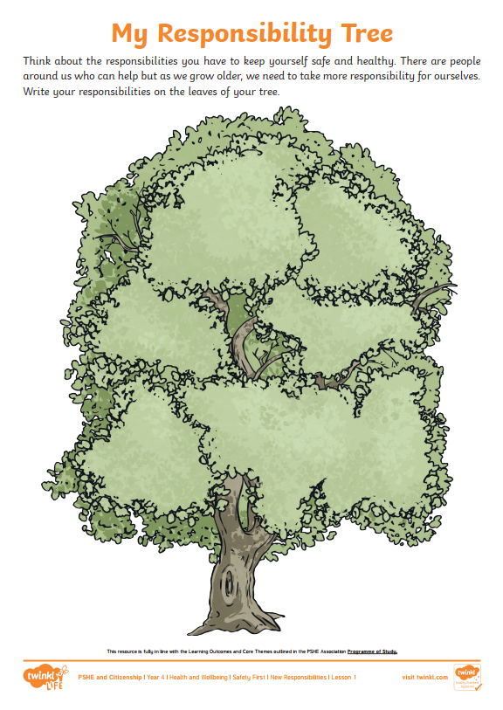
Responsibility
Responsibility
Responsibility
Responsibility
Responsibility

