Drawing a simple electrical circuit
Monday 22nd June
LO. To use symbols to draw a simple circuit.
When drawing a circuit, we do not use literal representations of the components. We use symbols instead.
Look at the symbols below. What do you think they represent?
Can you label each one using the word bank below to help you? Beware, there are more words than symbols. Just look at each part of the diagram and try to work out what each one may be.
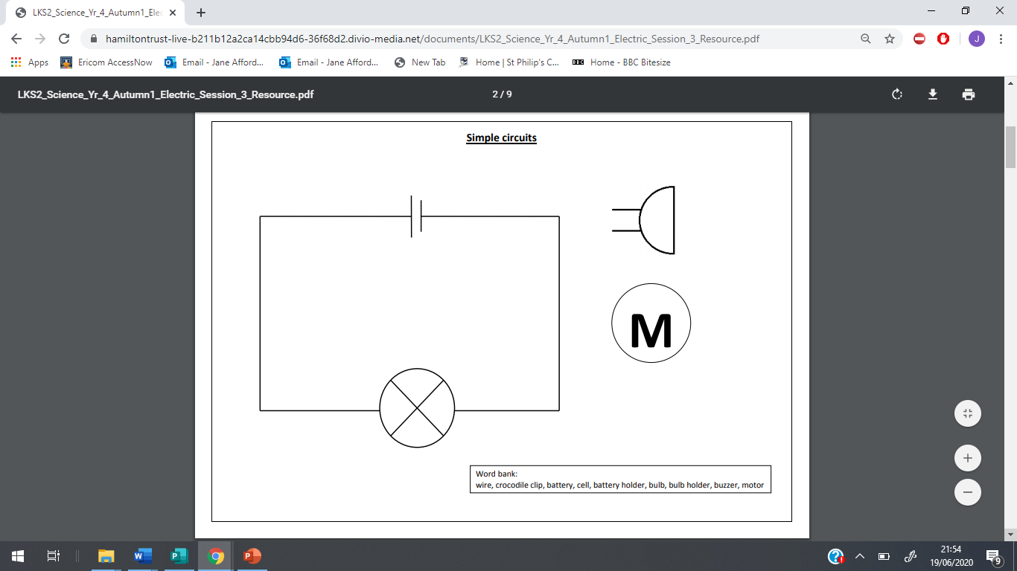
Word bank
wire, battery, cell, battery holder, bulb, bulb holder, buzzer, motor

Now can you draw your own simple circuit and label it?

