Monday 23rd November
LO: To identify the types and functions of teeth

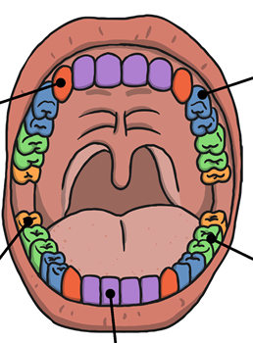
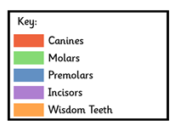
Name of tooth: Wisdom Tooth
Function:

Name of tooth: Molar
Function:

Name of tooth:
Function:

Name of tooth:
Function:

Name of tooth: Premolar
Function:

