Investigation
Sugary beverages are not good for teeth as they stick to the surface and bacteria then break down the sugar to make acid, which can damage teeth. When tooth enamel is exposed to acidic beverages or acid generated by sugary beverages, it softens and loses some of its mineral content. Saliva helps neutralize the acid, restore the mouth's natural pH balance, and slowly harden the tooth enamel again. However, because the tooth's recovery process is slow, if the acid exposure happens frequently, the tooth enamel does not have the chance to repair. Since egg shells are similar to tooth enamel, we are going to examine hard-boiled egg shells soaked for 7 days in various beverages to see if the acid weakens tooth enamel.
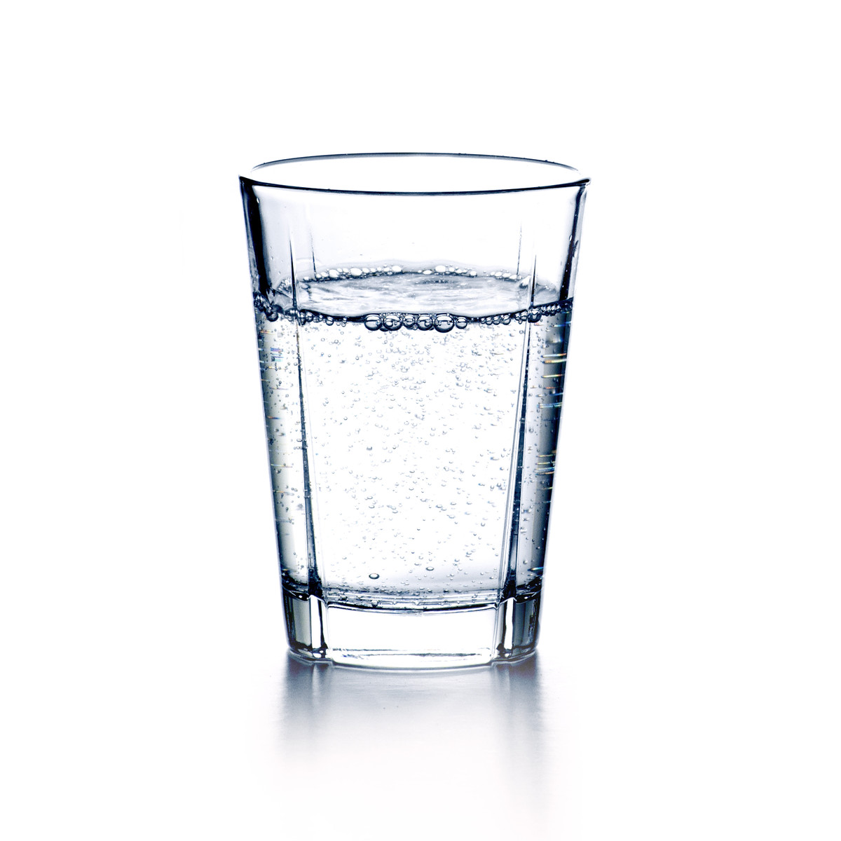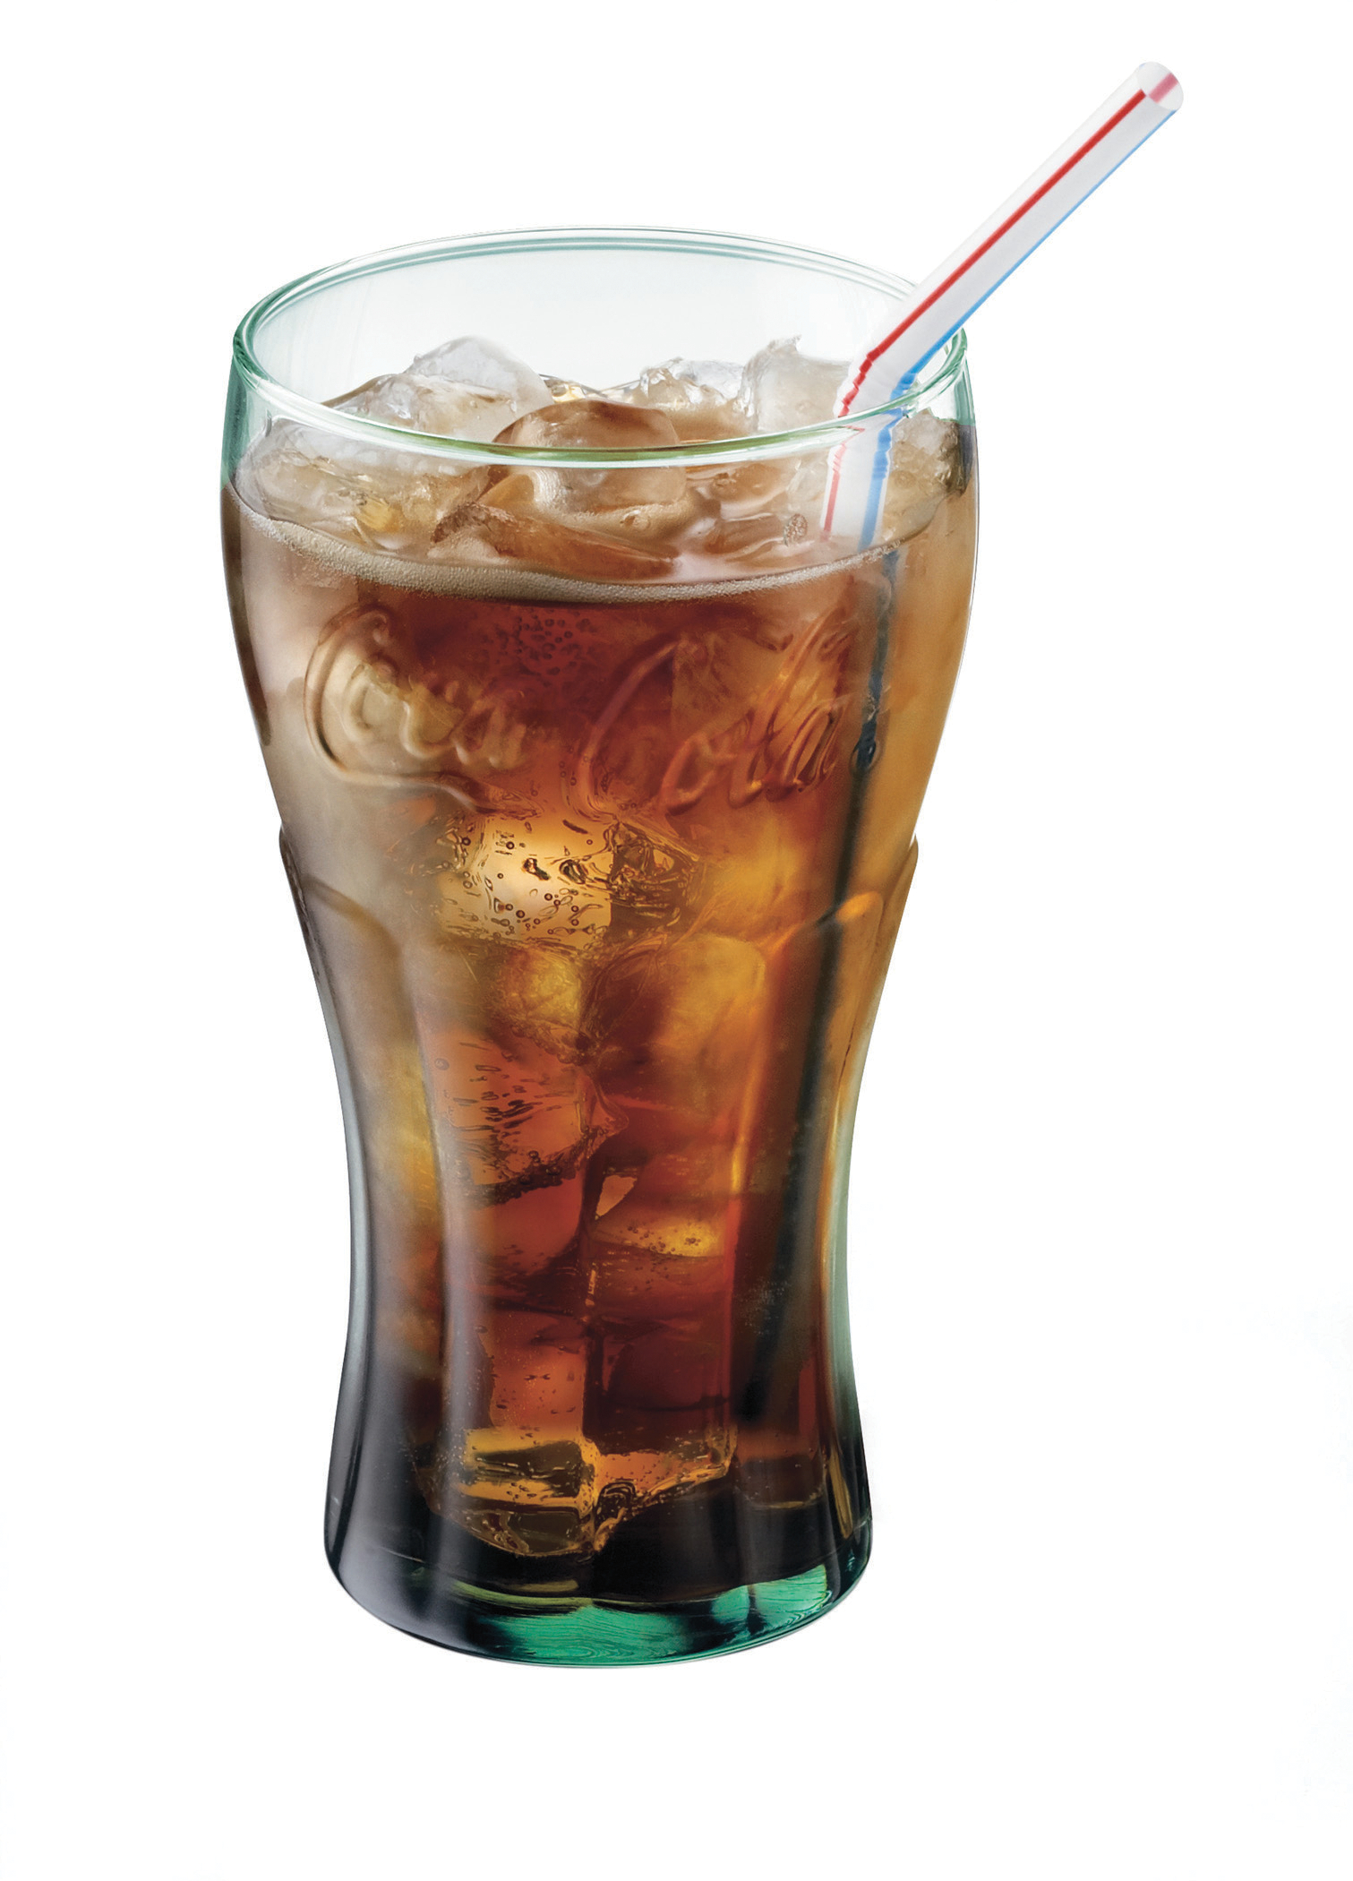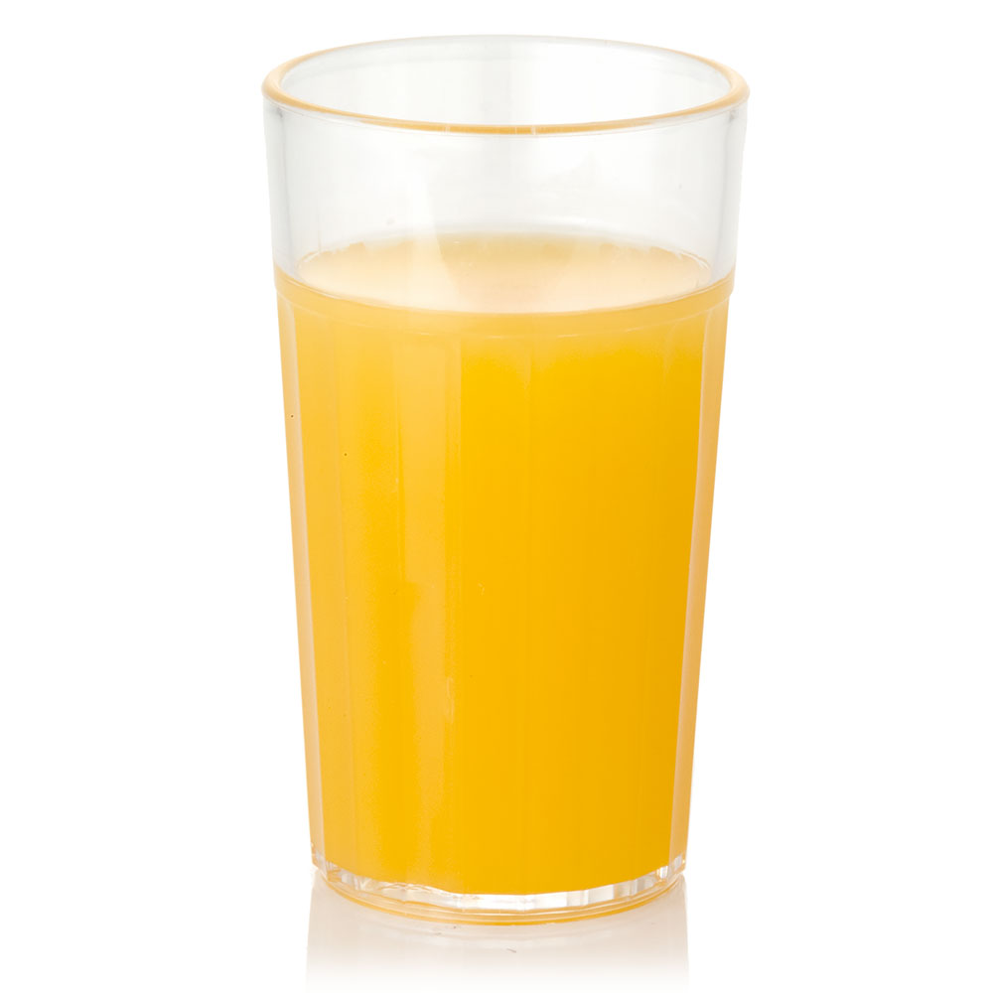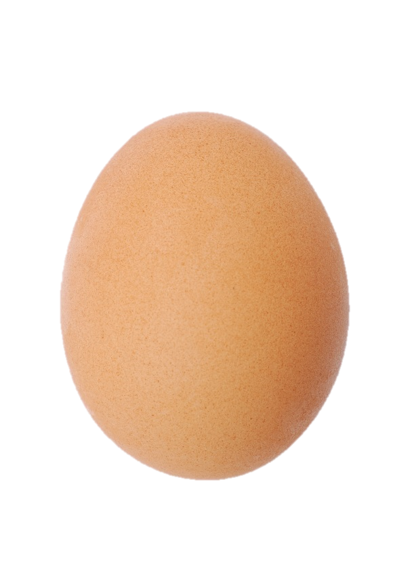

The type of beverage | Which egg shell has the most damage after 7 days | The egg

The water will cause the most damage to the egg shell.
The orange juice will cause the most damage to the egg shell.
The Coca-Cola will cause the most damage to the egg shell.

Method/Equipment:
You need: 3 eggs, orange juice, ___________________________, Coca-Cola, cups.
First you place the boiled eggs into cups containing different beverages ensuring you have the exact same measurement of liquid for each egg.
Then you place eggs in the same conditions and monitor the eggs for 7 days.
Finally, you remove the eggs and discover if the acid weakens the egg shell (your tooth enamel).

Prediction: Circle the one you think is correct.

Fair testing:
I will change _____________________________. This is called my independent variable.
I will keep __________________________ the same. This is called my controlled variable.
I will measure ____________________________. This is called my dependent variable.

Fair testing:

I will change _________________. This is called my ________________variable.

I will keep ______________________________________________________ the same.
This is called my ___________________ variable.

I will measure ______________________________. This is called my _____________ variable.

Prediction: I think that…
________________________________________________________________________________________________________________________________________________________________________ because _____________________________
________________________________________.
Method: How will you conduct your experiment? What equipment will you use?

_______________________________________________________________________________________________________________________________________________________________________________________________________________________________________________________________________________________________________________________________________________________________________________________________________________________________________________________.
How can you prevent tooth decay?

