Monday 30th November
LO:
- To understand what causes tooth decay and how I can prevent it.
- To carry out a fair test.

Tooth decay is damage to a tooth caused by _______________ turning sugars into acid. If plaque is allowed to build up, it can lead to problems, such as holes in the teeth (dental caries) and _____________________ .
Can you label the different parts of your tooth?

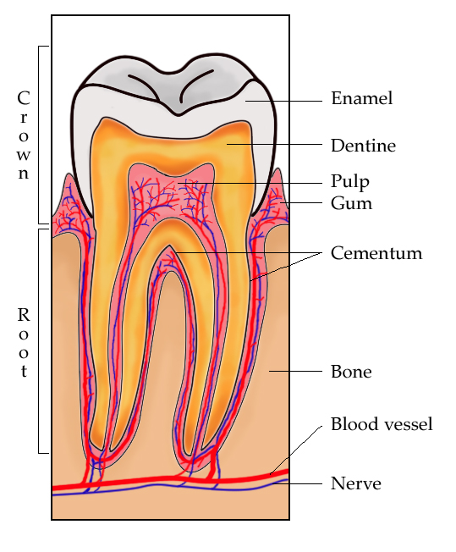

Key Words: pulp, bone, blood vessel, enamel, dentine, gum, nerve, cementum

