Unit: 4.6 What is prayer?

Suggested number of hours 5 (4+1)
Christian Concepts
God – Creation – Fall – People of God – Incarnation – Gospel – Salvation – Kingdom of God
The aim of this unit is to:
- ensure that the children know that prayer is a way of communicating with God.
- know that we/Christians believe that God listens and responds.

Christian Values
Hope
Faith
Key Skills
Reflect
Interpret
Key Questions
- What is prayer?
- How do people pray?
- When do people pray?
- Why do people pray?
- Where do people pray?
Key Vocabulary
Pray, prayer, collect

Key Experiences
Reflecting upon the different styles of prayer.
Creating prayers in different ways.
Explaining how prayer is an expression of belief and commitment.
Link to Understanding Christianity
There is no direct link to an Understanding Christianity unit
To Begin with
Begin by asking pupils the Key Questions.
As part of daily life in a church school the children should have experienced opportunities to pray in many different ways. They may also have different experiences of prayer as members of different faiths and this will affect their answers to the key questions.
A large collage display could be made of their responses to the questions and added to as the unit progresses.
Take a photo of your display.

Explore the Text

Read the passages in the Bible that record the occasions when Jesus prayed e.g. Matthew 19:13, Matthew 26:36, Mark 1:35, Luke 5:16, Luke 6:12, Luke 9:28, Luke 22:39, John 17:19-21.
What can we learn about prayer from Jesus? The children can be detectives feeding back to the whole class but record individually.
I think ……………
Jesus teaches…………
Jesus shows………….

Discover the impact
Prayer is communication with God that helps to build a relationship with him.
How do we build relationships with the people around us?
Can we build a relationship with God in the same way? Why? Why not?
Discuss and record in groups.

Prayer can be praise, intercession (prayers said on behalf of another), thanksgiving, confession (admission of sins), silence, meditation or simply talking with God.
Prayer can be planned or spontaneous, loud or quiet, fun or serious.
Have a collection of a variety of prayer books for the children to look at.
Set up prayer stations so that the children can experience praying in many different ways. There are lots of ideas on the internet, look at www.prayerspaceinschools.com and Pinterest.

Does the way you pray make it any more or less valuable?
Are any of these styles of prayer more worthy than the others?
In what ways does the way you pray reflect your character and lifestyle?
People have a preferred way of praying, why?
Discuss together, record individually opinions, thoughts and questions
Invite the clergy and members of the congregation, whom the clergy recommend, to visit and answer questions about prayer. Ask these adults to talk about favourite prayers they use or particular phrases they use when praying. Question them about prayers that have been answered.
Record in your class RE Scrapbook.

Read traditional prayers such as: -
The Prayer of St. Francis
The Prayer of John Wesley
The Irish Blessing ‘May the road rise up to meet you’
The Morning Collect, Evening Collect and Collect for Purity. (http://www.churchofengland.org/prayer-worship/worship/texts.aspx)
What do these prayers reveal to us about God and Christian belief?
Record individually

Read and critically review the prayer books in your collection. If possible i.e. if budgets allow, the children could choose some new prayer books to be used in school.

Make the Connection

Ask the children to explain how prayer is an expression of belief and commitment.
Record Individually.
Create a beautiful multi-sensory board including words, pictures and objects of things that the children want to pray for or about.

Spend some time being still and silent, light candles and reflect on the day or a situation. It may be possible for this activity to take place in church. Introduce quiet music to the silence and then discuss the whole experience with the children.
Record in your class RE scrapbook.

Give the children further opportunity to create prayers.
Use prayer trees, stringing beads, newspaper headlines, acrostic prayers, shape prayers, texts, bubbles, playdough, drawing, a walk outside, music and dance. The possibilities are endless. There are many books published full of ideas for ways to pray. The children can use their prayers during collective worship.
Take risks!
Take photos
Record in your class RE scrapbook.
In the pictures file on this CD there is a photograph of votive prayer candles lit automatically when activated by a coin. What do the children think of this idea? Is this the same as actually lighting a real candle as a prayer?
Discuss together

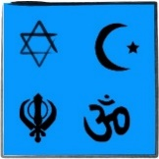
Non-Christian Faith Link
How do people of other faiths pray?
1 hour
Christians are not the only people who pray.
Briefly look at the prayer life of people from other religions. Notice the similarities and differences.
Record individually
Information and suggested activities can be found on the BDBE Islam and Judaism Curriculum CDs.
Hindus do not pray at any specific times of the day; chanting mantras is the most popular form of prayer in Hinduism.
Sikhs believe that God is present everywhere and there is no particular way to pray. However, there are prayers or readings from holy books which Sikhs are expected to recite each day. This daily routine is known as Nitnem, the first Nitnem, the Panj Bania is usually recited in the early morning. Retras Sahib is the evening prayer of the Sikhs. It is in four sections; each section refers to a different aspect of god. The night time prayer is the Kirtan Sohila which is said by all Sikhs before they go to sleep.

YouTube BBC Teach film clips Religious Studies My Life My Religion. Show children of all faiths talking about prayer.

By the end of this unit pupils will know that:
prayer is the way in which believers communicate with God.
prayer is connected to faith.
Christian beliefs are revealed in the content of prayers.
By the end of this unit pupils are expected to be able to:

talk about the similarities and differences in the ways people of faith pray.
talk using religious vocabulary to show understanding of the purpose, place and content of prayer in the life of a believer.

I know: |  | 
prayer is a way of communicating with God.
that prayer is an important part of the life of a believer.
I can:
talk using religious language about prayer in Christianity and other faiths.
talk about my own experiences of prayer.
identify the Christian beliefs revealed in the language of prayer.

Resources
Reflection and Response CD

Called to Prayer
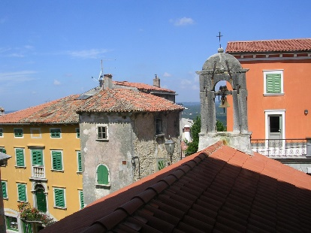
Look carefully on the top of the Church roof in the foreground.
What is the significance of the bell? When is the bell rung?
Why is the bell rung? What message does it give?
How do people feel when they hear the bell?

A flame of hope
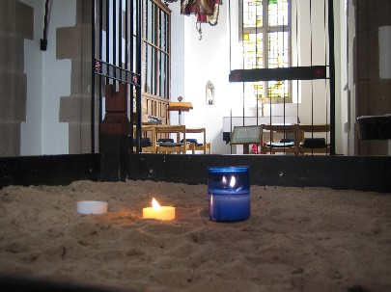
Candles are lit with a great sense of hope.
What is hope?
What does it mean to be hopeful?
What do you hope for?
What are your hopes for others and the world?
Express these hopes in prayers.

The full resources can be found on the Reflection and Response CD

