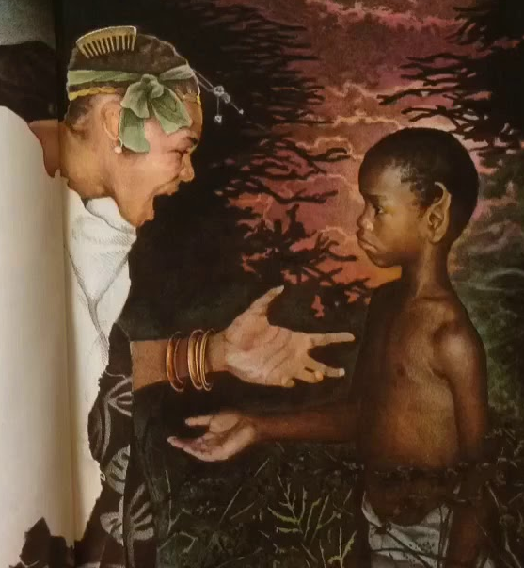
Wednesday 25th March
LO: To compare the different experiences of two contrasting characters.
Fill in the table below to compare what happened to these two characters on their way through the forest. What differences can you find?
It may be the way the characters behave that is different, or the way the forest and the people there behave towards the sisters that is different. (Be careful – one of the spaces may be blank!)
The first row has been done for you.
Part of the forest | Manyara | Nyasha
Small, hungry boy asking for food. | She refused to give him anything to eat.  She said, “Out of my way, boy! Tomorrow I will become your queen. How dare stand in my path!” | Gave the boy her yam that she had brought for her lunch to eat.
Old woman sat on the rock.
Trees behaving in strange ways.
Man with his head in his hand tucked under his arm.

