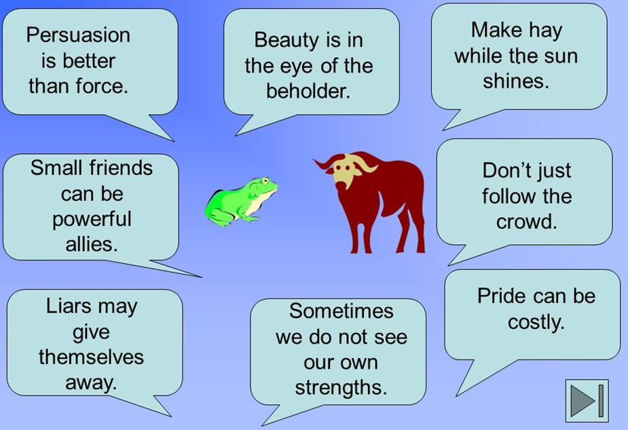
Here are some examples of morals from other stories:
TOP TIP: if you want to find out more, or read the stories these morals are from, use the internet to research ‘fables’!

