What is a moral?
A moral is a type of lesson.
It’s not like the lessons we do at school, or on the computer like this one! Instead it is a lifelong lesson, or a lesson that lasts for a very long time and is something that people believe in.
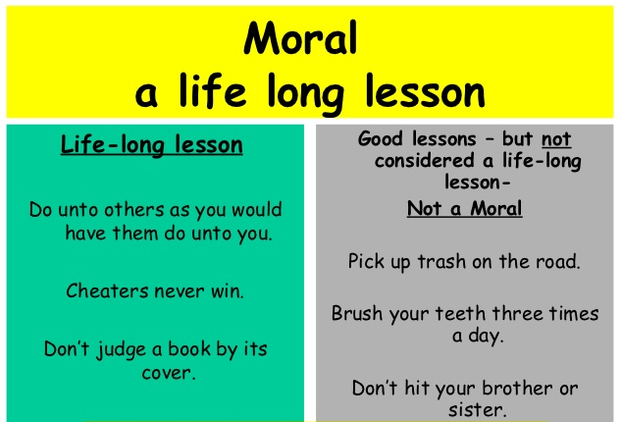
Here are some examples to show the difference between a moral and a normal lesson.

