Talking Animals
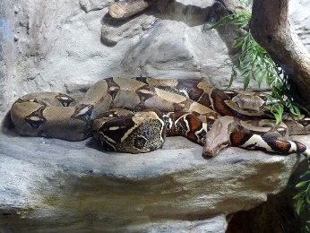
The boa constrictor is a large snake that constricts its prey.
“Senhor, this tree is a tree of miracles. It is my home, where generations of my ancestors have lived. Do not chop it down.”
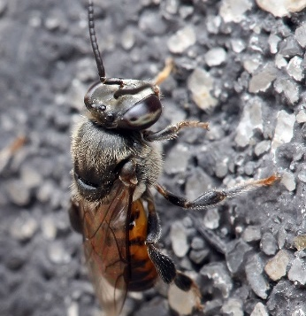
This type of bee stores pollen and honey and has no sting.
“Senhor, my hive is in this Kapok tree, and I fly from tree to tree and flower to flower collecting pollen. In this way I pollinate the trees and flowers throughout the rain forest. You see, all living things depend on one another.”
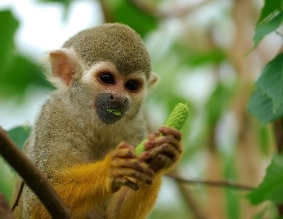
Squirrel monkeys can live in massive groups, of up to 500 members!
“Senhor, we have seen the ways of man. You chop down one tree, then come back for another and another. The roots of these great trees will wither and
die, and there will be nothing left to hold the earth in place. When the heavy rains come, the soil will be washed away and the forest will become a desert.”
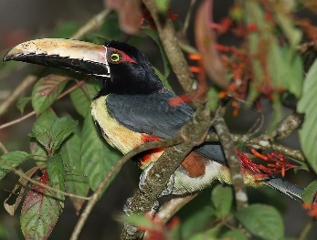
Toucans mostly eat fruit, lizards and small insects.
“Senhor! You must not cut down this tree. We have flown over the rain forest and seen what happens once you begin to chop down the trees. Many people settle on the land. They set fires to clear the underbrush, and soon the forest disappears. Where once there was life and beauty only black and smouldering ruins remain.”

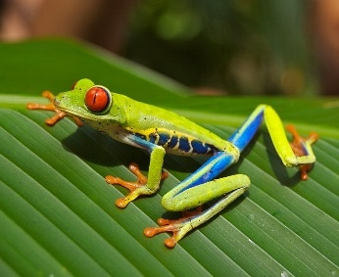
The red-eyed tree frog is threatened by forestry and pollution.
“Senhor, a ruined rain forest means ruined lives… many ruined lives. You will leave many of us homeless if you chop down this great Kapok tree.”
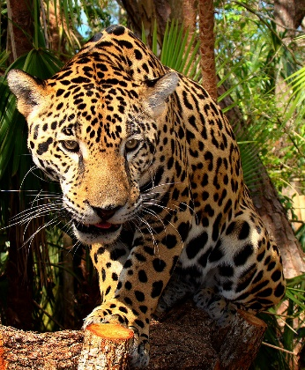
The jaguar has a very powerful bite compared to the other big cats.
“Senhor, the Kapok tree is home to many birds and animals. If you cut it down, where will I find my dinner?”

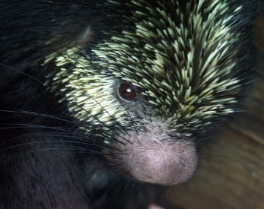
Tree porcupines are much lighter than other kinds of porcupine.
“Senhor, do you know what we animals and humans need in order to live? Oxygen. And, Senhor, do you know what trees produce? Oxygen! If you cut down the forests you will destroy that which gives us all life.”

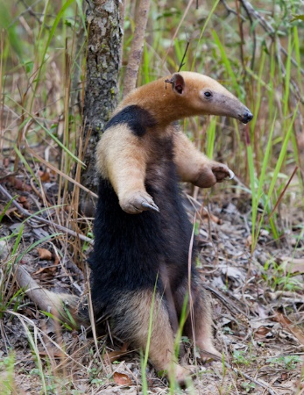
This anteater has very strong fore claws used to break insect nests.
“Senhor, you are chopping down this tree with no thought for the future. And surely you know that what happens tomorrow depends on what you do today. They big man tells you to chop down a beautiful tree. He does not think of his own children, who tomorrow must live in a world without trees.”

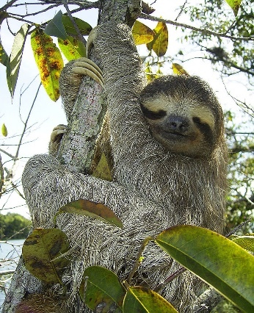
Three-toed sloths are the size of a big cat and are agile swimmers.
“Senhor, how much is beauty worth? Can you live without it? If you destroy the beauty of the rain forest, on what would you feast your eyes?”

