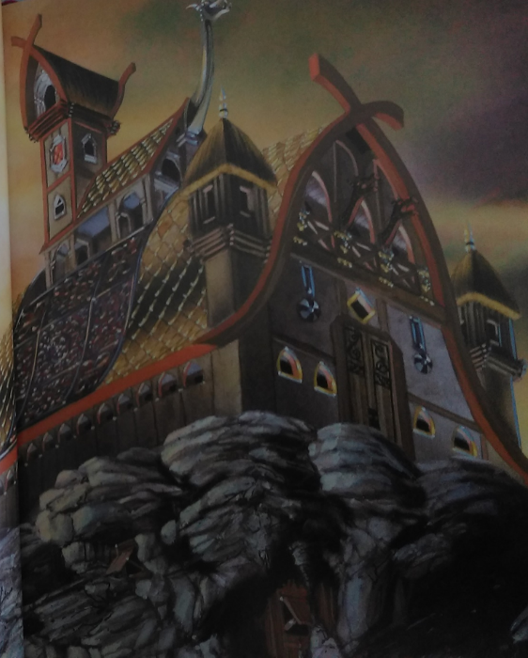
Beowulf - Chapter 1
The great hall

Long, long ago, Denmark ________ a wild place. Gruesome monsters _________ the misty moors. At night, they __________ and ______________ and _________________ and _________________.

The king of the Danes, a warlord named Hrothgar, _______________ to be _______________. He ____________ a huge hall for himself on top of a craggy hill at the edge of the moors.

The hall was _____________ of the finest wood, _______________________ with ivory, silver and dazzling gold. The king _____________ it Heorot.

make | refuse | is | call
scare | roam | build | howl
growl | decorate | shriek | snarl

