Task: We know what these characters are saying from the text, but what are they really thinking? Sometimes it can be a bit different!

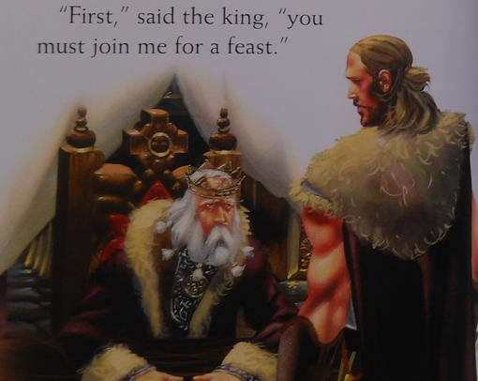
Example:
This young man is a fool, he does not understand what the monster Grendel will do to him!
He is brave though, so I will be kind. He should eat well and have a delicious last meal before he meets his end…

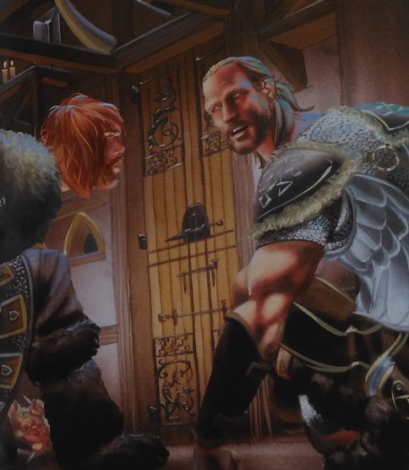
Leofrich:

Beowulf:

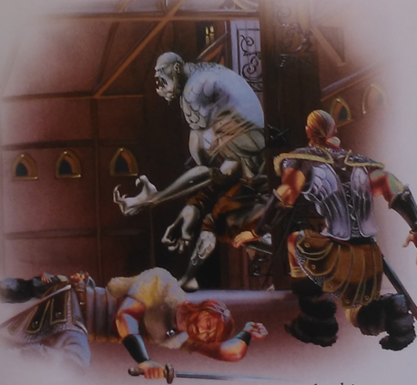
Grendel:

Beowulf:

