Thursday 14th May
LO: to use coordinating conjunctions in a sentence.
Fill in the sentences below with an appropriate coordinating conjunction – there might be more than one that could fit in the gap!

- Beowulf was a great hero ________ he was able to defeat Grendel and Grendel’s mother.
- Grendel was strong ________ Beowulf was stronger.
- The men were scared _________ Grendel was threatening them.
- Neither Grendel _________ Grendel’s mother were a match for Beowulf!
- The monster Grendel had been terrorising them for ages _______ Beowulf was not afraid.

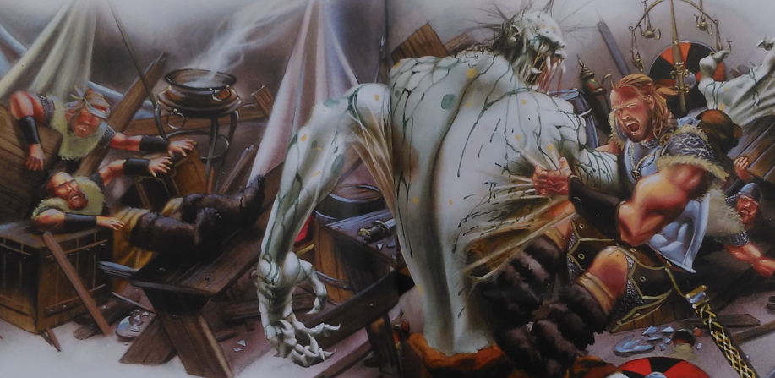
** Can you think of your own sentences for the coordinating conjunctions you haven’t used yet? **

