Victorious Vikings Comprehension
Friday 15th May
LO. To find the relevant information in a text to answer the following questions.
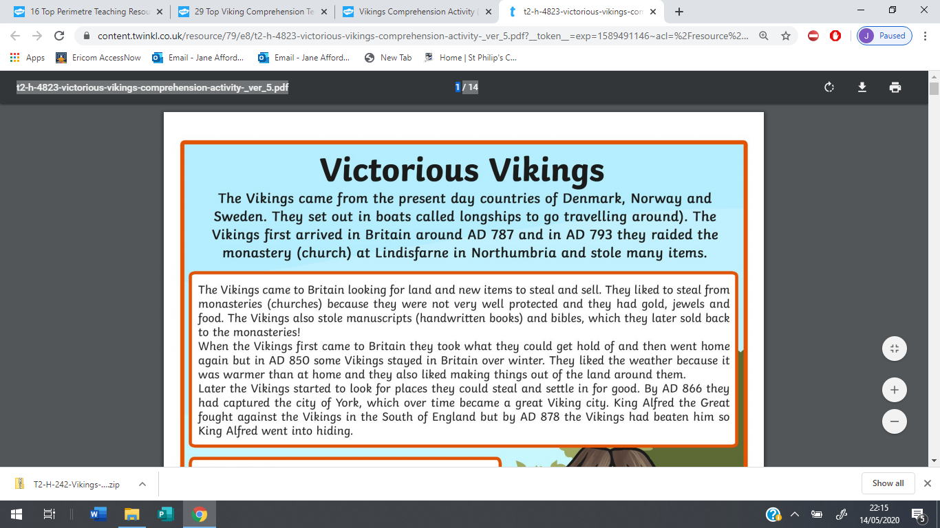
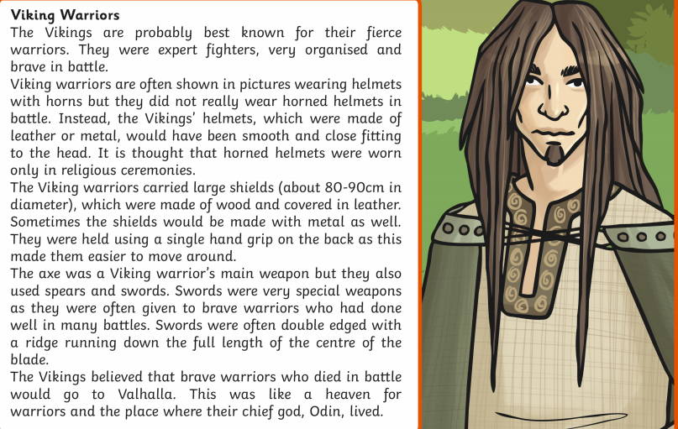
Now answer the questions below. Record your answers in full sentences.
Friday 15th May
LO. To find the relevant information in a text to answer the following questions.

- When did the Vikings first arrive in Britain?
________________________________________________________________________

- Why did the Vikings choose to come to Britain?
________________________________________________________________________
________________________________________________________________________

- Which Monastery did the Viking invade first? What happened?
________________________________________________________________________
________________________________________________________________________
________________________________________________________________________

- Why did the vVikings begin to settle permenantly in Britain? Find two reasons.
________________________________________________________________________
________________________________________________________________________
________________________________________________________________________

- Which city did the Vikings take over in AD 866?
________________________________________________________________________

- Who was King Alfred the Great and what did he do?
________________________________________________________________________
________________________________________________________________________
________________________________________________________________________

- Give two reasons why the Vikings made good warriors.
________________________________________________________________________
________________________________________________________________________

- Draw and label a Viking helmet, shield or sword.

- If you were a Viking warrior, which weapon would you chose and why?
________________________________________________________________________
________________________________________________________________________

- Where did Viking warriors believe they went if they died in battle?
_______________________________________________________________________
_______________________________________________________________________

Challenge
Can you draw and label what you think a Viking warrior might have looked like?

