Butser Ancient Farm
Butser ancient farm is an archaeological, open-air museum located near Petersfield in Hampshire, southern England. Butser features experimental reconstructions of prehistoric, Romano-British and Anglo-Saxon buildings. Historians and archaeologists use the farm to try and work out how people in the past might have lived. They do experiments to find out how they cooked, made things and built houses.
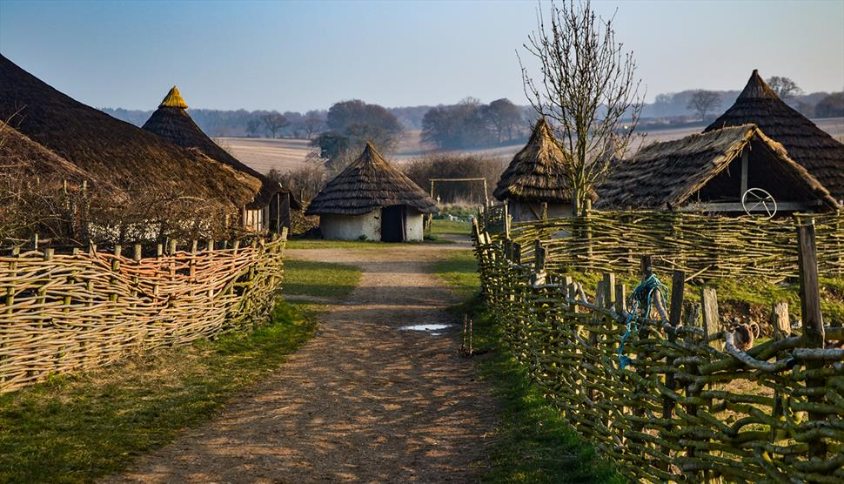
What can you see there?
Butser Ancient Farm is open to the public and to school groups. You can visit reconstructed Iron Age roundhouses and a Roman Villa. You might want to have a go at making a mosaic, doing some pottery, weaving or even learning how to write in Ancient runes!
Take part in special events; theatre in the roundhouse, storytelling, ancient festivals like Beltain or Samhain, there really is something for everyone.
There is a lot to explore and plenty of places to eat lunch. We also have a Visitor Centre and shop, where you can find out more about the site and buy a souvenir of your trip.

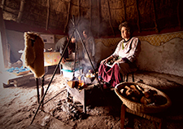

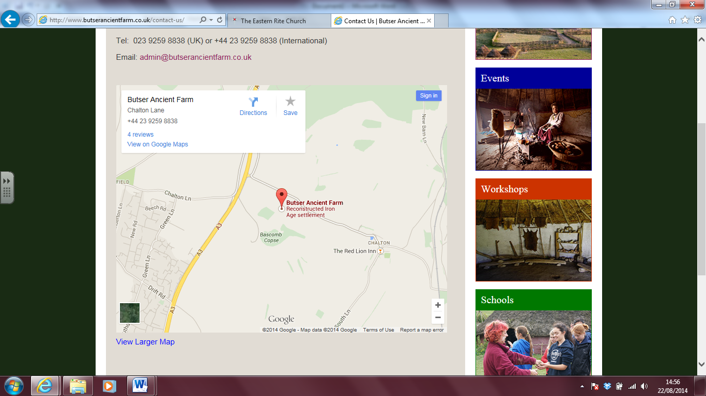
MAP

When can you visit?
Butser Ancient Farm is open all year round: Monday - Friday from October to March 10am – 5pm (4pm during Winter)
In the Spring & Summer months, it is open 7 days a week from 10am– 5pm.
Address Chalton Lane, near Charlton, Waterlooville. PO8 0BG
Phone: 023 9259 8838
Contact us at www.butserancientfarm.co.uk

Non-chronological report Reading comprehension
Friday 5th June
LO. To retrieve specific information from a text to answer questions.
- Where is Butser Ancient Farm?
___________________________________________________________________________________________
___________________________________________________________________________________________

- Why might someone want to visit Butser Ancient Farm?
__________________________________________________________________________________________
__________________________________________________________________________________________
__________________________________________________________________________________________

- List four things you could see or do at Butser.
__________________________________________________________________________________________
__________________________________________________________________________________________
__________________________________________________________________________________________
__________________________________________________________________________________________

- Would it be possible to visit Butser Ancient Farm on Saturday 17th February? Give a reason for your answer.
___________________________________________________________________________________________
___________________________________________________________________________________________

- Why has this non-chronological report been set out using text boxes?
__________________________________________________________________________________________
__________________________________________________________________________________________

- Why do you think the author has chosen to include a map?
___________________________________________________________________________________________
___________________________________________________________________________________________
___________________________________________________________________________________________
- If you were planning a visit, how could you book it?
__________________________________________________________________________________________
__________________________________________________________________________________________

