Tuesday 9th June
LO: To write an introduction and first paragraph for my non-chronological report on the Vikings.
Miss Byrne’s example – you can use this to help you, but please try to write yours yourself without copying! Look on page 2 to see the features highlighted.

Structure strip
Title | Why should we be interested in The Vikings?
Introduction | Introduction
- What is your topic?  - Who/what/where/ when/why?  - ‘Hook’ to read on. | The Vikings were a group of people originally from Scandinavia, who travelled across Europe from the 8th century to the 11th century. They are well known for their raids where they would steal food and resources from people, often destroying homes as well. Vikings weren’t all bad though! Read on to find out more about how the Vikings lived. | 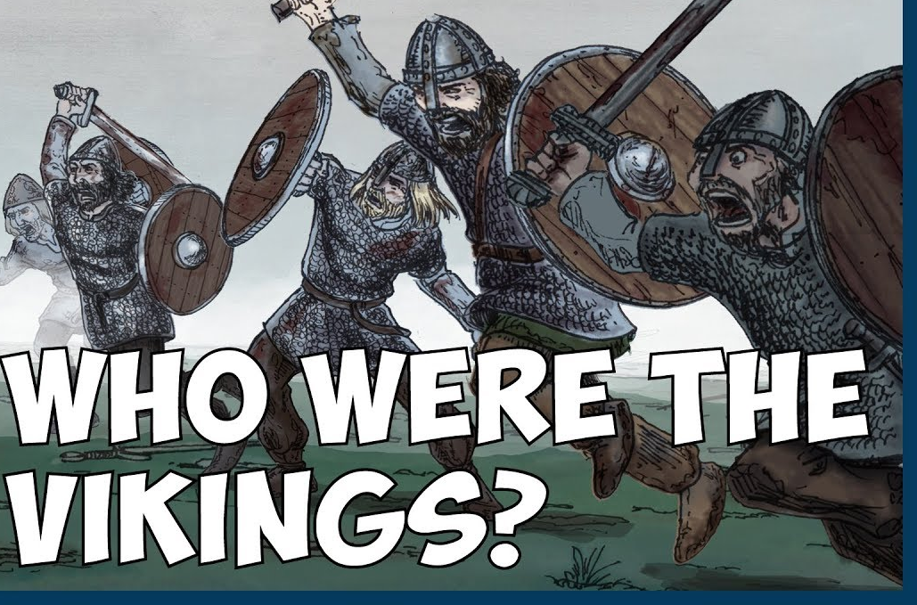
 |  | Who were the Vikings?
Subheading | Viking Shields
- Give at least 3 important facts.  - Use connectives and full sentences.  - Any key words for a glossary?  - Remember you can reuse your sentences from last week! | The Vikings were well known for being fierce warriors and they had a unique fighting style. Alongside their armour, helmets and swords, they also used a shield to protect themselves. The Vikings made their shields round. As a result, a lot of Viking heads and legs got injured in battle. Despite this, the Vikings kept their shields round and light so they could also be used to hit the enemy as well as defend! Wood was the usual material used for shields although it had to be made waterproof with oil before it was ready to be used. Viking shields were painted in bright colours, for example red, yellow, black and white were often used. | 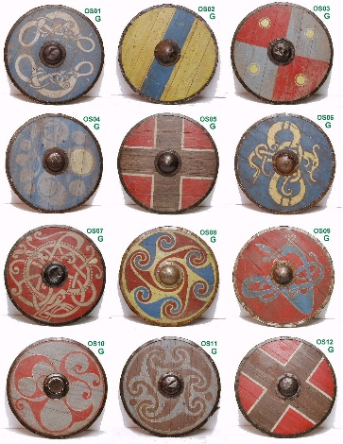
 |  | Some examples of Viking shields. Can you see the colours and patterns?

Structure strip
Title | Why should we be interested in The Vikings?
Introduction | Introduction
- What is your topic?  - Who/what/where/ when/why?  - ‘Hook’ to read on. | The Vikings were a group of people originally from Scandinavia, who travelled across Europe from the 8th century to the 11th century. They are well known for their raids where they would steal food and resources from people, often destroying homes as well. Vikings weren’t all bad though! Read on to find out more about how the Vikings lived.
 |  | Who were the Vikings?
Subheading | Viking Shields
- Give at least 3 important facts.  - Use connectives and full sentences.  - Any key words for a glossary?  - Remember you can reuse your sentences from last week! | The Vikings were well known for being fierce warriors and they had a unique fighting style. Alongside their armour, helmets and swords, they also used a shield to protect themselves. The Vikings made their shields round. As a result, a lot of Viking heads and legs got injured in battle. Despite this, the Vikings kept their shields round and light so they could also be used to hit the enemy as well as defend! Wood was the usual material used for shields although it had to be made waterproof with oil before it was ready to be used. Viking shields were painted in bright colours, for example red, yellow, black and white were often used.
 |  | Some examples of Viking shields. Can you see the colours and patterns?

