Thursday 11th June
LO: To write a conclusion, fact file and glossary for my non-chronological report on the Vikings.
Miss Byrne’s example – you can use this to help you, but please try to write yours yourself without copying! Look on page 2 to see the features highlighted.

Structure strip
Conclusion | Conclusion
- Reminder of your topic.  - Why are the Vikings remembered?  - Are the Vikings still important today? | To conclude, the Vikings were an incredible and powerful group of people, who conquered enormous areas of land because of how fierce they were. We remember them because of how much they shaped our lives today. There are signs of Vikings still all around us, for example ‘Formby’ was once a Viking town! Vikings are still important today, with books and films like ‘How to Train Your Dragon’ showing what Viking life was like for everyone to enjoy. | 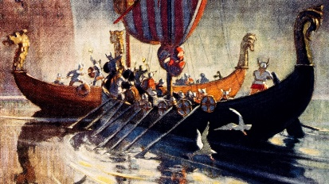
 |  | Artwork of a Viking longboat.
Did You Know? | Did You Know?
- Include any other facts that you liked but didn’t fit into your other paragraphs!  - Don’t forget any glossary words. | - The days of the week are named after Viking gods!  - Vikings were actually known for being very clean people!  - Vikings believed that runes could predict the future! | 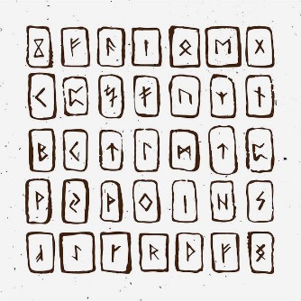
 |  | Viking runes.
Glossary | Glossary
- Here you put all of the key words from all paragraphs and tell your reader what they mean. | Raids – a quick surprise attack.  Warriors – fighters.  Shield – a piece of wood providing protection.  Runes – a letter of the Viking alphabet, often carved into wood or stone. | 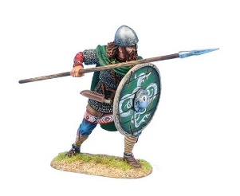
 |  | A Viking warrior.

Structure strip
Conclusion | Conclusion
- Reminder of your topic.  - Why are the Vikings remembered?  - Are the Vikings still important today? | To conclude, the Vikings were an incredible and powerful group of people, who conquered enormous areas of land because of how fierce they were. We remember them because of how much they shaped our lives today. There are signs of Vikings still all around us, for example ‘Formby’ was once a Viking town! Vikings are still important today, with books and films like ‘How to Train Your Dragon’ showing what Viking life was like for everyone to enjoy.
 |  | Artwork of a Viking longboat.
Did You Know? | Did You Know?
- Include any other facts that you liked but didn’t fit into your other paragraphs!  - Don’t forget any glossary words. | - The days of the week are named after Viking gods!  - Vikings were actually known for being very clean people!  - Vikings believed that runes could predict the future!
 |  | Viking runes.
Glossary | Glossary
- Here you put all of the key words from all paragraphs and tell your reader what they mean. | Raids – a quick surprise attack.  Warriors – fighters.  Shield – a piece of wood providing protection.  Runes – a letter of the Viking alphabet, often carved into wood or stone.
 |  | A Viking warrior.

