Viking Longboats Information

The Viking settlers sailed huge distances in their longboats, travelling far and a long way from home. The countries they sailed from are, Norway, Sweden and Denmark; known as Scandinavia.There were lots of mountains there and they learned how to sail on the fjords where the water was very deep, when they were young. All the Vikings were great sailors.

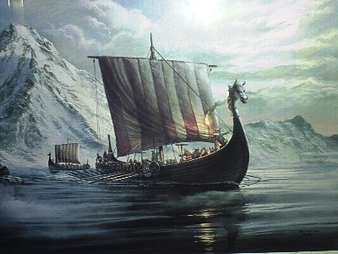

The Viking Longboats were known as DRAGON SHIPS to their enemies.
The Prow – front of the ship carved with a dragon like figure
The Stern – back of the ship with a carving similar to the one on the front
Clinker built hull allowed for great speed and strength in stormy seas.

- The Viking ships were strong, lightweight and beautifully shaped to skim quickly through the water.
- Warships and raiding ships were designed to come right up on the beach so that men could jump out and start fighting straight away.
- The ships were built of wood and made waterproof with tar from pine trees.
- The square sails were made of woven wool and were often brightly coloured.
- When the wind was wrong for sailing, they were rowed by teams of oarsmen.
- Longboats were expensive to build and to crew. Only the rich Viking Kings could afford to have such vessels.
- The smallest longboats had 26 oars, some had as many as 70 oars!!!

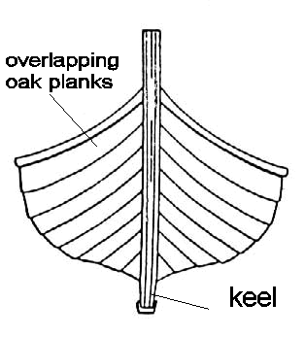

Viking longboatss were among the first ever ships to have a keel. The keel is extremely important as it provides the ship with support in rough weather.
The keel also enabled the ships to travel smoothly and quickly across the sea.
A large oar at the stern steered the ship.

