Odin Creates The world
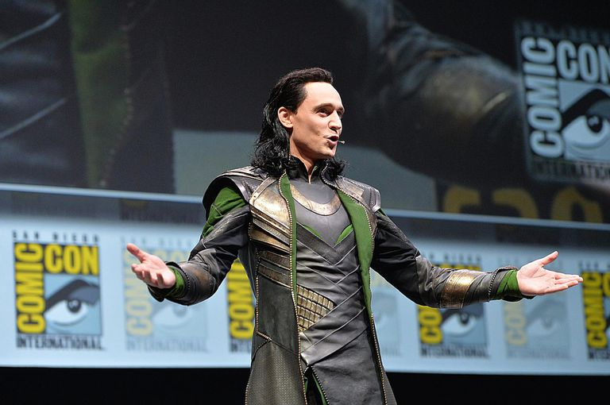
Monday 22nd June
LO. To identify contractions.
To re-write contractions in full form

In this story, we are introduced to Loki who tells the story in his own words. We call this ‘the first person’.
Read the following story telling us how according to Norse myths, Odin created the world. The activity is at the end!
Highlight the contractions Loki uses because he is ‘speaking’-telling the story as these sagas were passed down by word of mouth.

I my friends am Loki. Ah, don’t say you haven’t heard of me. Loki by name, jokey by nature. Expert story-teller and a good mate of the great god, Odin. What? You don’t know Odin either?! Oh dear, oh dear.
Odin and I are gods, Viking gods. You know the Vikings – lived a long time ago and sailed around in very, long ships. The Vikings told stories about us gods…the same stories I’m going to tell you. Now, a story has to have a setting and to tell you where my stories are set I think we better go back to the very beginning, to a time before there was anything – no people, no animals, no earth, no sky. How do you think it all began? I’ll tell you.
In our Viking stories Odin made the world. I should know… I was there when it happened. I stood at his elbow and watched him do it. Brilliant it was… “First I shall make a home for our enemies the giants.” Odin said.
Yes, that's what Odin said. Can you believe it? And I said... “Make them a home? Isn't that a bit generous, my lord?” I was dead puzzled. The giants were our enemies and Odin hated them. But then he said:
“Ah Loki, wait till you see what sort of home I make for them! Aaaaahhhh!!!”
And with a great roar, he sent this freezing wind across the blackness, and a terrible land of frost and ice appeared wrapped in a thick, thick mist and I said to Odin…
“I'm not going there for my holidays!”
“Not very pleasant, eh, Loki? Asked Odin
“They’ll hate it! What are you going to call it?” I asked
Odin replied, “Jotunheim. The home of the giants - Jotunheim.”
“And what's next Odin?” I questioned.
“Wait and see. Haahhh!” he laughed.
This time Odin breathed gently and a warm wind blew, and this beautiful green world full of trees and lakes and flowers and rivers appeared. And I said...
“Cor, I don't mind that! That's for us gods, is it?
“No Loki. It's for people.”
“People? What are they?” I asked puzzled.
“I haven't made them yet.”
Then Odin took two trees, muttered something into the leaves, and turned them into the first man and the first woman. Honestly! That’s the way it happened in our Viking stories. And Odin said, “There! What do you think, Loki?”
“Not bad. What are you going to call this place then?”
“Midgard – home for humans – Midgard.” Odin answered.
“Isn't it a bit too good for skinny, hairy things like them?”
“Ah maybe, but you haven't seen what I've planned for us!” Odin stated proudly.
“Is it even better than this Midgard?”
“Ooooh yes. Stand back! Aahhhh.
“Incredible!” I exclaimed as in the blinking of an eye there rose up a shining, dazzling city, full of palaces made of gold and silver. With towers that almost touched the clouds. And Odin said, “I shall call it Asgard! City of the gods! In the day it will glitter in the light of the sun, in the night it will glimmer in the light of the moon. Asgard!” I was impressed and said, “I’m amazed!”
That was that. In five minutes flat, Odin had made the lot: Jotunheim, home of the giants; Midgard, home of you humans, and Asgard, city of us gods. And - as a final touch - he joined Asgard to Midgard with a fantastic bridge made from a rainbow!
That’s how Odin created the world.
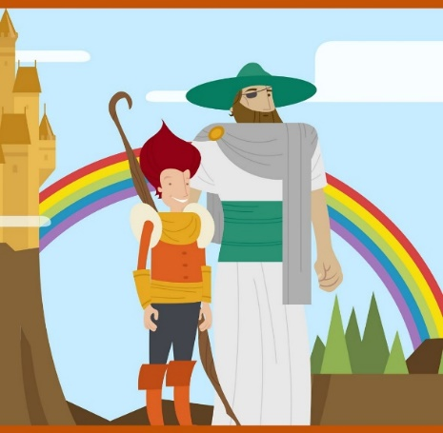

Monday 22nd June
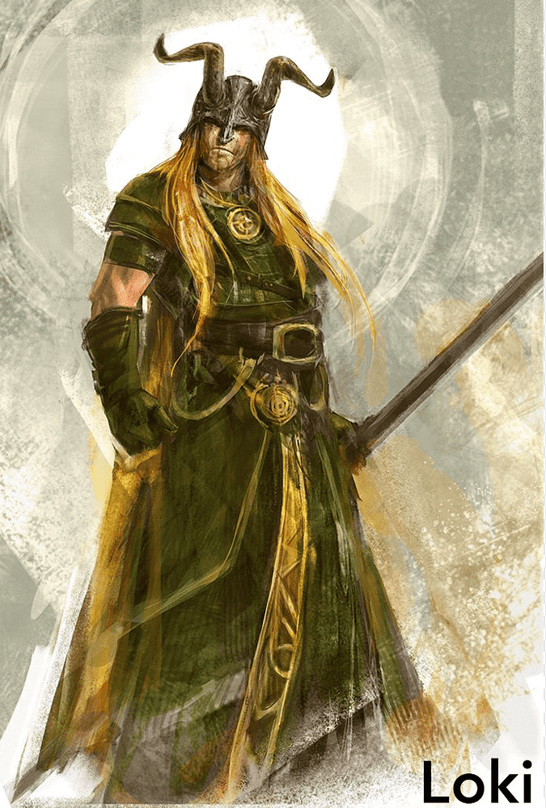
LO. To identify contractions.
To re-write the contractions in their full form.

Once you have highlighted all the contractions you
have found, either using the highlighter tool on word
or by underlining or highlighting on the printed sheet,
you need to re-write the contractions in the correct
formal way.

Do it like this;

Don’t = do not

