Character Profile for Loki
Tuesday 23rd June
LO. To find evidence in the text to identify characteristics of Loki.
Think about;
- the way Loki speaks, to the reader, Thor and the villager
- what he actually says
- Thor’s opinion (way he treats and speaks to Loki)
- use words from the text to help you
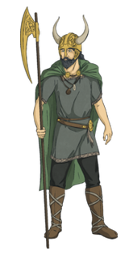
Adjectives for Loki | Words he says | Thor’s opinion
mischievous | yeah right! | impatient with Loki
Your opinion of Loki

Character Profile for Thor
Tuesday 23rd June
LO. To find evidence in the text to identify characteristics of Loki.
Think about;
- the way Thor speaks to Odin, Loki and the villager
- the language he uses
- Loki’s opinion (way he treats and speaks to Thor)
- use words from the text to help you
Adjectives for Thor | Words he says | Loki’s opinion
stubborn | greetings | laughs at Thor behind his back
Your opinion of Loki

