Thor and the Giants Part 2 Playscript
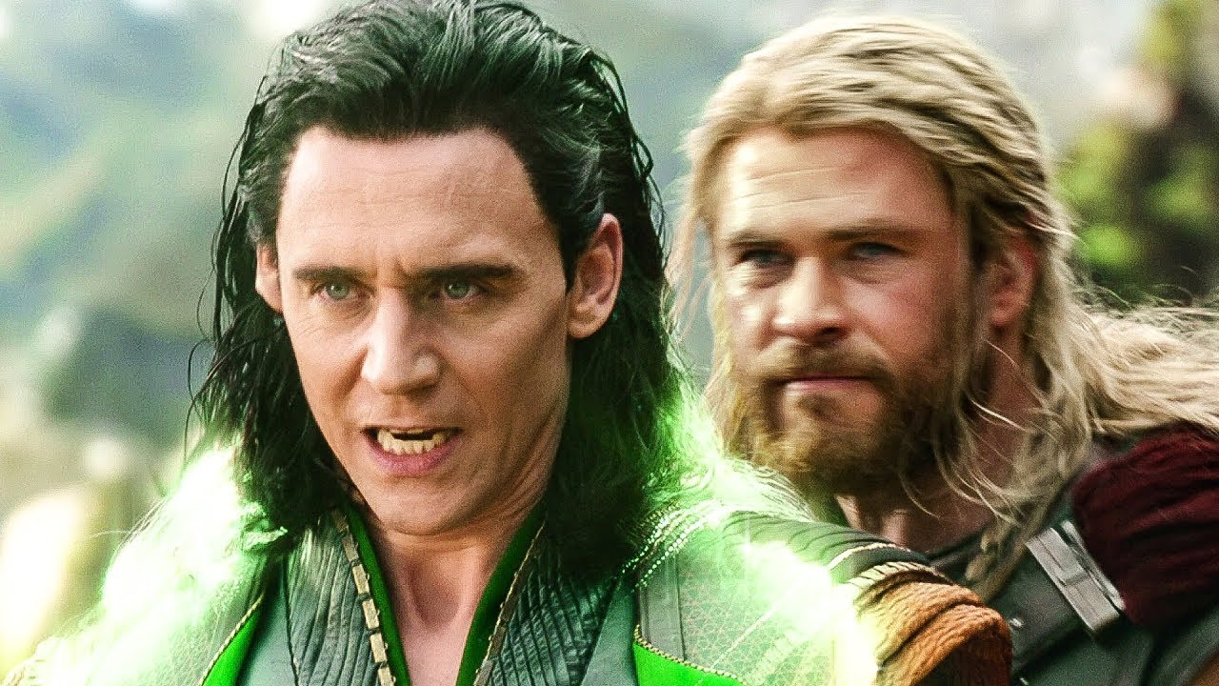
Wednesday 24th June

LO. To highlight direct speech in a text to be re-written as a playscript
Here is the first part of part 2 of our story, ‘Thor and the Giants’.
I have set it out as the spoken parts of a playscript to show you.
All the highlighted words were direct speech in the story.
Notice how in a playscript, when Loki is telling the story, this must also be set out like the direct speech.
LOKI: So…we travelled on and plunged into the icy mists of
Jotunheim, the land of the giants. Night began to fall. I thought we'd never find shelter, but suddenly out of the mists loomed a huge mansion.
It was a strange place; there was no doorway – just a huge round opening at one end. It didn’t worry Thor though, he strolled straight in.
THOR: Hallo-oh! There’s no one here, Loki.
LOKI: How weird. One vast open hall and five narrow rooms all stuck at one end.
THOR: Never mind. It's a fine place to rest.
You are going to look at your highlighted speech and set it out like this. The name of the character on the left (usually in CAPITALS) followed by a colon (:), then a space before the spoken words.
Remember, there are no inverted commas (speech marks) in a playscript.
You can choose any part of the story to re-write after Thor decides to rest.

