Thor and the Giants Part 2
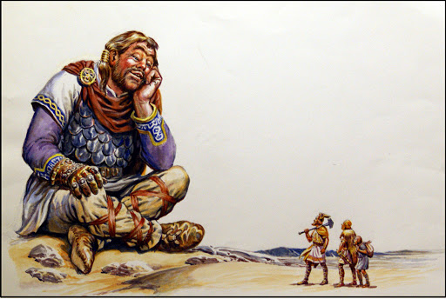
As told by Loki, the saga continues.

So…we travelled on and plunged into the icy mists of Jotunheim, the land of the giants. Night began to fall. I thought we'd never find shelter, but suddenly out of the mists loomed a huge mansion.
It was a strange place; there was no doorway – just a huge round opening at one end. It didn’t worry Thor though, he strolled straight in.
“Hallo-oh!” shouted Thor. “There’s no one here, Loki.”
“How weird. One vast open hall and five narrow rooms all stuck at one end.”
“Never mind. It's a fine place to rest.” said Thor.
So, we settled down for the night. But we'd hardly stretched out our weary legs when...
“What's that? It's an earthquake! Help! Help! Owwww!” I cried.
The mansion was rocking from side to side; I was thrown against the wall...
“Don't be afraid, Loki. I shall defend you.”
Amazingly, Thor showed no fear at all, even when...a huge eye appeared in the doorway! And then we heard a voice.
“What are you doing in my glove?” a deep voice asked.
It was a glove! The ‘mansion’, with its wide opening at one end and five narrow rooms at the other, was a giant's glove! Thor rushed to the opening and said...
“I am Thor, God of Thunder. I have come to fight with you giants!”
“And how will you do that?” laughed the giant.
“With my hammer. Aaaahhh!!!”
And with a roar Thor hurled his hammer at the giant's head. But the giant wasn't bothered in the slightest.
“Oh deary, deary me. Someone's throwing acorns at me.” The giant calmly said.
Thor picked up the hammer and he threw it again - this time at the giant's eye. This did not bother Skrymnir at all.
“Oh - there are lots of flies about today. One seems to have got into my eye.”
Then, summoning all his strength, Thor struck at the giant’s skull.
“Oh, I think a bird's done its droppings on my head!” was all he exclaimed with a laugh.
Thor stood panting. But the giant just laughed and strode away.
“Farewell! Go back to Asgard and boast of how you tickled the giant Skrymnir!” he shouted back at them.
“Nice try, Thor, but we've got no chance against these giants. Let's go home.” I suggested.
“What? Return in shame? Never! We're going after him!” cried Thor who was very angry.
There was no stopping Thor. We followed the giant’s footprints through the snow, till we came to the gates of a vast stone palace. Thor marched straight into an enormous hall where the giants sat feasting with a dozen other giants.
“Giants! It is I, Thor, God of Thunder!” he bellowed.
“Oh dear - you again. What do you want this time?” asked Skrymnir.
“Meat and drink before I do battle with you.” Replied Thor.
“You think you're fit to feast with us giants?!”
“I can drink like no other god in Asgard.” boasted Thor.
“Oh, can you? Well! See this cup? Every one of us can drink it dry in one go, can you?” Skyrmnir asked.
“Of course!”
“Thor are you sure about this?” I asked. I smelled a rat.
“Give it to me!” demanded Thor.
You've never seen anything like this cup. It was made from a long, curving horn and it was filled to the brim with foaming ale. Thor drank...and drank...and drank. He turned bright red, and then bright blue and finally, gasping, he gave the horn back. It was just as full as when he’d started. Thor had failed the challenge!


