Thor and the Giants Part 3
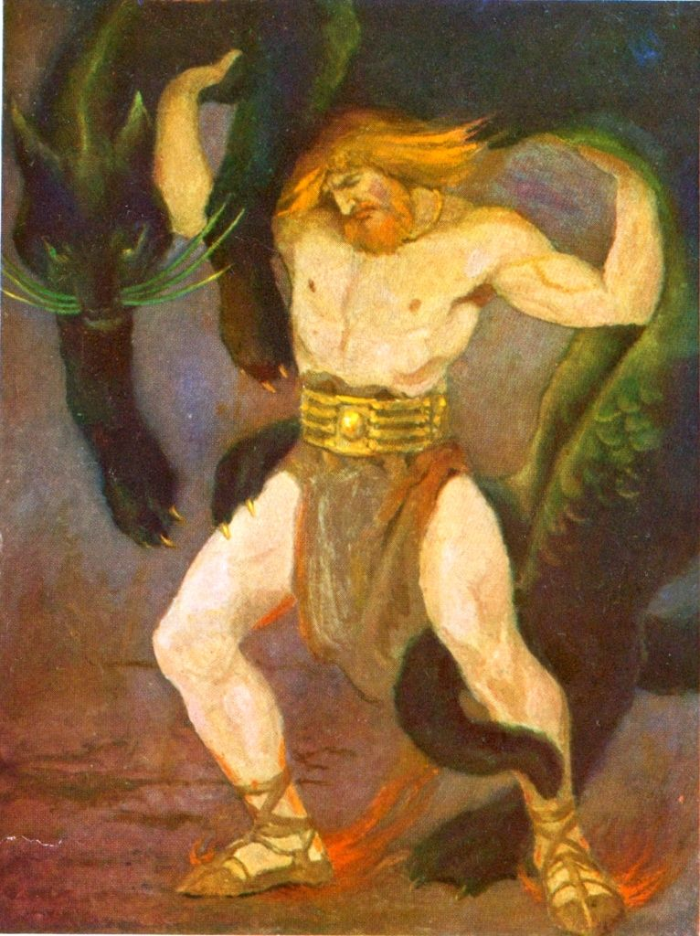
Loki left his readers on cliff edge…
Here, he resumes his tale.
Find out what happens to them both next.
Keep looking for additional information you
can add to your character profiles,

Well...would you be surprised to know that Thor’s next words were:
“Very well – I’m not as good a drinker as I was. But I demand another challenge!”
“What do you say, my friends? What shall we give him next?” asked Skrymnir.
Oh, no. The next test the giant set was a bit of a surprise. Up he stood and called out, “Bring me...my cat!”
This is no joke. The next challenge was to lift his pet pussy off the floor. A doddle, you might think. But we're talking giants here, remember, and Skrymnir's cat was the size of your average cow. Thor clutched the cat in a mighty hug...he strained till I thought he'd burst...and he managed to lift just one paw from the ground!
So much for the mighty gods!
“Enough! Let me wrestle with a proper fighter!” cried Thor
“I know just the person. Send for Hel!” Skrymnir replied.
Uh, hell, I don’t like the sound of that!
“Terrifying! Just the test I wanted!” he smiled.
“What?! Are you mad?” I asked him completely bewildered by his attitude.
“Ah, here comes Hel. Welcome!” boomed Skrymnir
“Hello!” said Hel.
“How dare you! What kind of challenge is this?” demanded Thor
Hel was about as frightening as a bag of old bones. In fact, Hel was a bag of old bones. A little old lady with no teeth and wobbly legs.
“I can't wrestle with your mother!” he said
“She's not my mother. She's my great, great, grandmother. And she's stronger than you think!”
“Rubbish!” said Thor.
So, up went Thor and grabbed her round the waist. It was the most uneven contest you've ever seen. She had Thor pinned to the ground before you could say ‘Round One’.
“Victory! Well done, Hel! So, Thor, great god of Asgard, will you go home now and say how you fought the giants?” asked Skrymnir.
“You have won. I must accept it gracefully.” He said in a defeated tone.
“Oh, well said! What a very good loser you are!”
Thor's face was like thunder. But it was nothing to how he looked next day, when Skrymnir said goodbye. The giant was about to wave us on our way when he suddenly said, “I defeated you by magic Thor.”
“You did what?” cried Thor incredulously.
“Yes! When I found you in my glove, and you threw your hammer at me, you'd have killed me if I hadn't used an invisible mountain as a shield!”
“I don’t believe this!” exclaimed Thor
“And the end of the cup you drank from reached into the sea. You drank more than any giant could. The cat I set against you was no cat at all but a serpent dragon that winds itself right round our land – to lift one paw was a miracle. Skrymnir admitted.
“This is an outrage!” shouted Thor angrily.
“And don’t be ashamed to lose to Hel - she is not an old woman but death itself – and no one can win against death. Thor, you are stronger than any giant, but we tricked you with magic.”
At this point I thought was going to burst. He grabbed his hammer and aimed another blow at Skrymnir, but the giant...disappeared into thin air!
“Where’s he gone Loki? Thor asked me puzzled.
And had Thor finally learnt his lesson? Not a bit of it... same old Thor.
“I’ll be back and next time – I shall win!” were his final words.
So, what did you think? Did you enjoy my story of Thor?



