The Apples of Iduna Part 1
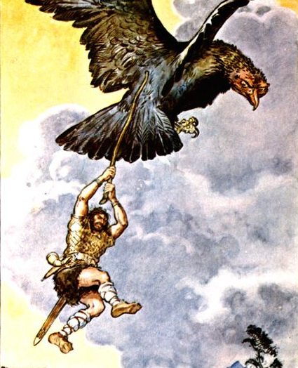
Monday 29th June

LO. To read a story set out as a playscript and
find evidence in the text to answer questions.

Read the first part of ‘The Apples of Iduna’ and
answer the following questions.
You may find it easier to highlight the evidence in the text before writing your answers.
- Who is Iduna?
_________________________________________________________________________________________________________
- What is Loki’s opinion of Iduna?
_________________________________________________________________________________________________________
_________________________________________________________________________________________________________
- Where did Odin decide to go on a trip to?
_________________________________________________________________________________________________________
- What reason does Loki give for Odin’s decision to take Loki with him?
_________________________________________________________________________________________________________
- Which of these words best describes the way Loki describes a bird to Odin? Circle, highlight or underline the one you think it is.
considerate flippant polite cruel
- What did the eagle want?
_________________________________________________________________________________________________________
_________________________________________________________________________________________________________
- Why do you think Loki tried to frighten off the eagle with a stick?
________________________________________________________________________________________________________
_________________________________________________________________________________________________________
_________________________________________________________________________________________________________
- What happened to Loki?
_________________________________________________________________________________________________________
_________________________________________________________________________________________________________
_________________________________________________________________________________________________________
- How did Odin react? Do you think he was behaving like a brave god?
What word would you use to describe Odin’s behaviour?
_________________________________________________________________________________________________________
_________________________________________________________________________________________________________
- Describe Loki’s ordeal from being grabbed by Thiassi
_________________________________________________________________________________________________________
_________________________________________________________________________________________________________
_________________________________________________________________________________________________________
- Who was Thiassi?
_________________________________________________________________________________________________________
- What did he want from Loki?
_________________________________________________________________________________________________________
_________________________________________________________________________________________________________



