The Apples of Iduna Part 1
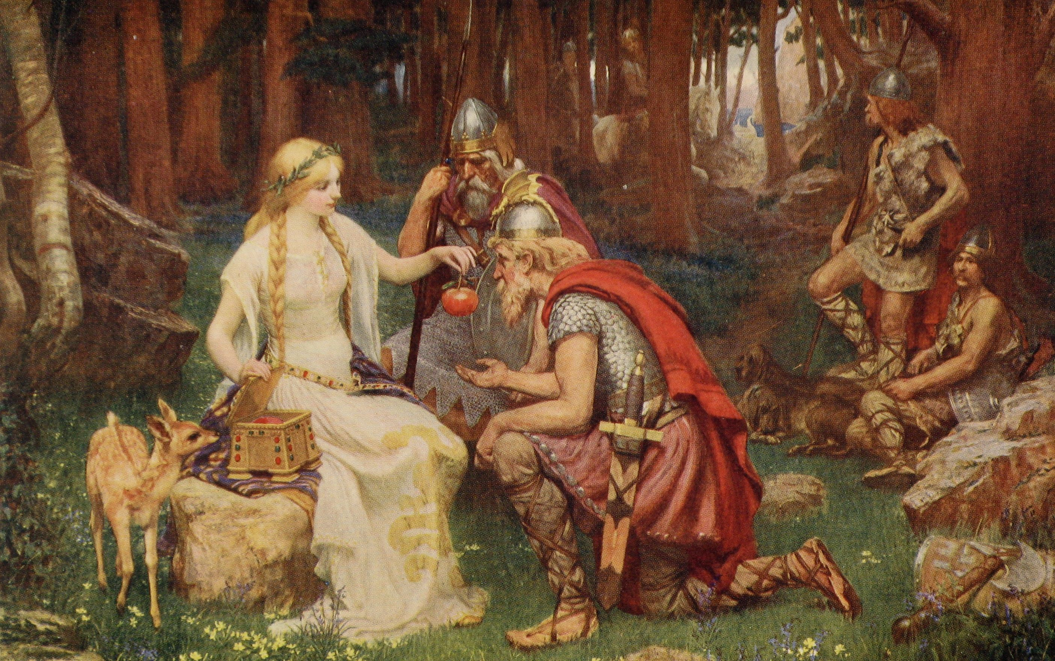
Monday 29th June

Loki: Hello! Remember me Loki by name, jokey by nature? Today I’m going to tell you another story that the Vikings told long ago. This one’s about a Viking goddess. She’s called Iduna...and she really gets up my nose! All the other gods think she’s the bee’s knees, you know what I mean? They think she’s little miss perfect. And all because of the magic apples that she grows in her garden... You see her apples hold the secret to everlasting youth. If the gods and goddess eat one of Iduna’s apples everyday they stay young and beautiful for ever. I expect you’re wondering how I could have a story about Iduna. After all, a good story needs surprises, interesting twists and turns. But here, everything seems so perfect: we all live young and beautiful forever. What could there possibly be to make the story interesting? Ha-ha, well I’ll tell you, I’ll tell you how I, Loki, did something to complicate Iduna’s prefect life and cause tremendous trouble. Now then, one day Odin decided to go on a trip to Midgard, home of you humans and, what do you know, he took me with him. He said it was because he liked my company. But I reckon it was so I could do the cooking.
Odin: Woo, there, woo. Don’t know about you Loki, but I could do with a bite to eat. Can you rustle up a meal?
Loki: See what I mean? But I couldn’t very well say no to Odin. So I put on my nicest smile and said: Of course, my lord, a spot of ox stew?
Odin: That will do nicely.
Loki: Right then, stand back. Sometimes it’s handy being the god of fire. Starting a fire by clicking my fingers is a special trick of mine... There we are.
Odin: Oh, very impressive. Keep an eye on the stew - I’m going to go and study my book of spells.
Loki: Yeah, wasn’t going to strain himself was he? He had his nose stuck in that book for the next two hours. Just long enough for me to do all the cooking. So two hours later I was feeling really cheesed off when something happened.
Thiassi: Arghh!
Loki: It didn’t seem much at first, just a bird in the trees - but you wait. Odin lifted his nose from his book and said:
Odin: I say, Loki, what’s that up there?
Loki: What - you mean that feathery thing with two wings and a beak? I think you’ll find it’s a bird my lord.
Odin: It’s jolly big.
Loki: It would be if it was a sparrow, but it’s an eagle.
Odin: It’s landed in that tree.
Loki: They do tend to do that birds...they build things in them called nests.
Odin: Loki, are you being cheeky?
Loki: Cheeky, me, course not. I’m just trying to be helpful, my lord.
Odin: Doesn’t look friendly, quiet threating in fact...
Loki: Right, stew up! Oh!
Odin: What’s the matter?
Loki: It’s the stew, it’s raw. It hasn’t cooked at all.
Odin: What? But it’s been going for two hours!
Loki: I know.
Odin: And the fire is blazing away. Loki: I know, but the stew is stone cold.
Thiassi: It’s magic.
Loki: Who said that?
Thiassi: I did.
Loki: What on earth?
Odin: It’s the bird.
Thiassi: Give me some of the meat and your stew will cook.
Odin: What?
Thiassi: I said, give me some of your meat and then it will cook.
Odin: Well I never. Er, what shall we do?
Loki: You’re in charge - but I’d say we better give it some or we’ll never eat.
Odin: Come then, great eagle. Come and take your share.
Thiassi: Good. I will.
Loki: ‘Ere, steady on! Don’t take it all!
Thiassi: Clear off - it’s good!
Odin: Oh I say!
Loki: ‘Ere that’s enough, there’ll be nothing left. Eh, give me that stick Odin, I’ll show it. I went for the bird with a heavy stick. Go on, clear of out of it... But it was a big mistake. Because it grabbed the other end of the stick in its beak and whisked me off the ground... Argh! Argh! Argh! Odin just stood there like a lemon and shouted:
Odin: LOKI!!!
Loki: Before I knew it, my feet left the ground and I was holding on to the stick for dear life. The speed of the bird - zooming along like an arrow it was... You’re flying too low! It was as well. First it dragged me through a freezing river...and then it dragged me through a thorn bush... LOOK OUT! Bottom first! Noo...ow! Ow! Stop! Put me down!
Thiassi: I’ll land on one condition.
Loki: Anything!
Eagle: Anything?
Loki: Anything at all!
Eagle: You must help me to get something I want.
Loki: It’s a deal, it’s a deal. Just put me down!
Eagle: Ok...
Loki: Argggghh! And at last the great bird dropped me in a gibbering heap. I ached all over. But I was so relived to be back on the ground. Thank you, thank you. Now what is it you want?
Thiassi: Revenge on the gods.
Loki: What? How? Why?
Thiassi: How? I don’t know yet - that’s where I need your help. Why? Because the gods are my enemies. I am no ordinary eagle but a giant in disguise. I, my friend, am Thiassi, king of the giants of Jotunheim.
Loki: Well I’ll be blowed!


