Apples of Iduna
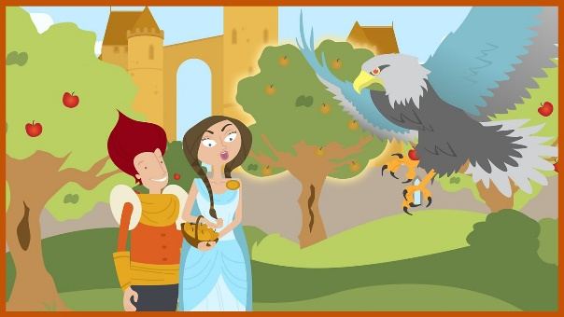
Tuesday 30th June

LO. To write paragraphs in the first person as a character from a story.
We have met two new characters in this Viking saga. Iduna, goddess of youth and Thiassi, one of the Giants who were banished to a land of ice and cold winds – Jutoheim by Odin.
Re-read Part 1 read Part 2.
Think about Loki’s character. You are going to imagine you are Loki.
From Loki’s point of view
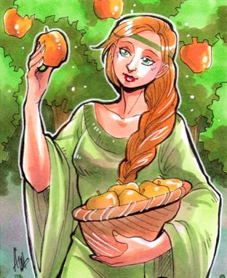 Describe Iduna
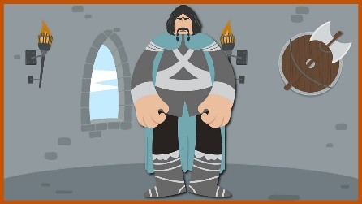 Explain why you agreed to help Thiassi
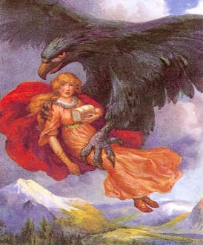 How you felt after you helped Thiassi kidnap Iduna
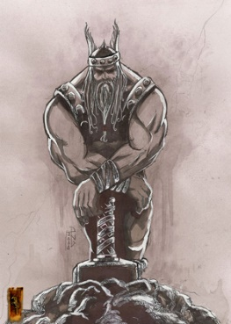 What you think may be the consequences of your actions.

