The Apples of Iduna - Part 2
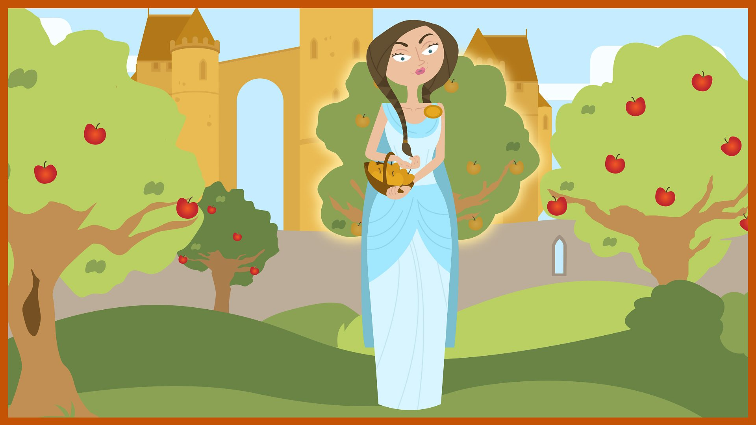
Loki: Now, I’d agreed to help the giant
Thiassi against the gods. So I
took him somewhere. Somewhere
we’ve been before... This is the
place, Thiassi. You hide in that tree.
Thiassi: Right, don’t let me down, Loki. I’m warning you!
Loki: Can you guess where I’d taken the giant? That’s right, back to Iduna’s garden and I’m sure you can guess why. If I could get Iduna to leave Asgard then Thiassi could really harm the gods. She was the only one who could pick the apples. Therefore without her the gods would grow old. Ha, ha - that’d be a good laugh...and I wouldn’t have to put up with little miss prefect anymore either. I had to get Iduna out of her garden. To go somewhere quiet where none of the other gods would see us. So I called to her: Iduna!
Iduna: Yes, Loki?
Loki: Can you give me one of your apples? I’m feeling so tired after my journey to Midgard.
Iduna: Of course, dear Loki - with pleasure. Here.
Loki: Thank you. Oh! Aren’t they small?
Iduna: Small? These apples are as ripe and as delicious as ever.
Loki: Oh well! It’s just that I’ve seen some much better ones today.
Iduna: Better?
Loki: Oh yes, a gorgeous red they were and so juicy and delicious.
Iduna: But Odin says the apples that grow here are the loveliest in the world.
Loki: I’d always thought so too...until today.
Iduna: Where are they?
Loki: Oh, about half mile beyond the rainbow bridge. I promise you, they’re much better than yours.
Iduna: I don’t believe you. Loki: Come and see for yourself.
Iduna: Oh no, I mustn’t leave my garden. Loki: Why ever not?
Iduna: Odin will not allow it - the gods might need the magic apples
Loki: Great - Odin had forbidden Iduna to leave her garden. But old Loki doesn’t give up that easily. Just think, Iduna - these other apples may be magic too! And some other goddess might find the tree. What would happen to you then?!
Iduna: Oh yes, I hadn’t thought of that.
Loki: Believe me, it won’t take long.
Iduna: Oh, very well. I’ll bring my basket.
Loki: Good idea. So off we went out of her garden. It was working a treat, but just as we were about to leave the strangest voices came wafting through the air...
Trees: Iduna! Don’t go!
Loki: Get this, talking trees!
Trees: Iduna! You are in danger!
Iduna: My trees...they’re speaking to me. Warning me not to go with you.
Loki: Nonsense, off we go.
Trees: Iduna! Don’t go!
Iduna: Don’t push me, let me go back!
Loki: Come on, come on!
Iduna: Oh! What’s that?!
Loki: Where?
Iduna: That! That!
Loki: Oh, that! That’s nothing to worry about...it’s only a giant disguised as an eagle!
Iduna: What?!
Loki: Thiassi had had enough of hanging around. He swooped down out of the tree, seized Iduna and her basket full of apples in his claws and carried her up into the sky.
Thiassi: Well done, Loki! I’ll take Iduna and her basket of apples too!
Iduna: Loki! How could you betray me?!
Loki: Quiet easily!
Iduna: Traitor!
Loki: Byeee! A few flaps of Thiassi’s great wings and Miss Goodie-Two-Shoes Iduna was just a speck in the sky. Yippee! So the weeks went by and it was jolly quiet without her, no gods and goddesses sucking up to Iduna. But there was just one problem. Can you guess what it was?
Odin: Oh, Loki, I feel terrible...
Loki: Oh yes, Odin, I don’t feel too bright myself. That’s right with Iduna gone, it wasn’t just Odin and the other gods getting older - I was as well! I’m all stiff in my arms and legs, my lord.
Odin: Oh dear! Only Iduna can pick the apples. Loki we must get her back before it’s too late! What are we going to do?
Loki: What indeed? If I ever needed a really good twist it was now!


