Superheroes
Thursday 9th July
LO: To compare well-known superhero characters from the Marvel comics.
Look at the PowerPoint showing you some of the Marvel comic superheroes. Now choose three of them and compare them. Look closely at their skills/special powers, appearance, weakness and ‘jobs’.
Draw a picture of superhero | Name of superhero | Skills/special powers of superhero | Do they have a Nemesis (enemy) | Do you like him/her?  Why?
Draw and label your favourite superhero.
Do it like this;
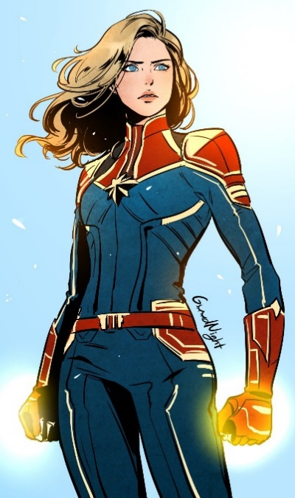
Blonde hair & blue eyes
Special powers: Flight. Superhuman strength. Can shoot energy blasts (and lasers) from her hands.
Has extensive military training.
Female originally from Earth

