Elements of a newspaper front cover Christie
Date:
LO: To label different elements of a newspaper front cover.
Label each feature of the newpaper. Draw a line with your ruler to write each feature on.
There are 7 elements to label

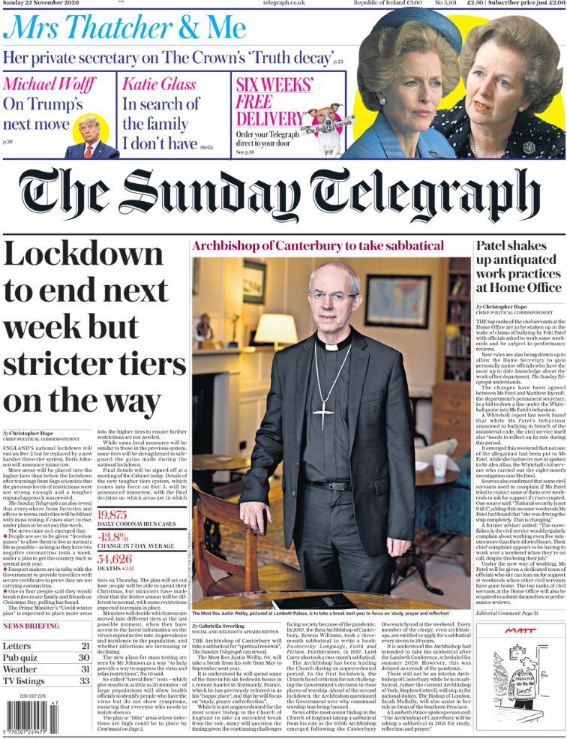

Elements of a newspaper front cover Lewis
Date:
LO: To label different elements of a newspaper front cover.
Label each feature of the newpaper. Draw a line with your ruler to each element and label. Two are already done for you.
Name of newspaper
caption

Elements of a newspaper front cover Wilson
Date:
LO: To label different elements of a newspaper front cover.
Label each feature of the newpaper. Draw a line with your ruler to each element and label. Two are already done for you.

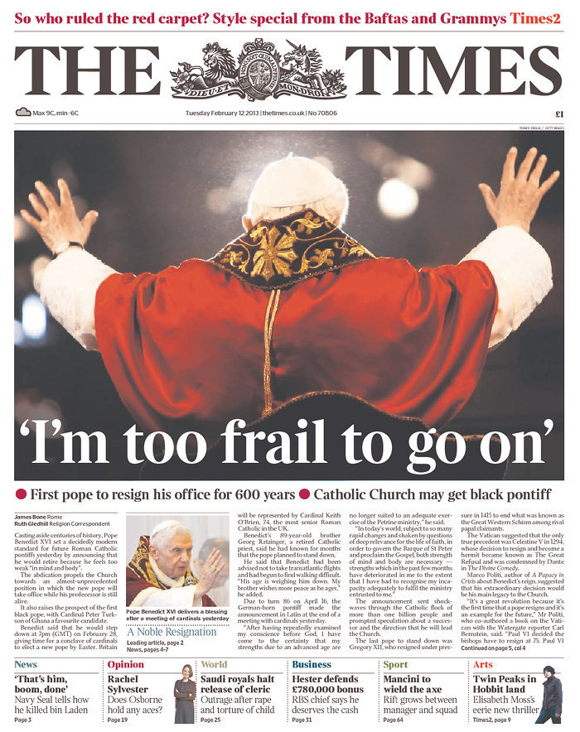

Word bank
headline columns image sub-headings
caption opening paragraph name of newspaper

Elements of a newspaper front cover Walliams
Date:
LO: To label different elements of a newspaper front cover.
Label each feature of the newpaper. Draw a line with your ruler to each element and label. Two are already done for you.
Name of newspaper

caption
Word bank
headline columns image sub-headings
caption opening paragraph name of newspaper

