Date………………………………………………….
L.O: To write a caption for a picture in a newspaper article.

Using the word bank to help you, write a caption for each picture

Caption:


Caption:

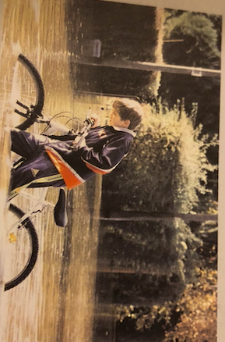

Caption:


Word bank
Discovered Floods Treasure Reading

