Date………………………………………………….
L.O: To write a caption for a picture in a newspaper article.

Cut the pictures out and write the captions that match.
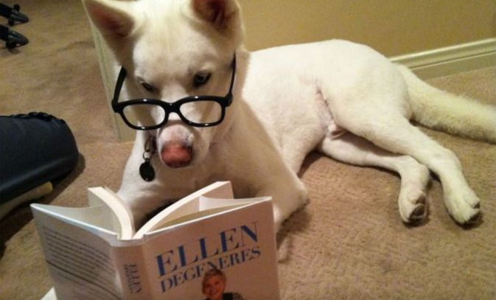
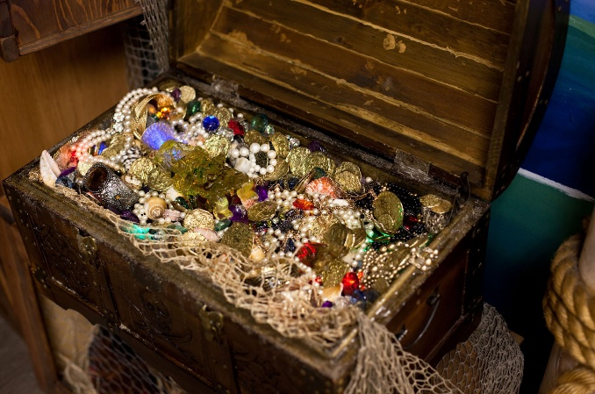

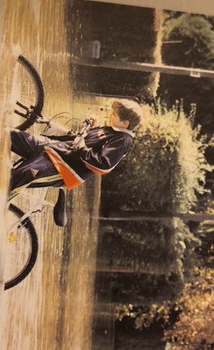

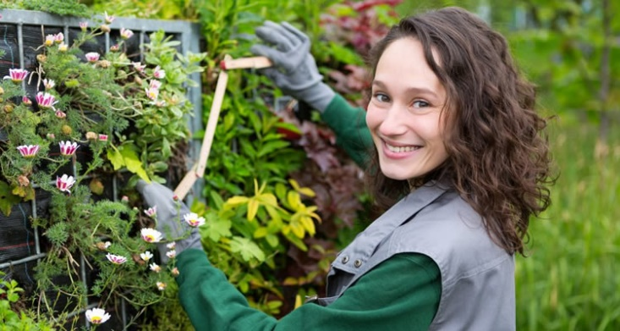

Zoe hopes her new gardening business will be a success!
Bike rider goes for an unintentional dip after a heavy rainfall
Owners claim their dog enjoys reading!
The treasure was discovered in a garden near Somerset

